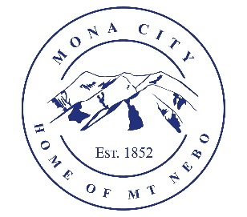
Mona City
435-623-4913
www.monautah.gov
20 West Center Street Mona, Utah

Mona City Council Meeting Agenda
Tuesday, June 24, 2025
Mona City Building – 20 West Center
7:00 p.m.

- Pledge
- Prayer
- Public Hearing
  - Amendment of Mona City’s 2024-2025 Budget & approve Mona City’s 2025-2026 Budget
- Approval of June 10, 2025, City Council Meeting Minutes
- Miscellaneous:
  - Janet Ware – 911 Day of Service for East Juab County
- Action Items:
  - Approval of Resolution 2025-15: Interlocal Cooperation Agreement Between Mona City and Nephi City for Natural Gas Services
  - Approval of Mona City Code Ordinance 2025-14: updates to Mona City Code 5-2-2: Licensing and Regulation of Dogs
- Shay Morrison R6 Community Advisor
- Secretary/Treasurer
  - Park Bathrooms
  - Street Flags
- Director of Finance
  - Approval of Finances
  - Approval of Resolution 2025-13 for the amendment of Mona City’s 2024-2025 budget and approval of the 2025-2026 budget
- Gas & Water & Roads
- Sewer
- Recorder
  - Acceptance of the State Historic Preservation Office Cemetery Grant and approval of converting Mona City Cemetery to a digital program
- Council Reports
- Public Comment
- Adjournment

CERTIFICATE OF POSTING
This agenda is hereby properly advertised on this 23rd day of June 2025 by posting copies in the following places: the Mona City Office, on the Mona City website at monautah.gov, at the United States Post Office Mona City Branch, and on the Utah Public Notice Website at www.utah.gov/pmn/index.html.

_____________________________________
Alicia Hills, Mona City Recorder
Upon Request, in compliance with the Americans with Disabilities Act, reasonable accommodations for individuals with disabilities will be provided. For assistance, please call 435-623-4913.

