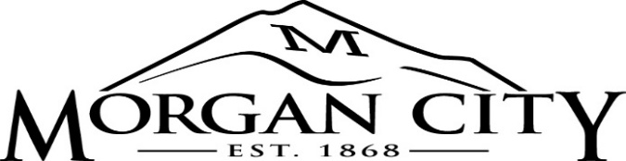

MUNICIPAL BUILDING AUTHORITY OF MORGAN CITY AGENDA
June 24, 2025 – 6:15 P.M. – SPECIAL MEETING
MORGAN, UTAH

PUBLIC NOTICE is hereby given that the Municipal Building Authority of Morgan City, Utah, will hold a public meeting in the Council Conference Room in the City Office Building, 90 West Young Street, Morgan, Utah, commencing at 6:15 p.m. on June 24, 2025.

1. CALL TO ORDER AND APPROVAL OF AGENDA
A. Welcome – Steve Gale, Chair
B. Approval of Meeting’s Agenda

2. CONSENT AGENDA
A. Municipal Building Authority Meeting Minutes – May 13, 2025

3. PUBLIC HEARING
A. Open & Amend the Municipal Building Authority of Morgan 2025 Fiscal Year Budget
B. Adopting Final Budget for the Municipal Building Authority of Morgan for the Fiscal Year Beginning July 1, 2025, and ending June30, 2026

4. ACTIVE AGENDA
A. Review / Action - Open & Amend the Municipal Building Authority of Morgan 2025 Fiscal Year Budget - Resolution M25-12
B. Review / Action - Adopting Final Budget for the Municipal Building Authority of Morgan for the Fiscal Year Beginning July 1, 2025, and ending June30, 2026 - Resolution M25-13

5. Adjournment
________________________________________________________________________________________________________
The Board at its discretion may rearrange the order of any item(s) on the agenda.
In compliance with the American with Disabilities Act, individuals needing special accommodation (including auxiliary communicative aids and service) during the meeting should notify Janet Pace, City Recorder, at (801) 829-3461 at least 48 hours prior to the meeting.
This meeting may involve the use of electronic communications for some of the members of this public body. The anchor location for the meeting shall be the Morgan Council Conference Room, 90 West Young Street, Morgan, Utah. Elected Officials at remote locations may be connected to the meeting electronically to participate.
Notice is hereby given that by motion of the Board of the Municipal Building Authority of Morgan City, pursuant to Title 52, Chapter 4 of the Utah Code, the Board may vote to hold a closed session for any of the purposes identified in that Chapter.
The undersigned, duly appointed City Recorder, does hereby certify that the above notice and agenda was posted within the Morgan City limits on this 20th day of June 2025, at Morgan City Hall, on the Utah State Public Notice Website, at morgancityut.org, and three public places within the City.
/s/ Janet Pace, City Recorder

