CERTIFICATE OF POSTING

I, THE DEPUTY CITY RECORDER FOR VINEYARD, UTAH, HEREBY CERTIFY THAT COPIES OF THE FOREGOING ORDINANCE SUMMARY for Ordinance 2025-01 WERE POSTED AT THE FOLLOWING PUBLIC PLACES WITHIN THE MUNICIPALITY ON THE 18th DAY OF June 2025. WHICH PUBLIC PLACES ARE:

POSTED:
- VINEYARD CITY OFFICES; 125 SOUTH MAIN
- VINEYARD CITY WEBSITE; www.vineyard.utah.gov
- UTAH PUBLIC NOTICE WEBSITE

AND THAT SAID NOTICE REMAINED SO POSTED AND AVAILABLE UNTIL THE 18th DAY OF JuLY 2025.

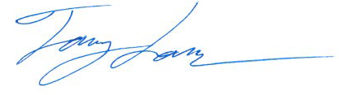


Name/Signature

Deputy Recorder
Title

