Posted on June 18, 2025, on the Utah Public Notice Website www.utah.gov/pmn/ Draper City Website www.draperutah.gov/news/ and at Draper City Hall, 1020 E. Pioneer Road, Draper, UT

NOTICE OF PUBLIC HEARING: City Initiated New and Unlisted Land Uses Zoning Text Amendment Request
Notice is hereby given that Draper City will hold a public hearing before the City Council to consider the above listed request. The purpose of the request is to amend the text of Draper City Municipal Code (DCMC) Sections 9-3-040, 9-3-060 and 9-8-050 to address recent changes to Utah State Code due to Senate Bill 179.
The hearing will be held at Draper City Hall in the City Council Chambers, on July 1, 2025 at 7:00 p.m. The complete notice is posted on the Utah Public Notice Website; www.utah.gov/pmn/, Draper City Website; www.draperutah.gov/news/, and at Draper City Hall.
To request a copy of the public notice or for additional inquiries contact Todd Taylor at (801) 576-6510 or todd.taylor@draperutah.gov.
Dated this 18th day of June, 2025.

Attest:
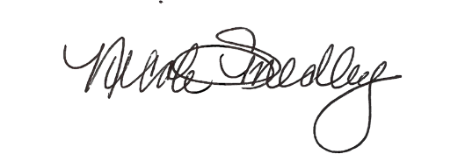

_______________________________
Nicole Smedley, City Recorder

