Milford City Council Special Meeting
Tuesday, June 3, 2025 12:30 PM
Milford City Hall, 26 South 100 West
Milford, Utah 84751

Members Present: Mayor Nolan Davis, Council Members Ian Spaulding, Russell Smith, Scott Symond, Les Whitney, and Terry Wiseman.
Absent: None
- Follow-up conversations with management regarding employee evaluations
Mayor Davis called the meeting to order at 12:30.
MOTION: Council Member Scott Symond moved to enter into Executive Session for the purpose of discussing personnel. Motion was seconded by Council Member Terry Wiseman. Roll call votes: Council Member Ian Spaulding – yes, Terry Wiseman – yes, Les Whitney – yes, Scott Symond – yes, Russel Smith – yes. Motion passed unanimously.

City Recorder Seifers was excused for the closed portion.

  - 12:30 PM – City Foreman (Ben Stewart and council were in attendance)
  - 1:00 PM – City Administrator (Makayla Bealer, Ben Stewart, and council were in attendance)
  - 1:30 PM - Collective meeting with all city office staff and crew members to discuss items from employee evaluations. (Makayla Bealer, Lisa Thompson, Monica Seifers, Ben Stewart, Lance Alger, Derek Griffiths, Riley Rose and council were in attendance)

MOTION: Council Member Scott Symond moved to leave Executive Session and reconvene in an open meeting at 2:02 PM. Motion was seconded by Council Member Russell Smith. Roll call votes: Council Member Ian Spaulding – yes, Terry Wiseman – yes, Les Whitney – yes, Scott Symond – yes, Russel Smith – yes. Motion passed unanimously.

- Action on items discussed
- No action or comments.

- Adjournment

Meeting Adjournment ~ as there was no further business the meeting adjourned at 2:03 PM.
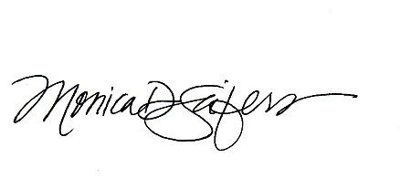
APPROVED by the City Council on the 17th day of June, 2025

MONICA D. SEIFERS, City Recorder

