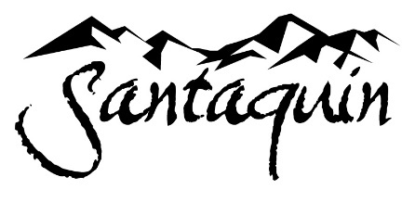

LIBRARY BOARD
Wednesday, April 9, 2025, at 6:00 PM
Council Chambers at City Hall Building

BOARD MEMBERS PRESENT: Riana Jasperson, Alicia Thornton, Anna Shaw, Ashlyn Nguyen
OTHERS PRESENT: Library Director Jen Wagner, Council Member Travis Keel
WELCOME
PLEDGE OF ALLEGIANCE
Held the pledge of allegiance.

INVOCATION/INSPIRATIONAL THOUGHT

MEETING MINUTES
- January 2025 Minutes. Board Member Jasperson motioned to approve minutes. Board Member Thorton seconded the motion. All approved.

NEW BUSINESS
- Updated Internet policy was approved per State requirement. Board Member Jasperson motioned to approve. Board Member Nguyen seconded. All approved.
- Library Director Jennifer Wagner discussed:
- Numbers Jan 2025-Apr 2025
  - 209 Jan 1-Apr 9th new cards opened on average 69 per month
  - 18,054 checkouts 6018 per month average not including Libby
- Summer Reading -theme is Color Our World. May 29th is the Summer Reading Opening between 1-4pm.
  - Will include youth council face painting
  - Pool party July 16th Payson Pool for the closing of Summer Reading
  - Colors and sizes of all board members with the Summer Reading logo
  - Sign ups sheet passed for Board Members to volunteer

- Budget costs for 2025-26
- Libby has gone up-was $1500 for our library, this year went to $2693 and they’re planning on it going up next year, could be double
- Utah State trying to figure out what to do with Libby
  - Raise our prices per library
  - Only buy certain books and curate it more strictly
  - FeTech (part of our library IT) is $1693, will go up $600 next year
- Federal Grants-have seen the news, less money may be available, so it may be tight with our budget, since we've received over 100k over the past 4 years in grants
- City is discussing the next fiscal years budgets right now, Councilman Keel discussed budgets of the city and how they're working to sort through it still, meeting next week.

BOARD MEMBERS UPDATES, QUESTIONS, RECOMMENDATIONS

Santaquin joined with Provo in putting an article in the Herald together for some of the Utah County libraries to advertise for National Library week

Board members asked how they can better advocate for the library, its budget and the building of the new library. Councilman Keel discussed some ideas with them.

NEXT MEETING
9. Wednesday July 9, 2025 at 6pm

ADJOURNMENT
Board Member Thorton motioned to adjourn the meeting and it was seconded.

ATTEST:
Board Chair | Meeting Recorder
________________________________ _________________________________

