
Summit County Health Department
650 Round Valley Drive
Park City, Utah 84060
summitcounty.org
30 Day Comment Period:
Proposed Changes to Clinical/Nursing Division Fee Schedule

June 7, 32025 – July 6, 2025
The Summit County Health Department is issuing a 30-day formal notice and comment period during which the public can review proposed additions to the Clinical/Nursing Division’s fee schedule. These include new fees for rapid lead testing, MMR titers, a combination STI test, and an updated fee structure for the Vaccines for Adults (VFA) program to match the sliding scale used for children. Please submit comments to the Health Department in writing by email or mail, or by telephone at 435-333-1500.
Details of the proposed changes can be viewed online at https://summitcounty.info/boh, or by scanning this QR code.
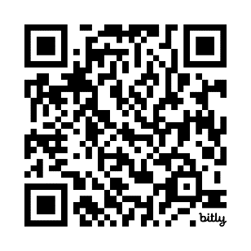
All public comments must be postmarked or received no later than 11:59 p.m. on July 7, 2025.
Please contact Derek Moss with any comments or questions related to these proposed changes.
- Email: dmoss@summitcountyutah.gov
- Phone: 435-333-1500
- Mail written comments to:
Attention: Derek Moss
Summit County Health Department
650 Round Valley Drive
Park City, Utah 84060
Public comments will also be accepted at the Board of Health meeting held on Monday, July 7, 2025, at 4:00 p.m.

