RESOLUTION NO. 2024-04
RESOLUTION OF THE UTAH FAIRPARK AREA INVESTMENT AND RESTORATION DISTRICT BOARD ADOPTING THE UTAH AREA INVESMENT AND RESTORATION DISTRICT AREA PLAN
WHEREAS, the Utah Fairpark Area Investment and Restoration District (“UFAIR District”) was established by the Utah State Legislature under the authority of Art. XI, Section 8 of the Utah Constitution; and
WHEREAS, the purpose of the UFAIR District is to fulfill the statewide public purpose of encouraging and facilitating development within the UFAIR District Boundary (UFAIR Boundary) to provide economic and other benefits to the area within the UFAIR District Boundary, surrounding areas, the region, and the state consistent with the strategies, policies, and objectives described in Utah Code §§ 11-70-101 et seq. including:
- the development and construction of a qualified stadium and related facilities for a major league sports team;

- the development and construction of infrastructure to support a qualified stadium, associated uses, and recreational uses on land within the UFAIR Boundary;

- the improvement and restoration of areas along the Jordan River within the UFAIR Boundary for aesthetic and recreational purposes;

(iv) coordinating with and supporting the Utah State Fairpark Authority (Fairpark Authority) in the use of Fairpark Authority land; and
- other development on land within the UFAIR Boundary; and

WHEREAS, the UFAIR District Boundary includes both publicly and privately owned land and is located at approximately 1200 W North Temple, Salt Lake City, Utah and consists of approximately 323 acres ("Project Area) as more particularly described on Attachment A incorporated herein by reference; and
WHEREAS, pursuant to Utah Code §11-70-501, the UFAIR District may adopt a project area plan (“UFAIR District Area Plan”) for the development of some or all land within the District Boundary in consultation with the Fairpark Authority board and the consent of a Qualified Owner of at least 65 contiguous acres of privately owned land within the District Boundary; and
WHEREAS, the state-owned land is comprised of the Utah State Fairpark and other state properties and office buildings; and
WHEREAS, the LHM Dev. E, LLC, is the Qualified Owner of privately owned land within the UFAIR District Boundaries and has consented to the project area plan; and
WHEREAS, the UFAIR District Board desires to adopt the UFAIR District Area Plan attached hereto as Attachment B to effectuate the public purpose of providing opportunities for housing, recreation, employment, and entertainment in addition to strengthening State Fairpark assets and developing privately owned underutilized and abandoned property within the UFAIR District Boundaries.
NOW, THEREFORE, BE IT RESOLVED BY THE UFAIR DISTRICT BOARD as follows:

The UFAIR District board has found and determined that the UFAIR District Area Plan meets the statutory requirements that include the legal description of the boundary of the project area, the purpose and intent with respect to the project area and the board’s finding and determination that:
  - there is a need to effectuate a public purpose;
  - there is a public benefit to the proposed UFAIR District Area Plan;
  - it is economically sound and feasible to adopt and carry out the UFAIR District Area Plan; and
  - carrying out the UFAIR District Area Plan will promote the goals and objectives stated in Utah Code § 11-70-201.

PASSED AND ADOPTED by the UFAIR DISTRICT Board this 9th day of December 2024.

Utah Fairpark Area Investment and Restoration District

Scott Sandall, Chair

Attest:

UFAIR Staff

Attachment A
Description and Map of Proposed Area

Description of Project Area
The Project Area boundaries are coextensive with those of the UFAIR District and are described in the Shapefile available at https://le.utah.gov/~2024/documents/HB0562_shapefile.zip and may be publicly accessible at https://www.google.com/maps/d/edit?mid=140hCtPp_tbgfo4lm2PFBCipH5bJmFTs.

Map of Project Area
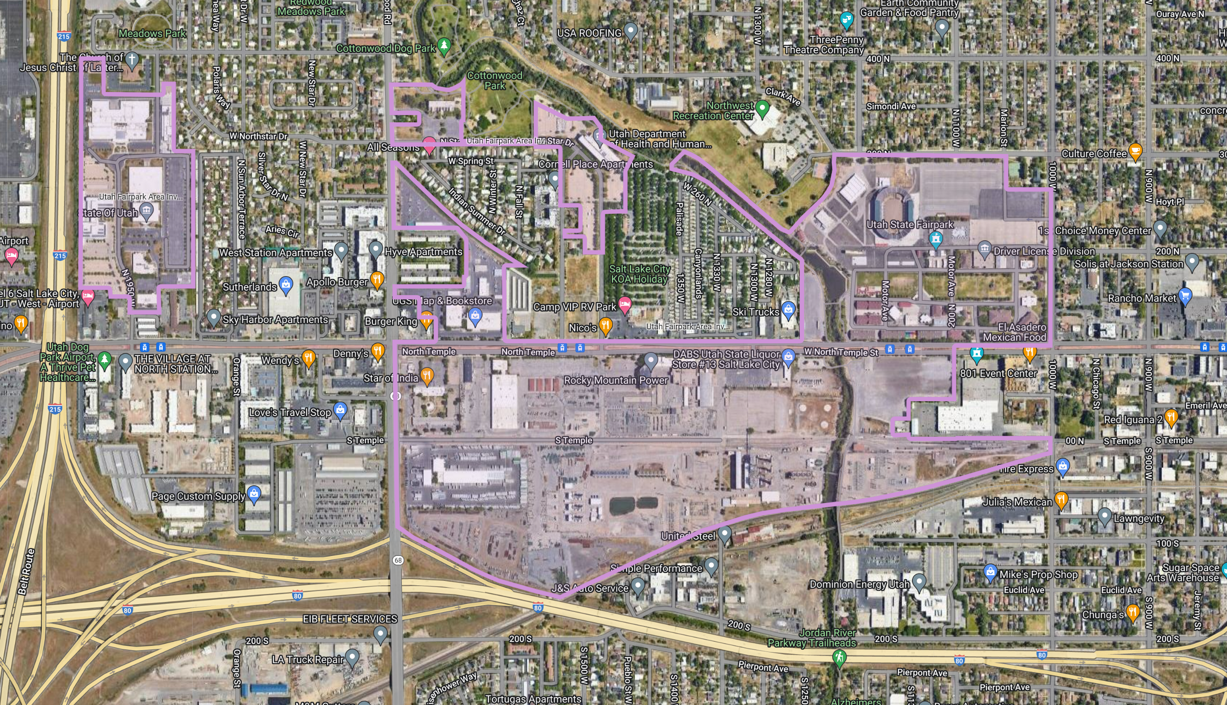

Attachment B

Project Area Plan and Budget

