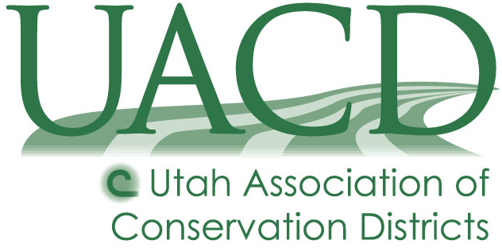

Salt Lake Conservation District
1152 Windfield Court
West Jordan, UT 84088

Meeting Location
Jordan Valley Water Conservation District
Education Building
8275 S 1300 W
West Jordan, UT 84088
Or as announced in the agenda

Board Meeting Schedule for FY26
Thursday, July 10, 2025, 1:00 P.M.
Thursday, August 21, 2025, 1:00 P.M.
Thursday, September 4, 2025, 1:00 P.M.
Thursday, October 9, 2025, 1:00 P.M.
Thursday, November 13, 2025, 1:00 P.M.
Thursday, December 11, 2025, 1:00 P.M.
Thursday, January 8, 2026, 1:00 P.M.
Thursday, February 12, 2026, 1:00 P.M.
Thursday, March 12, 2026, 1:00 P.M.
Thursday, April 9, 2026, 1:00 P.M.
Thursday, May 14, 2026, 1:00 P.M.
Thursday, June 11, 2026, 1:00 P.M.

Approved at the May 8 2025 Board Meeting of the Salt Lake Conservation District

