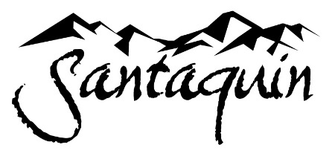

COMMUNITY SERVICES BOARD
Monday May 19, 2025, at 6:00 PM
Council Chambers at City Hall Building

BOARD MEMBERS PRESENT: Keela Goudy, Sara Olson, Hunter Nilson, Ramesus Stewart-Johnson
OTHERS PRESENT: Community Services Director John Bradley, Recreation Supervisor Shauna Jo Eves, Events Coordinator Ivan Mangum, Councilmember Brian Del Rosario, Recreation Intern Tanner Johnson

WELCOME

Recreation Staff were introduced to the Board. Director Bradley noted that Board Member Tolman has asked to be released from her position due to her changing schedule.

INVOCATION/INSPIRATIONAL THOUGHT

MEETING MINUTES
- Board Members unanimously approved the January 2025 Minutes. Motion by Board Member Olson, second by Board Member Goudy.

NEW BUSINESS

- Recreation Supervisor Shauna Jo Eves and Event Coordinator Ivan Mangum shared updates regarding annual community events.
  - Senior events have also increased with a recent field trip to the theater to watch Wicked. Seniors are also participating in the Slothathon.
  - June 7 is the upcoming Family Fitness Festival which includes a free 5k, kids run and event includes the final portion of Kids Marathon program.
  - Councilmember Del Rosario asked about efforts to keep participants warm at winter events.
  - A discussion was held regarding the need to be able to dim the lights in the Multipurpose Room for dances. Board Member Stewart-Johnson recommended looking into Smart Lights

- Recreation Supervisor Shauna Jo Eves gave an update regarding Summer Camps
- Director Bradley showed preliminary building plans for Phase 2 of the Recreation Activity Building. Construction will go from June until July 2025. It is estimated that the interior of the building construction and development will be completed by March 2026. The existing Recreation Activity Building will house cardio and weight equipment.

BOARD MEMBERS UPDATES, QUESTIONS, RECOMMENDATIONS

Board Member Olson gave an update about plans for a Geo Cache Scavenger Hunt at Prospector View Park and Trailhead during the week of Orchard Days. Event Coordinator Mangum shared his experience with geo caching, they will connect and continue to plan for the event.

NEXT MEETING
5. Thursday, July 17, 2025 at 7:30pm

ADJOURNMENT
Board Member Olson motioned to adjourn the meeting and Board Member Nilson seconded the motion.
It was recommended that we share the Department Activity Guide link on Social Media.

ATTEST:
Board Chair | Meeting Recorder
__________________________________ __________________________________________

