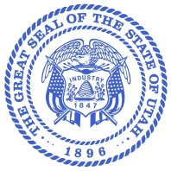
Department of Agriculture and Food

KELLY PEHRSON
Commissioner

TROY FORREST
Deputy Commissioner

LEANN HUNTING
Director, Animal Industry
State of Utah

SPENCER J. COX
Governor

DEIDRE M. HENDERSON
Lieutenant Governor

Agenda

- Call Meeting to Order – Steve McIntyre, Chairman
- Approval of Meeting Minutes (Action)
- Race Reports (Informational)
  - Dr. Amanda Price, race veterinarian
  - Kortee McGee, licensing
  - Jim Openshaw, steward
- Introduction and Confirmation of the new Executive Director, Thane Marshall (Action)
- Utah workouts (Action)
- Public Meetings Training – Leann Hunting & Curtis Grow
- Board Roundtable
- Public Comment
- Adjourn

