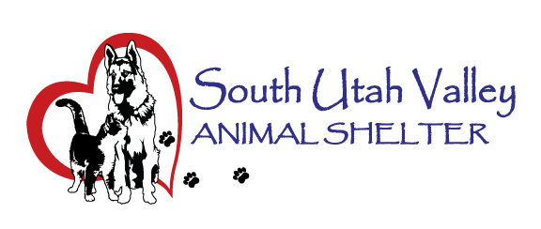
South Utah Valley Animal Special Service District
Board Meeting Minutes Tuesday September 10, 2024
South Utah Valley Animal Shelter Conference Room
582 W 3000 N Spanish Fork UT 84660
Board Member Attendance
Lt. Laursen Kayson Shepherd @RandiLyn Warner
Chief Lance Haight Chief John Jackson @Dr Bott*
Phil Christensen Chief Brad Bishop @Legal-not filled
Kari Malkovich* Kevin Oyler Shawn Carter
(*Absent / @ At large)
Also present: Kierstan Munford Executive Director, Carrie Ward taking minutes, Tom Sinnott representing Best Friends and Diane Anesi and Kim Laursen from the public.
The meeting was called to order by Chairman Bishop at 10:35 AM.
- Approve minutes of Board Meeting held on July 9, 2024. I move to approve the minutes. 1st Chief Haight, 2nd Kevin Oyler. Motion passed unanimously.
- Shelter Report by Kierstan Munford. The daily count of animals was given as 119 dogs and 142 cats. Clinic totals were given for Spanish Fork. Payson, Salem and Provo are still coming up. There will be an adoption event this Friday here at the shelter with $13 dollar adoptions. Santaquin will be getting a private mobile vet clinic. Kierstan will send out the information for it to Board Members.
- Financial Report by Kierstan Munford. Current numbers were passed out and financials are on track.
- To set a date, time and location for a closed meeting to discuss the character, professional competence or physical or mental health of an individual. No Business.
There was no public comment.
The next meeting will be held November 5, 2024 at 10:30 AM at SUVAS.
Chief Jackson informed the Board he will be retiring by January 2025 and will have another member to represent Mapleton. He also pointed out that the Chairman position should be nominated soon. It will be put on the agenda for November.
Motion to adjourn. 1st Chief Jackson, 2nd Phil Christensen. Motion passed unanimously.

