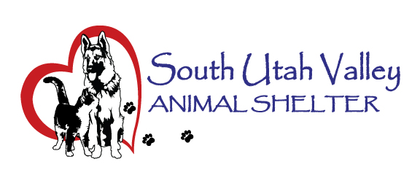
South Utah Valley Animal Special Service District
Board Meeting Minutes Tuesday November 5, 2024
South Utah Valley Animal Shelter Conference Room
582 W 3000 N Spanish Fork UT 84660
Board Member Attendance
Lt. Laursen* Officer Shepherd @RandiLyn Warner
Chief Lance Haight Chief John Jackson @Dr Bott
Chief Brad James Chief Brad Bishop @Legal-not filled
Kari Malcovich Kevin Oyler Shawn Carter
(*Absent / @ At large)
The meeting was called to order by Chairman Bishop at 10:35 AM.
- Approval of Minutes of Board Meeting held on September 10, 2024. I’ll make a motion to approve the minutes from the meeting held on September 10, 2024. 1st Chief Jackson, 2nd Chief Haight. Motion passed.
- Board Member Appointments. Chief Bishop will step down as Chairman. Chief Hurst will become the new Chairman and Co-Chair will be Chief Haight. Motion to approve Chief Hurst as Chairman. 1st Kevin Oyler, 2nd Chief Jackson. Approved unanimously. Motion to approve Chief Haight as Co-Chair. 1st Chief Jackson, 2nd Shawn Carter. Motion passed unanimously. These are effective January 1, 2025.
- Shelter Report by Kierstan Munford. The animal count this morning was 81 dogs and 163 cats in care. Volunteers have helped by walking dogs, helping get photos of the pets and one provided Billboard advertising for the shelter. Financial statement will be sent out to Board Members for the next Board Meeting. Best Friends has sent emails to all city councils in our District. Cat intake numbers were given from the stats. There was discussion about the feral cat proposal and the issues seen in various cities associated with feral cats.
- Public Comments. There are two members of the public here: Kayla Lyman and Megan Walker. They have both volunteered here at SUVAS. They said they had only heard one side of the TNVR/TNR issue from Best Friends. They were very glad to hear another side to this issue. Humane for the animal, public health issues are all things to consider. They were both loving volunteering here.
- To set a date, time and location for a closed meeting to discuss the character, professional competence or physical or mental health of an individual. No Business.
Motion to adjourn. 1st Chief Jackson, 2nd Kevin Oyler. Motion passed.
Next Board Meeting will be on Jan 14, 2024 at 10:30 AM.

