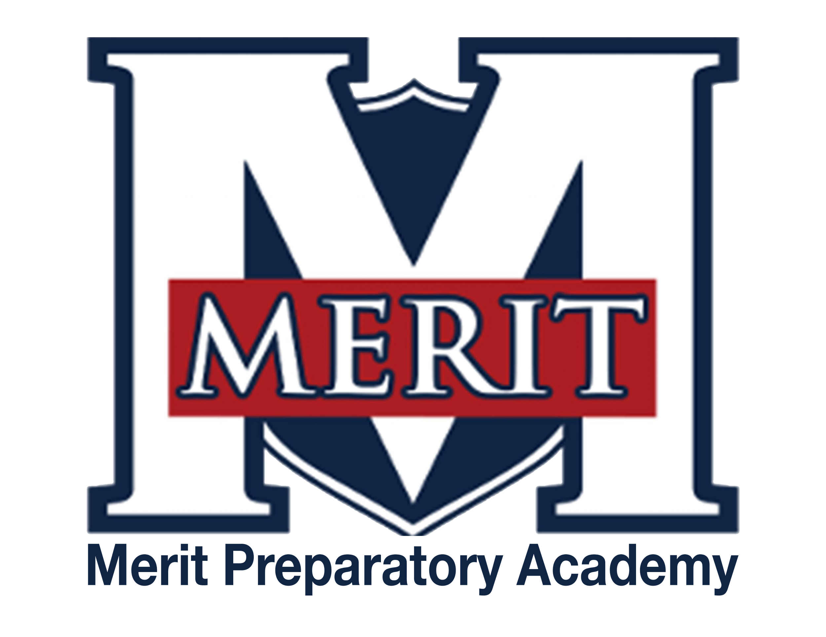
Professional Standards and Training for Non-Licensed Employees and Volunteers

References: R277-316;
Utah Code §67-20-4
PURPOSE
Non-licensed employees and volunteers are vital members of the educational team, contributing significantly to the success and well-being of Merit students. In alignment with Utah Administrative Rule R277-316, this policy establishes the professional standards and training requirements for non-licensed employees and volunteers at Merit Preparatory Academy.
DEFINITIONS
- Immediate family member: a parent, stepparent, legal guardian, sibling, stepsibling, grandparent, or child of the volunteer or non-licensed employee.
- Non-Licensed Public Education Employee: An individual employed by Merit Preparatory Academy who:
  - Does not hold a current Utah educator license issued by the Utah State Board of Education; or
  - Is employed under a contract.
- Significant, Unsupervised Access to Students: A situation in which an adult, who is not an immediate family member of the student, is alone with one or more students without direct supervision by school staff and outside of a public or observable area. This includes any setting where school personnel are not present and where the interaction cannot be readily seen or heard by others (e.g., private rooms, vehicles, secluded outdoor areas).
- Volunteer: An individual who provides services without compensation and may have significant unsupervised access to students in connection with their volunteer duties.
POLICY
- Approval and Supervision
  - In accordance with Utah Code §67-20-4, all volunteers must receive approval from the Director before commencing their services and shall operate under the supervision of an assigned Merit Preparatory Academy employee.
  - Non-licensed employees will be assigned a licensed educator as their supervisor to ensure proper guidance and adherence to educational standards.

- Compliance with Laws, Rules, and Policies
  - Volunteers and non-licensed employees are required to follow the directives of their assigned supervisors and adhere to all applicable laws, administrative rules, and Merit school policies.
    - In compliance with Utah Administrative Rule R277-316, all non-licensed employees and volunteers who are given significant unsupervised access to students must undergo a criminal background check and submit to ongoing monitoring prior to their beginning work at the school.
    - Volunteers driving for school-related activities must have on file, with Merit Academy, a valid driver’s license, proof of current auto insurance, and a certificate of completion from a certified defensive driving course.
      - In accordance with Utah Administrative Rule R277-316, all non-licensed employees and volunteers who drive a motor vehicle as an employment responsibility must self-report, within 48 hours:
        - Convictions, including pleas in abeyance and diversion agreements;
        - Any matters involving arrests for alleged sex offenses;
        - Any matters involving arrests for alleged drug-related offenses;
        - Any matters involving arrests for alleged alcohol-related offenses.
        - Failure to comply with this reporting requirement may result in disciplinary action, including termination of employment or volunteer services.
      - Drivers are strictly prohibited from being alone in a vehicle with a minor student unless the student is an immediate family member.
    - Upon receiving report of criminal activity, the school shall:
      - Immediately suspend student supervision responsibilities during the period of investigation to protect the safety of students;
      - Protect the confidentiality and due process rights of employees and volunteers;
      - Maintain records with strict requirements for the protection of confidential information.
- Confidentiality
  - During their service, volunteers and non-licensed employees may encounter confidential information. They are expected to maintain the confidentiality of such information in strict accordance with Merit Preparatory Academy's policies and the Family Educational Rights and Privacy Act (FERPA)

- Training Requirements
  - All non-licensed employees, volunteers, and coaches shall complete training in accordance with R277-316 to meet professional standards, including but not limited to:
    - Ethical Conduct Standards;
    - Student Safety and Supervision;
    - Confidentiality and FERPA Compliance;
    - Appropriate Interactions with Students;
    - The prevention of Abusive Behavior, Bullying, Cyber-bullying, Hazing, Harassment, and Retaliation;
    - Recognizing and Reporting Child Abuse.
  - Coaches must also complete:
    - Emergency Procedures and First Aid;
    - Any additional training required by the Utah High School Activities Association (UHSAA), as long as Merit is a member of this organization, and Merit Preparatory Academy.
- Termination of Services
  - Failure to comply with supervisor directions, applicable laws, rules, or policies may result in the termination of employment for the non-licensed employee or the volunteer's services.
  - Volunteers at Merit Preparatory Academy are appreciated. However, the administration reserves the right to deny or terminate volunteer services if they are no longer needed or if the volunteer's presence is deemed disruptive to the educational environment.

Approved: 1/17/ 2023
Revised and Approved: 5/14/2025

