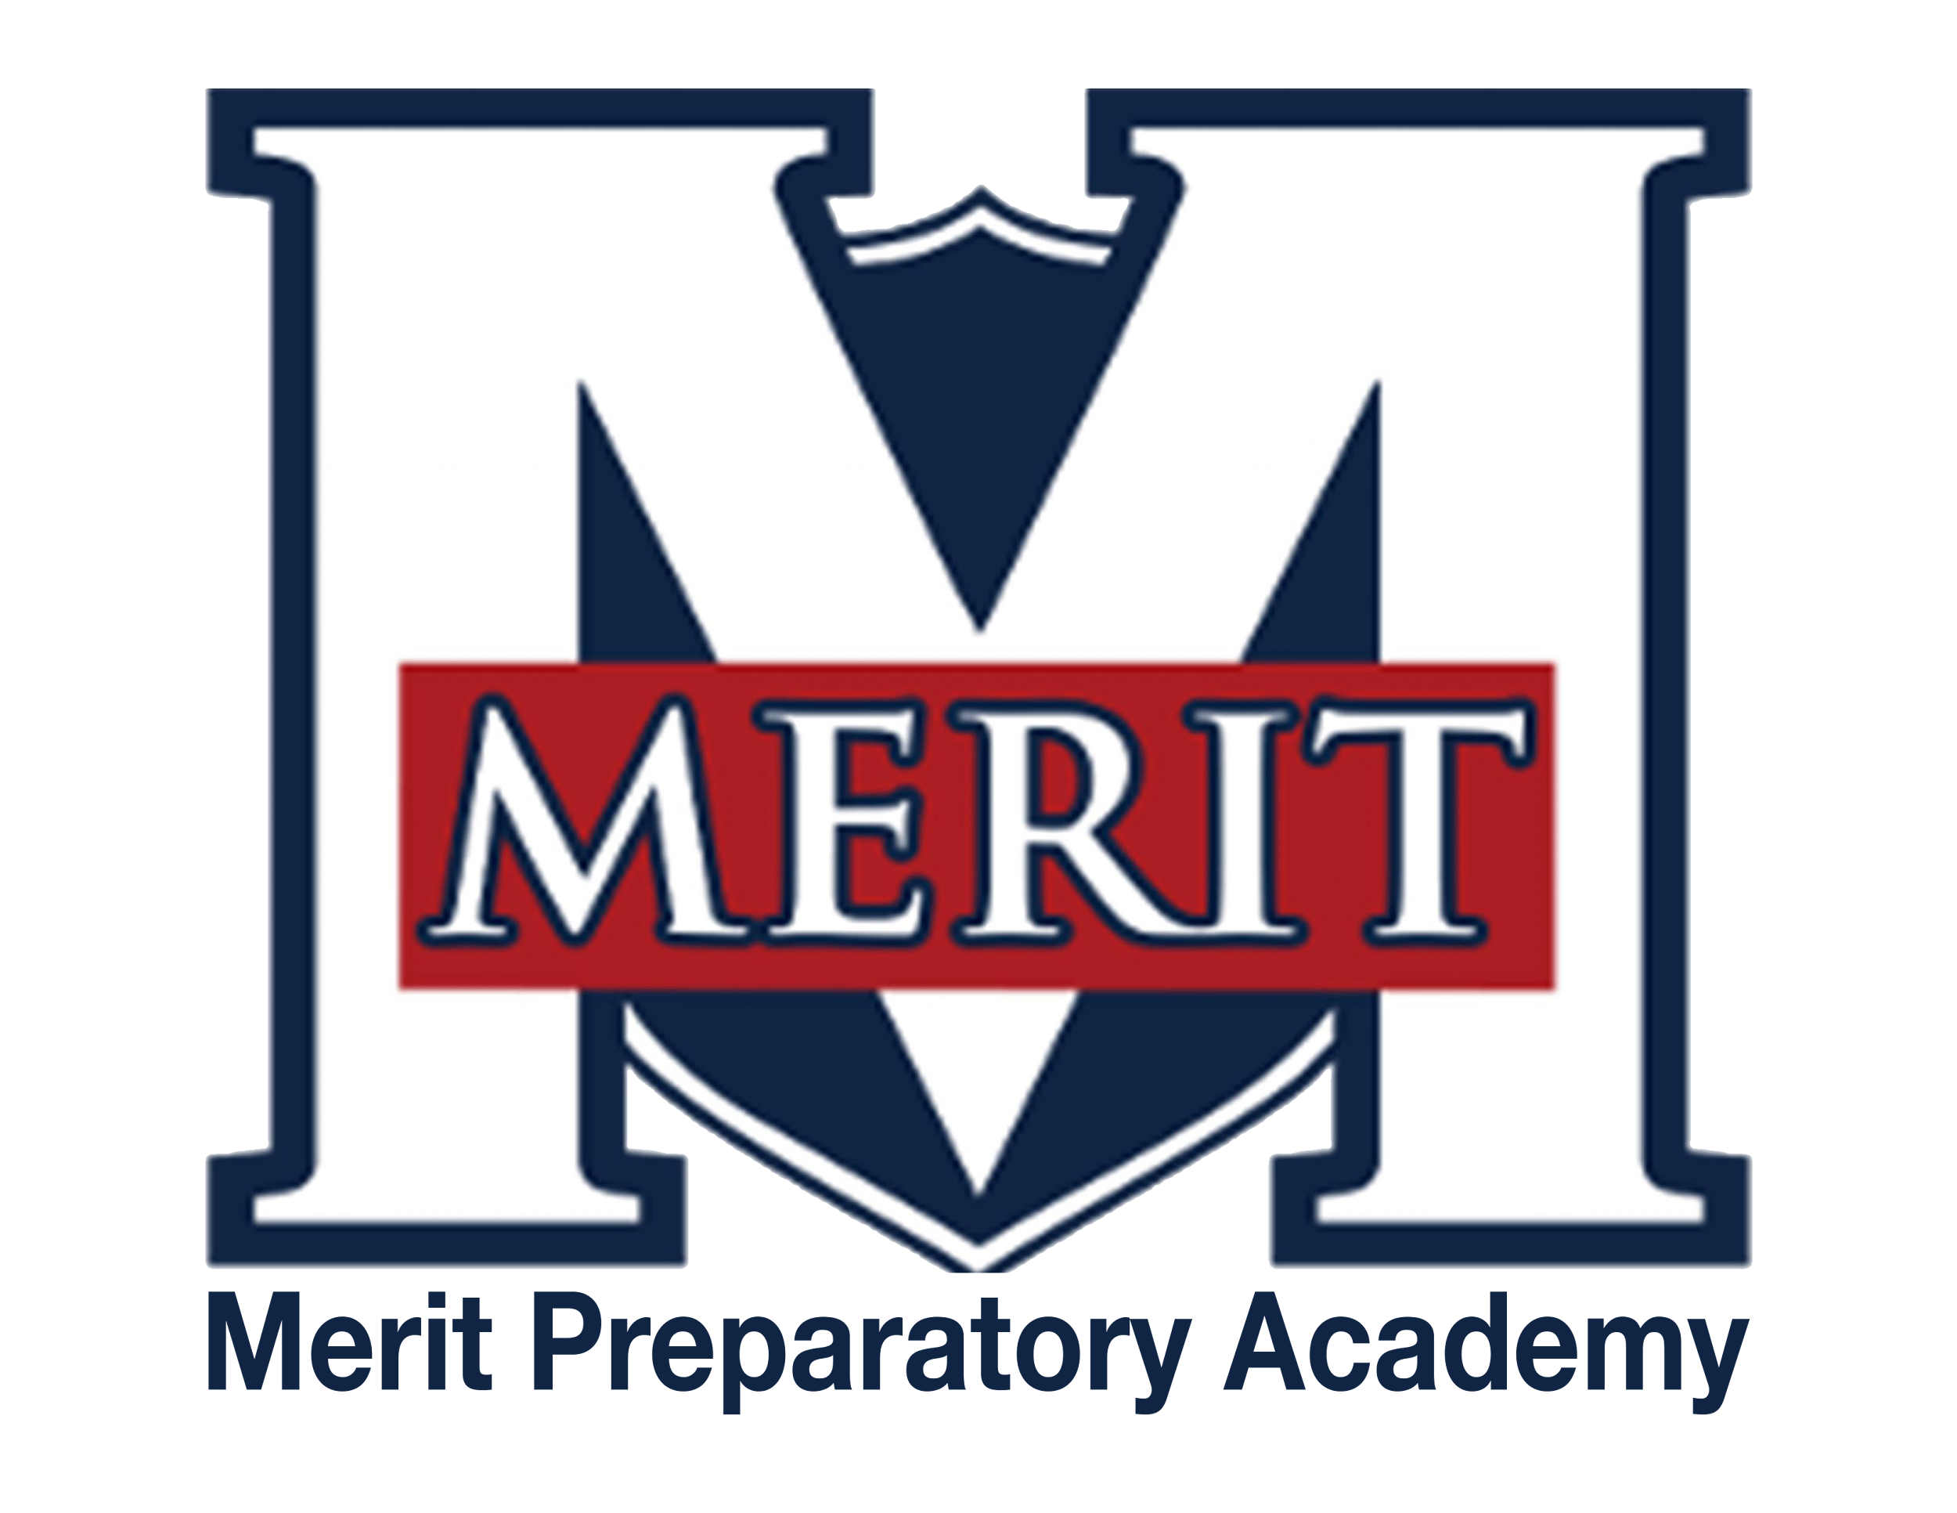
Merit Preparatory Academy
Board Meeting Minutes
March 19, 2025 at 6:30pm
Meeting at 1440 W. Center Street, The Keep

Join us on Zoom:
https://us06web.zoom.us/j/82560288867?pwd=WhOkcndQRcOb3K1UC9rhNbDcTZuKby.1

- Welcome, Roll Call and Pledge 6:34pm
- In Attendance: Anglea Bunker, Alex Tovmasyan, Rachel Jay, Jeri Mellor, Jeanné Condie, Amy Wiser
- Online: Sandra Campbell

II. Good News from Around the School
- Meritorious Knight award for March– Mike Condie
  - Meritorious Knight Award was given to Dr. Glenn Hicks for his contributions to the music program
  - Dr Hicks has taken the program and has moved it forward with professionalism and a positive impact on the music program

III. Reports-
Fiscal and Enrollment Responsibilities
- Finance Report
  - Casey Holmes from Red Apple Financial
    - Currently 66.7% through the fiscal year
    - Overall, the budget is tight
    - Interest revenue is strong
    - Salary and benefits are a little high and will need to be watched
    - Supply expenses are high due to the purchase at the start of the year of Chromebooks but this number will come in line as the year progresses
    - We are on budget with $65,000 forecasted net income
    - We are currently at a debt ratio of 1.07 and need to be at 1.10 for the Bond
    - We will be able to reach the debt ration of 1.10 when the safety upgrades are capitalized
    - Enrollment is steady at 466-467 students
    - Next year’s budget will be helped by a State funding increase: WPU up 4%, Local Replacement Fund up 9%
    - We will need 460 students enrolled to hold steady at our current funding
    - If we have 500 students enrolled that would be great

  - Finance Committee Report– Rachel Jay
    - Safety Grant was awarded at $6,000 compared to $180,000 last year
    - We are still sitting in good shape based on the improvements that have already been made
    - New window safety requirements are costly, but we will be given time to implement this requirement
    - The doors will still get done this year by moving some things around

- Marketing and QuestTime Reports
  - Marketing report– Stephanie Healey
    - 53 new students have enrolled
    - 237 students re-enrolled for next school year
    - We have a 90.5% retention rate this year
    - Upcoming feeder school tours from 8 to 10 April
    - Back to school open house went well with a lot of people expressing interest

- QuestTime and Curriculum committee report– Jeri Mellor
  - Things are going well

Academic Outcomes and Other Strategic Plan Areas
- Director Report
  - Mike Condie
    - 2026 School Land Trust plan
      - $55,000 for higher qualified teachers
      - $7,646.17 for Chromebooks/technology
      - $7,646.17 for professional development
      - Goal: Improve test scores by 1-2%
    - We are close to one-to-one on Chromebooks
    - Plan to rotate technology every five years

    - Health Education Assurances
      - Board review of Utah County information and Health Education curriculum
      - What is the board’s part in reviewing the curriculum?
      - The curriculum needs to be reviewed every two years by the committee
      - Discussed the need for parental consent and alternative materials if consent is not given

Charter Fidelity & Adherence to Statute, Rule & Policy
- Policy Committee Report– Angela Bunker
  - Professional Standards and Training for Non-Licensed Employees and Volunteers
    - Tabled until next month

  - Board Members Code of Conduct Policy
    - Add background check to this policy

  - Conflict of Interest Policy
    - Tabled until next month

  - Staff Conduct with Students Policy
    - Text or other social medica contact from teachers to students were discussed
    - Text and social media guidelines are provided to the teachers at the beginning of the year

  - Sex Education Instruction Materials
    - A committee and parents’ group will review the curriculum every two years
    - Question: What is the purpose of the identity chart and how is it used
      - It is used on the first day as an activity
      - It is focused on who they are, self-esteem, body image and self-reflection
      - This is not turned in
    - Question: What is the question box and how is it used?
      - It is a box where students can place questions that they may have and do not feel comfortable in raising their hand to ask the question
      - The State law is reviewed at the start of the class and she explained that there are questions she cannot answer
    - Question: How do you use the speed dating exercise?
      - They will get a profile, and they have to go through to see who they would match with based on the characteristic on the card

    - Question: What will the high school students be turning in on the assignment for reproductive disease and cancer? Will this include pictures?
      - This assignment will be charts and graphs and no pictures
    - Question: What will be on the video of pregnancy and development?
      - No live births will be shown
      - The video just shows what is developing at different stages of pregnancy
    - Question: In the relationship area do you talk about the issues with having premarital sex and the impact on mental health
      - It currently is not part of the curriculum, but she is open to adding the impact to one’s mental health
    - The Board needs to review incidences of pornography in the school
        - Mike is not aware of any reports
        - Firewalls are set up to alert the staff if someone tried to use school technology to access pornography

  - Abusive Behavior, Bullying, Cyber-bullying,
Harassment, and Hazing Policy
    - Committee had reps from all Stakeholders
    - Tabled until next month

- Audit Committee Report– Alex, Rachel, Sandra

IV. Public comment- 15 minutes
As per Board procedure, public comment will be limited to 3 minutes per person. Anyone who would like to make a public comment will need to sign up prior to the start of the public comment period. Grievances, complaints, or concerns with individual employees or board members will not be allowed during this time as they must be dealt with by following the Conflict Resolution Policy process, and defamatory statements regarding any individual will not be allowed during an open public meeting.

V. Action Items
- Vote to approve February 13, 2025 Board Meeting Minutes
  - Motion: Alex Tovmasyan, Second: Jeri Mellor, All in favor: All

- Vote to approve LEA Specific License for Earth & Space Science for David Buckley
  - Motion: Angela Bunker, Second: Alex Tovmasyan, All in favor: All

- Vote to approve Health Education curriculum
  - Motion: Angela Bunker, Second: Alex Tovmasyan, All in favor: All

- Vote to approve Professional Standards and Training for Non-Licensed Employees and Volunteers
  - Tabled until next month

- Vote to approve Board Members Code of Conduct Policy
  - Motion: Alex Tovmasyan, Second: Amy Wiser, All in favor: All

- Vote to approve Conflict of Interest Policy
  - Tabled until next month

- Vote to approve Staff Conduct with Students Policy
  - Motion: Amy Wiser, Second: Alex Tovmasyan, All in favor: All

- Vote to approve Sex Education Instruction Materials
  - Motion: Amy Wiser, Second: Alex Tovmasyan, All in favor: All (Please note that Rachel Jay withdrew from voting on this topic)

- Vote to approve Abusive Behavior, Bullying, Cyber-bullying,
Harassment and Hazing Policy
- Tabled until next month

VI. Board Business
- Director performance evaluation
  - Send Director’s eval to Jeanné and we will discuss next month
- Stakeholder survey– Jeri Mellor
  - Wil send out after spring break
  - There are three different surveys, one for teachers/staff, parents and students
  - Will need some help to translate the questions into Spanish
  - The students may be able to do their survey during QuestTime
  - The Evals will be shared with the board before it is sent out

- Expanding the board and preparing for the future
  - Thanked Sandra Campbell for her work on the board
  - New board members:

  - David Jensen
    - He has children at Merit and would like to give back
    - He has a background in IT and other areas that he believes would be helpful to the school
- Vote to approve David Jensen as a new board member:
  - Motion: Amy Wiser, Second: Jeri Mellor, All in favor: All

  - Ashley Watts
    - Has children at Merit
    - She is an HR manager and registrar at Franklin Discovery Academy
    - She has knowledge of Charter School Boards and regulations
- Vote to approve Ashley Watts as a new board member:
  - Motion: Angela Bunker, Second: Jeri Mellor, All in favor: All

- Board Calendar
  - The next board meeting will be held on April 10, 2025, at 6:30pm in Merit’s library
  - Board members are responsible to attend the end of year knighting ceremony on May 21, 2025 at 8:30am, and graduation on May 22,2025 at 4pm

VII. Executive Session
- To discuss the character, professional competence, or physical or mental health of an individual
  - Possible Action from Executive Session

VII. Adjourn: 8:52 pm

