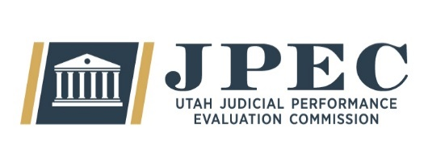
MEETING MINUTES

Committee | Judicial Performance Evaluation Commission (JPEC)
Date  Time  Location | Tuesday, May 13th 2025  9:00 a.m. – 12:00 p.m.  Online
Members Present | Gil A. Miller, Christian Hansen, Christine Durham, Bridget Romano, Curtis Jensen, Lisa Watts Baskin, Mallory Bateman, Blair Hodson
Members Excused | Tom Ross, Ally Isom, Mary Noonan, Sonya Martinez-Ortiz
Guests
Staff | Mary-Margaret Pingree, Madison Klein, Chris Russell, Jamie Nelson, Paul Tonks (AG), Cameryn Coffey (intern)
Agenda Item: | Announcements / March 11th, 2025 Minutes Mary-Margaret Pingree  Bridget Romano
Notes: | Motion – Blair motions to pass the March minutes, Curtis seconds, passes unanimously.  JPEC has hired a summer intern, Cameryn Coffey. She is helping to complete observations before the deadline this fall.
Agenda Item: | Judicial Conduct Commission Presentation Alex Peterson  Open Session Aimee Thoman
Notes: | The Executive Director of the Judicial Conduct Commission, Alex Peterson, gives an overview of their investigation process. He highlights that complaints to the JCC have “exploded” in recent years and they have brought on an additional staff member to help with the new workload. JPEC commissioners ask a few clarifying questions on the intricacies of their process.
Agenda Item: | Institute for the Advancement of the American Legal System (IAALS)  IAALS and Judicial Performance Evaluations  JPE 2.0 Report Danielle Kalil  Open Session
Notes: | Danielle Kalil from IAALS gives an overview of the new JPE 2.0 report that was released earlier this week. The Institute has done extensive research over the past couple of years and has published new recommendations and best practices for JPE groups. Mary-Margaret asks commissioners to closely review the report and prepare to discuss protentional changes and improvements that can be made to JPECs current process.

Agenda Item: | Basic Court Evaluations Madison Klein  Open Session
Notes: | Madison follows up on a conversation from last deliberation about possibly incorporating the procedural fairness standard for “basic” evaluation judges. Although these judges now have additional information collected on them from the newly implemented observation program, the Commission decides to keep the basic evaluation process the same. Not enough information is available to make an informed vote on Procedural fairness at this time.
Agenda Item: | Appellate Test Mary-Margaret Pingree  Open Session
Notes: | Mary-Margaret gives an overview of current recommendations for the Appellate Pilot survey. The Commission does not have enough time to discuss the current survey tool at length but plans to be prepared to finalize the survey in the July meeting.
Next Meeting | July 8th, 2025  9:00 a.m. – noon  CCJJ Conference Room  East Senate Building

