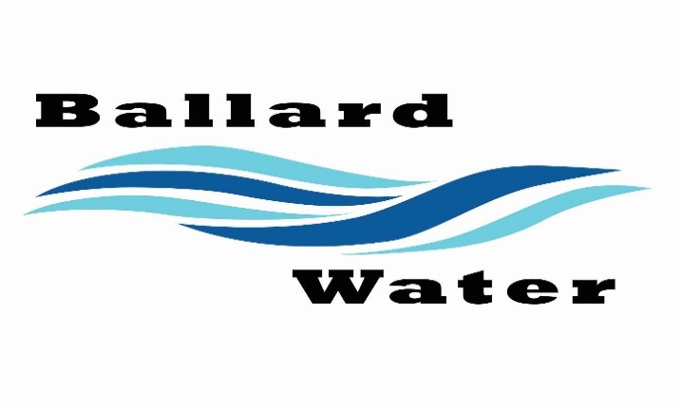

Board Chairman

Mark Reidhead

Board Members

Cory O’Driscoll

Andrew Ercanbrack

Ronny Rich

Jesse Danley

2381 E. 1000 S.

Ballard, UT 84066
Phone: (435) 722-3393
Email: amcdonald@ballardcityut.gov

Water District Meeting

April 15, 2025, 5:30 pm

MINUTES

Item

CALL WATER BOARD MEETING TO ORDER

Welcome and Roll Call – Chairman Mark Reidhead welcomed all in attendance and called roll. Those in attendance were Board Members Jesse Danley, Ronny Rich, Andrew Ercanbrack, and Secretary Anissa McDonald.
Board Member Cory O’Driscoll was excused.

Prayer – Andrew Ercanbrack

Pledge of Allegiance- Was said by all in attendance.

- PROJECT UPDATE –
Jeffrey Baker from Jones & DeMille said that the environmental permitting process is about 80% done and said that he is discussing right of way concerns with attorney. All permitting should be done in a couple of months.

- UINTA WAX PIPELINE –
Joe Garcia from Uinta Wax said that in the right of way they are asking to install a water line for future completions and while in the process they want to take the existing 2 gas lines and put in with the water line. Discussion was held regarding the contract including right of ways, replacing the fence with H brace 5 wire and that for any purpose in future that the Water District needs anything that Uinta Wax would need to fix at their expense.
Joe stated that they want to start the project in June and would be done by August.

- FINLEY RESOURCES PIPELINE –
No representatives in attendance.

- STIPEND INCREASE –
Board Members held discussion and agreed to raise Chairman Mark Reidhead’s stipend by $200.00 for total of $500.00.
Motion made by Board Member Andrew Ercanbrack to increase Chairman Mark Reidhead’s stipend by $200.00 to equal total of $500.00, 2nd by Board Member Jesse Danley. All in favor.
YEA NAY
Board Members
Jesse Danley
Ronny Rich
Andrew Ercanbrack
Mark Reidhead
Board Member Cory O’Driscoll was excused.

- ENGINEERING UPDATE –
No further updates from engineers.

- REVIEW & CORRECT MINUTES –
- March 18, 2025
Motion made by Board Member Jesse Danley to approve the minutes of March 18, 2025 as written, 2nd by Board Member Andrew Ercanbrack. All in favor.
YEA NAY
Board Members
Jesse Danley
Ronny Rich
Andrew Ercanbrack
Mark Reidhead
Board Member Cory O’Driscoll was excused.

- FOLLOW-UP ON PAST MINUTES
No follow up.

- FINANCES: Checks, Statements, Reports and Budget
Checks and finances were gone over and approved.

- ADJOURN WATER BOARD MEETING –
Motion made by Board Member Andrew Ercanbrack to adjourn meeting at 6:10 pm, 2nd by Board Member Jesse Danley. All in favor.
YEA NAY
Board Members
Jesse Danley
Ronny Rich
Andrew Ercanbrack
Mark Reidhead
Board Member Cory O’Driscoll was excused.

Chairman Mark Reidhead Date

Secretary Anissa McDonald Date

.

