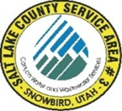
NOTICE OF
REGULAR MEETING
of the Board of Trustees of
SALT LAKE COUNTY SERVICE AREA #3 - SNOWBIRD
to be held on Monday May 19th, 2025, at 12:00 P.M.
Join the meeting electronically from the link below.
https://teams.microsoft.com/l/meetup-join

Meeting ID: 246 969 066 656 0
Passcode: SY9Ms9aQ

Dave Richards
Chris Bremer
Tom Prosek

MEETING AGENDA

- Richards Approval April 21st, 2025, meeting minutes.

- Carpenter Systems Operations and Development.

- Carpenter Treasurers Report ending April 30th, 2025.

- Richards Approval of April 18th through May 15^{th,} 2025.

Post Date: __________________
Attest: ______________________
Bryauna A. Alderin/ Clerk

