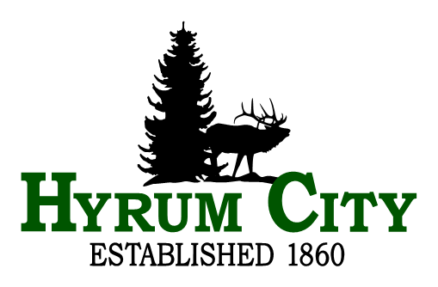
Hyrum City Council Meeting
Thursday, May 15, 2025 at 5:00 PM
Council Chambers, 60 West Main, Hyrum, Utah
Agenda
Public notice is hereby given of a Hyrum Hyrum City Council Meeting to be held in the Council Chambers, 60 West Main, Hyrum, Utah at 5:00 PM, May 15, 2025. The proposed agenda is as follows:
1. ROLL CALL
2. CALL TO ORDER
3. WELCOME
4. AGENDA ADOPTION
5. AGENDA ITEMS
A. 2025-2026 Budget Workshop.
6. ADJOURNMENT
7.
__________________________________
Stephanie Fricke
City Recorder

Council Members may participate in the meeting via telephonic communication. If a Council Member does participate via telephonic communication, the Council Member will be on speakerphone. The speakerphone will be amplified so that the other Council Members and all other persons present in the Council Chambers will be able to hear all discussions. In compliance with the Americans with Disabilities Act, individuals needing special accommodations (including auxiliary communicative aids and services) during this meeting should notify Hyrum City at 435-245-6033 at least three working days before the meeting.
8. CERTIFICATE OF POSTING - The undersigned, duly appointed and acting City Recorder of Hyrum City, Utah, does hereby certify that a copy of the foregoing Notice was emailed to The Herald Journal, Logan, Utah, posted on the Utah Public Notice Website and Hyrum City’s Website, provided to each member of the governing body, and posted at the City Offices, 60 West Main, Hyrum, Utah, this 12th day of May, 2025. Stephanie Fricke, MMC, City Recorder.

