BEAVER HOUSING AUTHORITY
BOARD MEETING AGENDA
April 8th, 2025

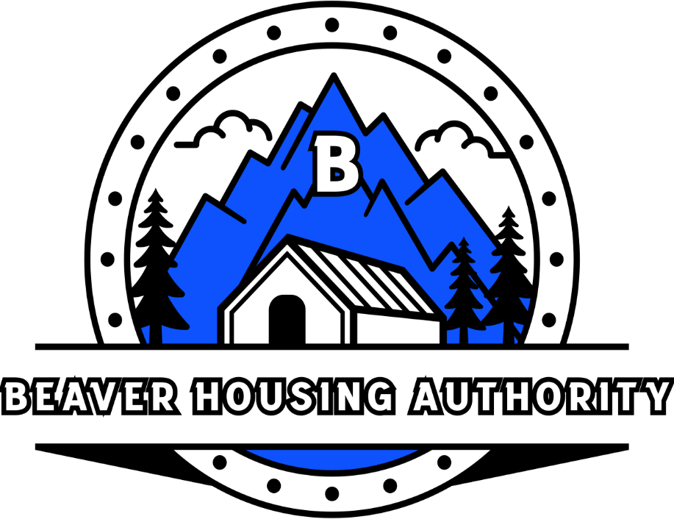
Welcome

- Prayer
- Attendance
- Bills
- Minutes
- Insurance – Open Enrollment (Medical portion)

- Program Updates

  - Public Housing
  - Crown(s)
  - USDA – Country Village
  - LIHTC – Beaver Meadows
  - Development
  - Section 8
- Other Business
  - Resident Advisory Board – (3 Participants – Feb 10th)
  - Removal of Aspen Sign – Complete
  - Upcoming Budget Meeting (4/28-4/30)
  - Paid Intern Program
  - Units currently being remodeled
    - Apartment D2 - BTown
    - White - TBD
    - Mansfield 6 - Team
    - Aspen Laundry - Licia
- Closed Session
- End Meeting

