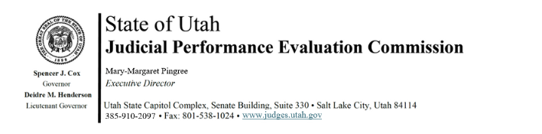
Judicial Performance Evaluation Commission
AGENDA
Tuesday, May 13, 2025
9:00 am-12:00
Hybrid Meeting *

Members: Lisa Watts Baskin, Mallory Bateman, Christine Durham, Christian Hansen, Blair Hodson, Ally Isom, Curtis M. Jensen, Sonya Martinez-Ortiz, Gil A. Miller, Mary Noonan, Bridget Romano, Tom Ross

Staff: Madison Klein, Jamie Nelson, Chris Russell, Mary-Margaret Pingree

9:00 a.m. Welcome Bridget Romano
Approval of Minutes – March 11, 2025

9:00 Announcements Mary-Margaret Pingree

9:05 Judicial Conduct Commission Alex Peterson Review of JCC Process Aimee Thoman
Q&A Joe McGivern

10:00. Institute for the Advancement of the American Legal System (IAALS)
IAALS and Judicial Performance Evaluations Danielle Kalil
JPE 2.0 Report

10:45 Basic Court Judges Madison Klein
Procedural Fairness Measure

11:00 Appellate Test Bridget Romano
Survey Questions Mary-Margaret Pingree

11:30 Adjourn

Next Meeting: Tuesday, July 8, 2025
9:00 a.m. – 12 noon
Large Conference Room, 3rd Floor, Senate Building

*Anchor Location: Senate Building, Suite 330, CCJJ Large Conference Room

