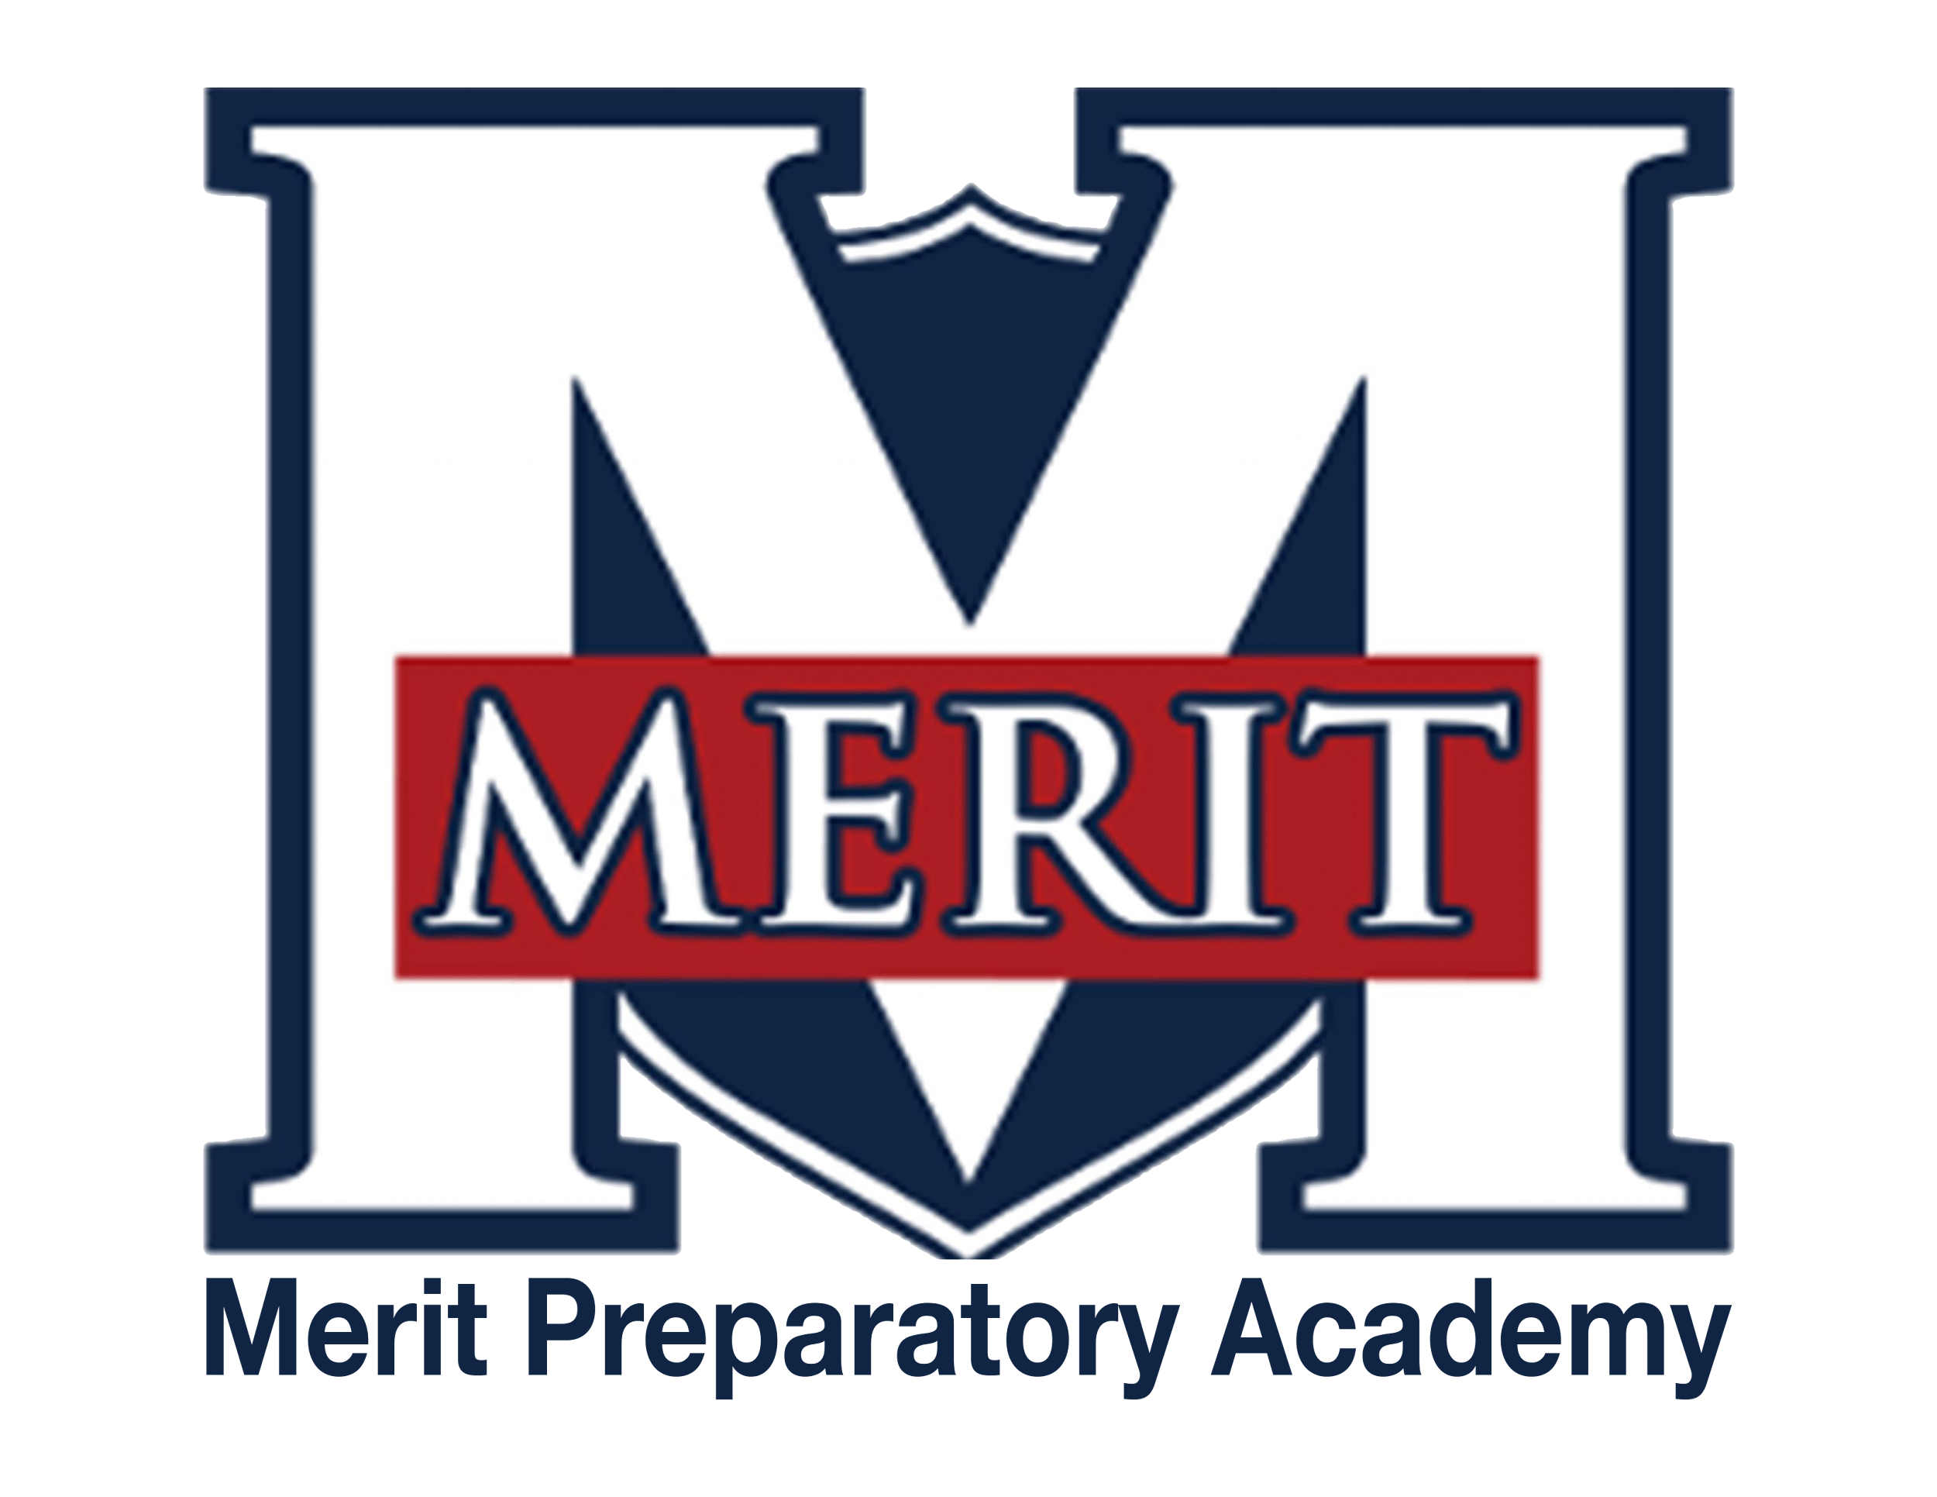
Merit Preparatory Academy
Board Meeting Agenda
May 14, 2025 at 6:30pm
Meeting at 1440 W. Center Street, The Keep

Join us on Zoom:
https://us06web.zoom.us/j/82560288867?pwd=WhOkcndQRcOb3K1UC9rhNbDcTZuKby.1

I. Welcome, Roll Call and Pledge

II. Good News from Around the School
- Meritorious Knight award for April– Mike Condie
  - Trinity Norman

III. Reports-
Fiscal and Enrollment Responsibilities
- Finance Report
  - Casey Holmes from Red Apple Financial
  - Rylie Lazaga– Spend plan, second review
  - Finance Committee Report– Rachel Jay

- Marketing and QuestTime Reports
  - Marketing report– Stephanie Healey
  - QuestTime and Curriculum committee report– Jeri Mellor

Academic Outcomes and Other Strategic Plan Areas
- Director Report
  - Mike Condie

Charter Fidelity & Adherence to Statute, Rule & Policy
- Policy Committee Report– Angela Bunker

IV. Public comment- 15 minutes
As per Board procedure, public comment will be limited to 3 minutes per person. Anyone who would like to make a public comment will need to sign up prior to the start of the public comment period. Grievances, complaints, or concerns with individual employees or board members will not be allowed during this time as they must be dealt with by following the Conflict Resolution Policy process, and defamatory statements regarding any individual will not be allowed during an open public meeting.

V. Action Items
- Vote to approve April 10, 2025 Board Meeting Minutes

VI. Board Business
- Training– board meeting agendas
  - Preparing the agenda
  - Using the agenda to conduct the board meeting
  - Notifying the public of the meeting
    - Requirements before the meeting
    - Requirements after the meeting
- Land Trust Council signature form
- Stakeholder survey– Jeri Mellor
- Board Calendar
  - The next board meeting will be held on June 12, 2025, at 6:30pm in Merit’s library.
  - Board members are responsible to attend the end of year knighting ceremony on May 21, 2025 at 8:30am, and graduation on May 22,2025 at 4pm.

VII. Executive Session
- To discuss the character, professional competence, or physical or mental health of an individual.
  - Possible Action from Executive Session

VII. Adjourn

