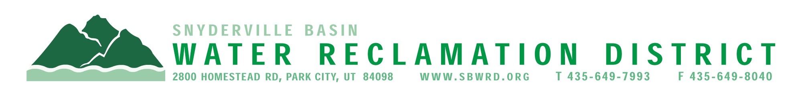

NOTICE OF ELECTION

BOARD OF TRUSTEES

Notice is hereby given of an election for members of the Board of Trustees of the Snyderville Basin Water Reclamation District to be held November 4, 2025. The positions to be filled at this election are for four-year terms beginning January 2026. One position will be filled from within the boundaries of the incorporated area of Park City and one position from within the boundaries of the Snyderville Basin Water Reclamation District but outside the boundaries of Park City.

Qualifications to be a candidate are:

- Be a United States Citizen at the time of filing.
- Be a registered voter.
- Be at least 18 years old by the election.
- Be a legal resident of Park City or a resident of a recently annexed area for at least 12 consecutive months immediately preceding the date of the election for the Park City position. Or a resident of Snyderville Basin area for at least 12 consecutive months immediately preceding the date of election for the Snyderville Position.
- In accordance with Utah Constitution Article IV, Section 6, any mentally incompetent person, any person convicted of a felony, or any person convicted of treason or a crime against the elective franchise may not hold office in this state until their right to hold elective office is restored.

Candidates may file a declaration of Candidacy with the SBWRD Clerk at 2800 Homestead Road between 8:00 a.m. and 4:30 p.m., June 2-6 and 9, 2025. For additional information call 435-649-7993.

Posted at www.sbwrd.org and the Utah Public Notice website.

