PUBLIC NOTICE IS HEAR BY GIVEN THAT THE
UTAH COUNTY CRIMINAL JUSTICE COORDINATING COUNCIL
WILL HOLD A PUBLIC MEETING AT
51 SOUTH UNIVERSITY AVE., PROVO, UTAH 84601
IN THE HISTORIC COURTHOUSE, 3rd FLOOR COMMISSION CONFERENCE ROOM
April 15, 2025 – 9:00 p.m.

~MEETING MINUTES~
In attendance: Josh Esplin, Monte Memmott, Jeff Gray, Ben Van Noy, Skyler Beltran, Judge Parkin, Irv Hale, Josh Adams, McKenna Potter
In attendance via Zoom: Mike Smith

(Meeting called to order: 9:04 pm)

- Welcome & introductions
-Jeff Gray

Had each member introduce themselves and their job responsibilities.

- Approve previous meeting minutes
Commissioner Beltran: Motion to approve October 8, 2024 Meeting Minutes
Judge Parkin: Second
All in Favor: Aye
Passed

- Ratify the 2024 Strategic Plan & Community Resource Map
Judge Parkin: Motion to approve & ratify Strategic Plan & Community Resource Map
Adams: Second
All in Favor: Aye
Passed

- Report from Pre-Trial Services Subcommittee
(Timestamp: 6:00)
- Ben Van Noy explained what pre-trial services are in the works within the county. The roadmap for the pretrial release and services program is in development.
- System is being developed where inmates in and out of jail will be notified on initial hearing and arraignment.
- Funding needs to be secured, and services need to be integrated so judges can easily use pretrial services.

(Timestamp 17:03)
- Josh Esplin briefly discussed Salt Lake County’s Pre-Trial System and the case managers they have assigned to help.

(Timestamp 28:12)
- Pretrial program may start through our end and then look to the courts to pick up after arraignment according to Jeff Gray

(Timestamp 30:04)
- Email should be the easiest and most efficient way to reach out for pre-trial services. Most systems are already set up to take emails and booking collects emails from inmates. Many people don’t have phones, but they have an email they can check from somewhere.
- The courts seem to be equipped to provide notification thereafter if their old program is reinstated.

- Report from Victim Services Subcommittee
Continued to the next meeting due to Christiana’s absence.

- Discuss goals and next steps
What will the program look like beyond notification?
Do we have the grants/money in place to fund this program?

- Next Meeting Date & Adjourn
Next meeting is scheduled for June 13th at 1 p.m.

(Meeting Adjourned: 9:44 pm)

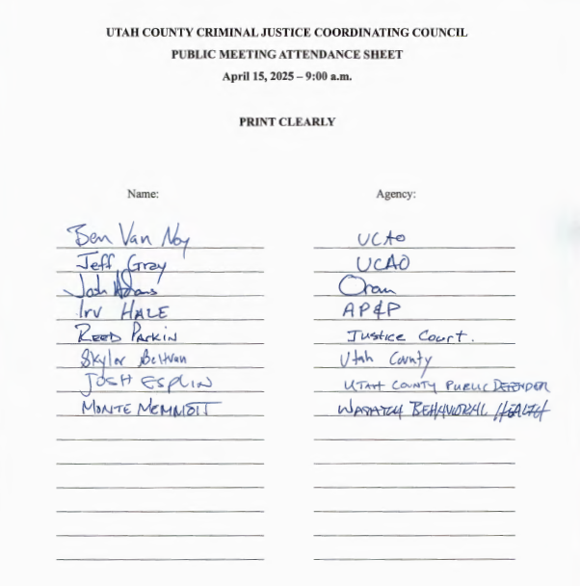
Minutes approved at the ____________________________ Utah County Criminal Coordinating Council meeting.

________________________________________________________
Jeff Gray, Chair

