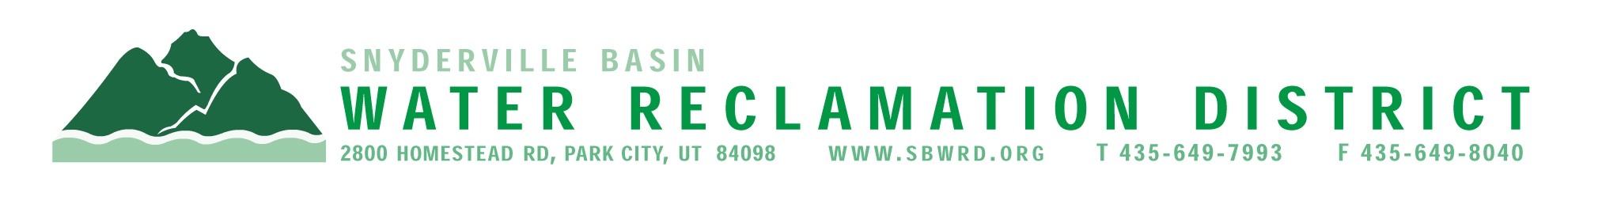
BOARD OF TRUSTEES MEETING

AGENDA

April 28, 2025
** District Office**
5:00 p.m.

** The meeting is open to the public and will also be
conducted electronically using Microsoft Teams**

** For information on how to connect to the meeting, please call 435.649.7993 or email
Dan Olson @ dolson@sbwrd.org by 4:30 p.m. on Monday, April 28, 2025**

I. CALL TO ORDER

II. CONSENT AGENDA
- Approval of Board Meeting Minutes for March 17, 2025
- Escrow Fund Reduction Approval
- Partial Substantial Completion – FJ Gillmor Subdivision MH1-4-22-141
to SSMH-13 (Serving FJ Gillmor Lot 3 – High Valley Transit)

III. PUBLIC INPUT

IV. APPROVAL OF EXPENDITURES – Bills in the Amount of $851,112.03

V. SERVICE AWARDS – Kray O’Brien – 30 years

VI. SUBDIVISION PROJECTS
Estimated LEA REs Year to Date: # Above Splitter 1.3; # ECWRF 5.33; # SCWRF 43; Total 49.33
Proposed this Meeting: # Above Splitter 0; # ECWRF 0; # SCWRF 0; Total 0

VII. DISTRICT MANAGER
- Discussion Items
  - Review draft Impact Fee Documents and Proposed
Impact Fees
  - East Canyon Treatment Facility Permitting
  - Discussion on the impact of tariffs
- Action Items – Consider setting Impact Fee Public Hearing for
May 19, 2025
- Information Items
- Senate Bill #50 – Board Member Compensation
- Financial Statement
- Impact Fee Report

VIII. FUTURE AGENDA ITEMS
- Projects
- Operations
- Finance
- Governmental Matters

IX. ADJOURN
If you are planning to attend this public meeting and due to a disability require reasonable accommodation in understanding, participating in or attending the meeting, please notify the District twenty-four or more hours in advance of the meeting, and we will try to provide whatever assistance may be required. Board members may appear telephonically.

AGENDA NARRATIVE
April 28, 2025

VII.C.1. Senate Bill 0050 – Board Member Compensation

Senate Bill 50 passed this last legislative session and goes into effect May 7, 2025. A copy of the Bill is attached. The biggest changes to the law include the removal of a limit of annual compensation for District Board members and requiring a public hearing and noticing if the compensation amount is changed.

District | Annual Compensation | Per Diem/Travel and Meeting Reimbursement
SBWRD | $3,500 | Expenses reimbursed for travel/meetings outside of typical duties
Kearns Improvement District | $7,500 (proposed)/  $7,197 (current) | -Special Meeting/Training - $200 full day, $135 half day  -Annual UASD Board Training Certification - $135
South Davis Sewer District | $5,000 | Mileage Reimbursement to UASD conference
Cottonwood Improvement District | $5,000 | Mileage Reimbursement to UASD conference
Central Davis Sewer District | $5,000 | Time & travel to meetings at $126/meeting (up to 12x)
Central Weber Sewer District | $5,000 | Expenses for District related travel
Central Valley Water Reclamation Facility | $5,208 – Chair  $4,500 – other members | $100 for full day travel, $50 for half day travel
Heber Valley Special Sewer District | $4,200 | Expenses reimbursed for travel/meetings outside of typical duties
Jordan Basin Improvement District | $5,000 | Reimburse travel and per diem for additional meetings up to 12 per year

