BEAVER HOUSING AUTHORITY
BOARD MEETING AGENDA
April 24th, 2025

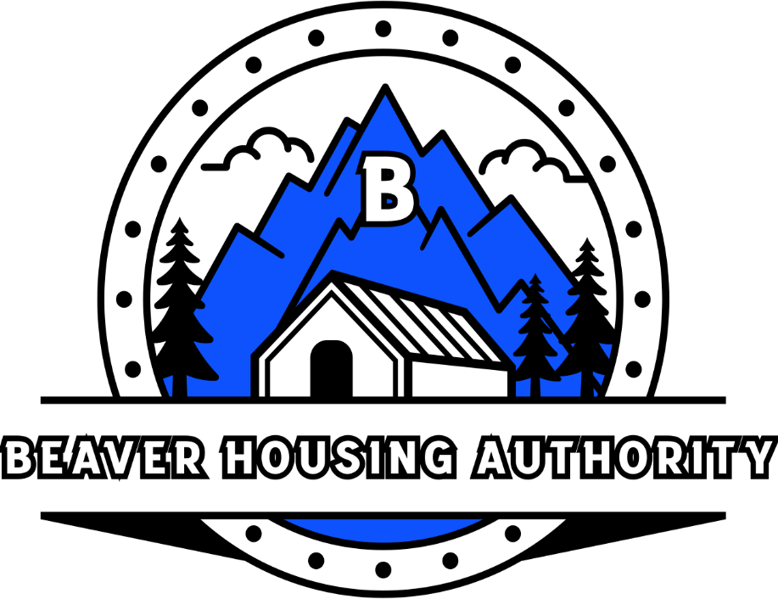
Welcome

- Prayer
- Attendance
- Closed Session

- End Meeting

