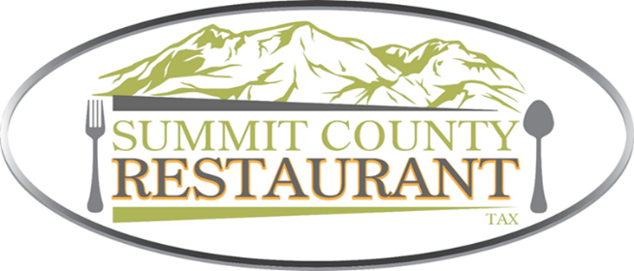

AGENDA

Summit County Restaurant Tax Advisory Committee

Wednesday, April 23, 2025

NOTICE is hereby given that the Summit County Restaurant Tax Advisory Committee
will meet electronically, via Zoom, and at the anchor location of the Richins Building
Room 133
1885 W Ute Blvd., Park City, UT. 84098

To participate in the meeting: Join Zoom:
https://summitcountyut.zoom.us/j/7079146500?pwd=ZUFpLzB6WU9jcEV5dnBUTDJRUWw4UT09&omn=99444056351
Meeting ID: 707 914 6500 Passcode: 010125
Or dial: 1 669 900 9128 US
Work Session
8:30 AM-5:00 PM The Summit County Restaurant Tax Advisory Committee will conduct interviews of applicants.

Members of the Committee will attend by electronic means, using Zoom (phone or video).
Such members may fully participate in the proceedings as if physically present.
Individuals with questions, comments, or needing special accommodations pursuant to the Americans with
Disabilities Act regarding this meeting may contact Amy Jones at 435-336-3042

Posted: April 21, 2025

