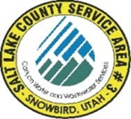
NOTICE OF
REGULAR MEETING
of the Board of Trustees of
SALT LAKE COUNTY SERVICE AREA #3 - SNOWBIRD
to be held on Monday April 21st, 2025, at 12:00 P.M.
Join the meeting electronically from the link below.
Join the meeting now
Meeting ID: 295 398 748 564
Passcode: Se9o8if2

Dave Richards
Chris Bremer
Tom Prosek

MEETING AGENDA

- Richards Approval March 17th, 2025, meeting minutes.

- Carpenter Systems Operations and Development.

- Carpenter Treasurers Report ending March 31st, 2025.

- Richards Approval of March 13th through April 17^{th,} 2025.

Post Date: __________________
Attest: ______________________
Bryauna A. Alderin/ Clerk

