MINUTES
Weber School Foundation Board Meeting
3/20/2025 12:00 PM | Meeting held at the Weber School District Office and called to order by Josh Skidmore

Attendance
Present: Craig Adams, Mark Adams, Dave Andersen, Jenna Andrascik, Matt Bell, Bryan Benard, Lindee Bess, Jan Burrell, Gina Butters, Flora Cassity, Michelle Darrington, Scott Dixon, Jamie Ellison, Branden Hansen, Matt Jensen, Brett Karras, Steve Kier, Ashley Loftus, Phillip Mickey, Clyde Moore, Emily Oyler, Kathy Saunders, Josh Skidmore, Shekeydrah Smith, Adam Stuart and Angie Towns
Guests: Jared Abney, Amy Hall & Nick Harris
Excused: Barry Beus, Dave Broadbent, Tyler Buxton, Craig Dearden, Tony Divino, Jeremy Dunn, Jen Dunyon, Kori Ann Edwards, Kimberli Green, Brandi Hammon, Bryan Hurst, Ryan Olsen, Jennie Taylor & Kerry Wahlen

Welcome
Josh Skidmore welcomed everyone to the meeting and thanked the board members who helped volunteer for Bridging the Gap.
Introduce Shekeydrah Smith- Emily introduced Shekeydrah Smith who is the Foundation’s new team member. She is the Communications and Content Creator. She recently moved from Alabama to Utah with her husband who is serving in the Army. We are excited to have her working for the Foundation.

Approval of Minutes
Steve Kier made a motion to approve the minutes from the February 20, 2025 meeting with a second from Jan Burrell. The minutes were unanimously approved.

Share our Story
StoryCon-Nick Harris, Director of Digital Teaching and Learning for the Weber School District along with Amy Hall, Librarian at Roy Jr. High worked to get students to be able to attend Operation Literacy-StoryCon held at the Salt Palace. This was a 2-day conference that 250 students and 30 teachers attended. There were keynote speakers, breakout sessions and panel discussions. There were classes for both students and teachers. This conference will strengthen school’s learning culture and reinforce the importance of literacy as a foundation for student success. This is a great kickoff for the Roy Cone Literacy Project called the Roy Community Literacy Night to be held on April 17, 2025. Nick and Amy thanked the Weber School Foundation for their support of $5,000.00 to attend this conference. It was an amazing opportunity! We have received many thank you notes from both students and teachers who attended.

Committee Reports
Special Needs— Flora Cassity informed the committee since our last meeting we have received 10 requests for communication devices, apps & cases totaling $6,693.00. We also received a request for orthotics for $1,454.00. Total for these requests are $8,147.00. The Special Needs Committee has reviewed and approved these requests. Steve Kier made the motion to approve these requests with a second from Kathy Saunders. The board unanimously approved.
Finance/Audit-Craig Adams reported that our investments include both stocks and bonds. As the markets go down our accounts don’t go down as much. It is normal for the market to drop 10%. Our investment accounts look good, our funds are in great shape.
Projects-Kathy Saunders reported that since our last board meeting we have had 9 Class Grants through DonorsChoose. Some of the projects funded include scientific calculators, adaptive seating, science sets and a novel series. There were no School Grants or non DonorsChoose requests this month.
For Special Education Class Grants, we received 3 DonorsChoose requests. The Special Education Classroom grant requests are low this year. We have reached out to the SPED Department directors and they will be emailing teachers reminding them of the opportunity and that they will have until April 30th to make their requests.
On March 25th there will be a double match from DonorsChoose because of their 25th Anniversary.
Jenna Andrascik made the motion to approve these projects with a second from Craig Adams. The board unanimously approved.
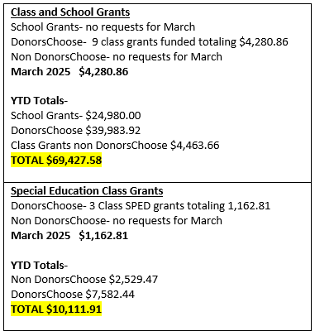
Teen Center-Steve Kier reported that our last Teen Center at West Field High School should be complete by June. The budget for this center is $350,000.00. We will wait to hold the ribbon cutting until August before school starts. We have asked the principals of these teen centers to report the usage which Emily will present to our board at our President’s Award Banquet on April 17, 2025.
Golf-Emily reported that we are SOLD OUT of sponsorships for our Gifts from the Heart Golf Tournament on Monday June 9, 2025 at the Ogden Golf and Country Club. We are working on SWAG Bags and raffle items. We do have Hole Sponsors available still. Tony Divino will be our Raffle Sponsor again this year. Ogden Made will provide hats, Goldenwest will sponsor the shootout, Browning is providing the rifle for the drawing, Kier Construction will supply the Ice Cream Truck and we will have another food truck again this year. We will hold a sit-down lunch again inside the Country Club when the tournament is over. We are really excited for our tournament this year!

Director’s Report
Unified Sports-Video-Jared Abney, Assistant Special Education Director, told about the Unified Sports Basketball Tournament that was held on February 28, 2025 at Roy High School. A video was shown to the board members. Unified Sports builds meaningful connection with Gen Ed and SPED students. The Adaptive PE Teachers in the District work with these students to prepare them for these events. Teams are formed with coaches and Gen Ed students who are Peer Mentors help them. This is an amazing day for these students! All the High Schools in the district come together to support each other. Last year we partnered with the Ogden School District. This year we did the tournament with just our district. With the Soccer Tournament in the Fall and the Basketball Tournament in the Winter the next process is to add Track. The district will be piloting this with one school this year to work out the details. Jared thanked the Foundation for our partnership and support!
Scholarship Update-Michelle reported that our endowment scholarship program has tripled in the last 5 years. We now have 39 endowed accounts and 42 scholarships. Our total endowment portfolio is $1,470,897.23. We have added 20 new scholarships in the last 3 years! The list of scholarships is included at the end of the minutes. Michelle works with the counselor’s office at each High School on these scholarships and each school holds a scholarship assembly at the end of the school year. We currently recognize the losses or gains years but we would like to change our process and recognize them quarterly. These scholarship funds are sent directly to the university the student will be attending.
Chamber of Commerce Annual Gala-Emily reported that the Ogden Weber Chamber no longer holds a Partners in Education Breakfast. Instead they are giving out the Sue Westenskow Award at the Annual Gala. This award is a joint decision from both the Weber and Ogden School Foundations. Sue Westenskow was a former educator in the Weber School District who passed away. This year the recipients will be George and Mary Hall who have been wonderful supporters of both school districts. Emily will be presenting this award at the Gala on March 26th. If any board members would like to attend please let Emily know.
President’s Award Nominations-Nominations for President’s Award are due by tomorrow, March 21st. Following this day the Executive Committee will make the final decision on the awardee’s for this year. These awards will be presented at our President’s Award Banquet on Wednesday, April 30, 2025 at the Timbermine.
Other Business-
-President’s Award Banquet RSVP-Please RSVP to Jamie by April 23, 2025.
-Light the World Giving Machine-The Weber School Foundation received $83,979.00 from the Light the World Giving Machine that was held in Ogden for 2 weeks in December.
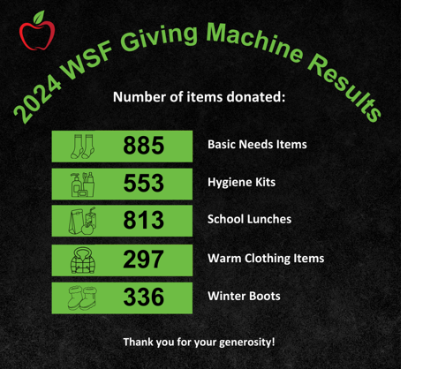
Adjourn

Next Meeting
April 17, 2025

