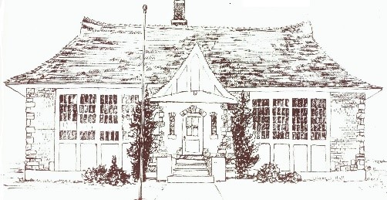

Public Hearing Notice
Mantua Land Use Code Proposed Zone Map Amendment
DATE CHANGE

Due to a scheduling conflict, we must change the date of our public hearing. The new date of the hearing is April 29th 2025.

The Planning and Zoning Commission of Mantua, Utah will hold a public Hearing at the Mantua Town Hall at:

409 North Main Street.
Mantua, Utah 84302

April 29, 2025, at 6:30 P.M.
The duration of the meeting to be from 6:30 pm to 8:00 pm.

The hearing is to obtain comments regarding a proposed Amendment to the Official Zone Map adopted in Ordinance 2024-10-17, Title 11.D in the Land and Management Development Code. The current map does not align with Title 11.7 of the current Code. The proposed zone map amendment is intended to align with the current code.

Additional information can be found on the city website Mantuautah.gov

For further information, contact the Town Office at 435-723-7054. Plan to attend or send in written comments within ten days of the Public Hearing on the proposed zone map amendment on April 29, 2025, 6:30 pm at Mantua Town Hall located at: 409 North Main Street Mantua, Utah 84302.

