Ephraim City Corporation
John Scott, Mayor

5 South Main, Ephraim, Utah 84627
Council Members
Margie Anderson
Chad Parry
Lloyd Stevens
Dennis Nordfelt
Anthony Beal

Manager
Katie Witt

Community Development Director/Engineer
Bryan Kimball

Recorder
Candice Maudsley

ege

City planner
Megan Spurling

Treasurer
Aubrey Adams

Finance Director
Jon Knudsen

Public Safety Director
Colby Zeeman

Power Director
Cory Daniels

Public Works Director
Jeff Jensen

ieghileigh


NOTICE OF PUBLIC HEARING

MINIMUM LOT SIZE AND FRONTAGE REQUIREMENT CODE CHANGE REQUEST

Public notice is hereby given that the Ephraim City Planning and Zoning Commission, in accordance with Sections 10.04.060 and 10.20.060 of the Ephraim City Municipal Code, will conduct a public hearing to discuss and possibly make recommendation to the Ephraim City Council regarding a proposed amendment to the Ephraim City code which would introduce a new zone with smaller frontage and lot size requirements.

The public hearing will be held:
Wednesday, April 9, 2025
beginning at 6:00 p.m.
Ephraim City Hall
5 South Main Street, Ephraim, Utah 84627

Should the Planning Commission recommend approval, the City Council is expected to review and possibly give final approval for the Amendment to the Ephraim City Off-Street parking requirements on Wednesday, May 7, 2025, at 6:00 PM at Ephraim City Hall.

Interested parties may attend in person or electronically via zoom. Those wishing to attend electronically should notify Ephraim City Staff prior to 3:00 p.m. of the day of the meeting. For further information, or to request a meeting link, please contact Megan Spurling, City Planner, 5 South Main Street, Ephraim, Utah 84624; call at (435) 283-4631; or email mspurling@ephraim.gov

Pursuant to the Americans with Disabilities Act, individuals needing special accommodations during this meeting should notify Ephraim City at (435) 283-4631 at least 24 hours prior to the meeting.

Posted: March 28, 2025
Published: March 28, 2025 – Ephraimcity.org and Utah Public Notice Website

Current City Code requires the following for single family, residential lots:

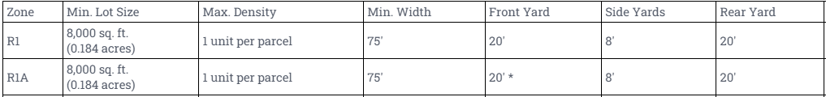

The applicant, Mike Ballard, CVG-Ephraim South, LLC, proposes the following change:

Create a new category for residential lots, potentially R1B, allowing for 40’ widths and 3,000 s.f. minimum lot size for single family homes.

Residential lots may have a minimum street frontage width of 40 feet in designated zones, subject to standard zoning regulations for setbacks, height, and lot coverage. The minimum lot size of 3,000 s.f. for single family homes. Consider 10’ or 15’ front and back setbacks and 5’ or 6’ side setbacks

