DRAFT CITY OF OREM
DEVELOPMENT REVIEW COMMITTEE MINUTES
March 24, 2025

The following items are detailed in these minutes:
- Administrative Approval – Five Rivers Hospitality La Quinta – Generally Located at 529 West University Parkway - Approved
- Prelim Plat Approval – Orem Center for Change – 1748 North State Street - Approved
- Site Plan Approval – Bank of America - Generally located at 1300 South State Street – Approved
- Site Plan Approval – Dex Auto - Generally located at 1901 N. State Street – Approved
- Minutes for March 10 meeting, 2025 - Approved.

Place: Exec Staff Conference Room 107

11:03 a.m. Grace Bjarnson called the meeting to order.

Those Present: Gary McGinn, Jared Hall, Derek Spencer, Chris Clements, Glen Giles, Taylor Taggart, and Rick Sabey DRC members. Rebecca Gourley and Grace Bjarnson, Associate Planners.

Those Excused: Chelsea Lindsey, Steve Norman (Norm), Taggart Bowen

- Administrative Approval – Five Rivers Hospitality La Quinta – Generally Located at 529 West University Parkway
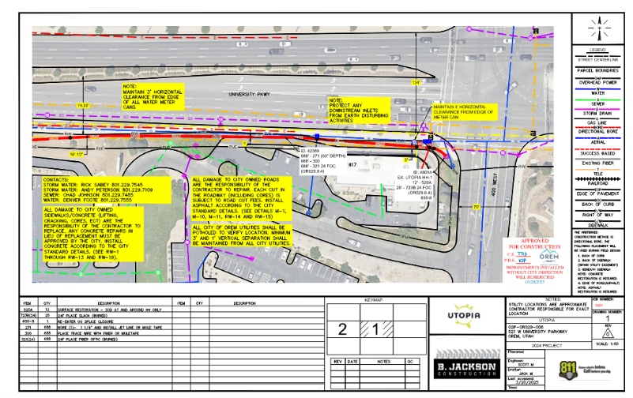
Shellie Moyer submitted an Administrative Approval Plan application for La Quinta Inn & Suites located generally at 529 West University Parkway. They are installing Utopia Fiber conduit. There will be directional drilling/boring along University Parkway from 400 W to 521 W. All comments during the DRC review have been met. There were no issues, or concerns voiced in this meeting about the project.

DRC Action: Derek Spencer moved to approve the Administrative Approval for the Five Rivers Hospitality La Quinta project, located generally at 529 West University Parkway in the HS zone. Chris Clements seconded the motion. The motion passed unanimously.

- Preliminary Plat Approval – Orem Center for Change - Generally Located at 1748 N State Street
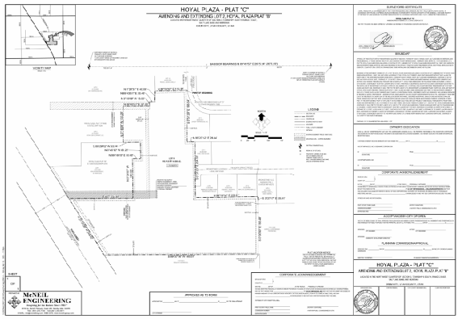

Chris Bick submitted a Preliminary Plat application for UHS Orem Center for Change generally located at 1748 North State Street. The project consists of approximately 3.01 acres and includes the construction of a new building expansion and a parking lot associated with the building. The Plat will include the additional 10' PUE adjacent to state street. All comments during the DRC review have been met. This is the approval just for the preliminary plat. There are submissions for the Final Plat and Site Plan which are not approved yet. There were no issues, or concerns voiced in this meeting about the project.

DRC Action: Chris Clements moved to approve the Preliminary Plat for the Orem Center for Change project, located generally at 1748 N State Street in the C2 zone. Rick Sabey seconded the motion. The motion passed unanimously.

- Site Plan Approval – Bank of America - Generally Located at 1300 South State Street

Bank of America plans on demoing the existing gas station and infrastructure to build a bank. There will be updates to landscaping, parking, utilities etc. All comments during the DRC review have been met. There were no issues, or concerns voiced in this meeting about the project.

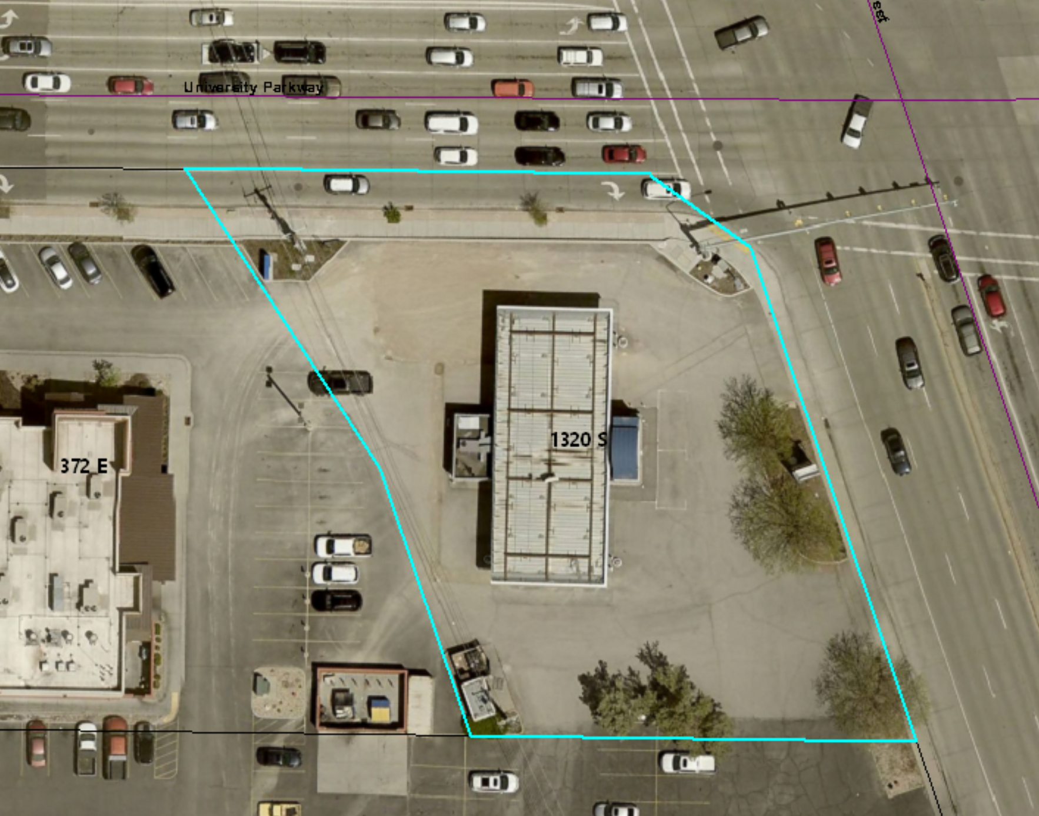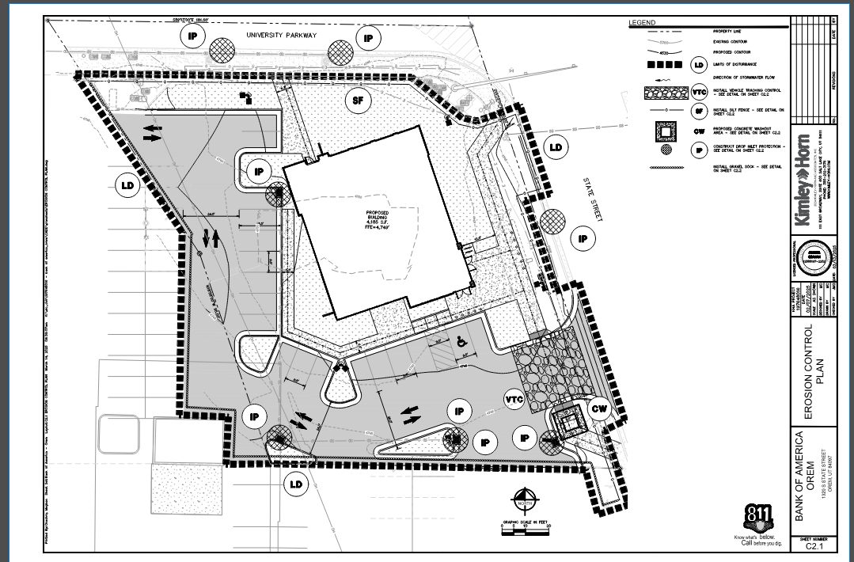

DRC Action: Glen Giles moved to approve the Site Plan for the Bank of America project, located generally at 1300 South State Street. Derek Spencer seconded the motion. The motion passed unanimously.

- Site Plan Approval – Dex Auto – Generally Located at 1901 N. State Street

The Dex Auto Project is the creation of a used car dealership with storm drainage, new landscaping, a small building and parking for 100+ vehicles. All comments during the DRC review have been met. There were no issues, or concerns voiced in this meeting about the project.

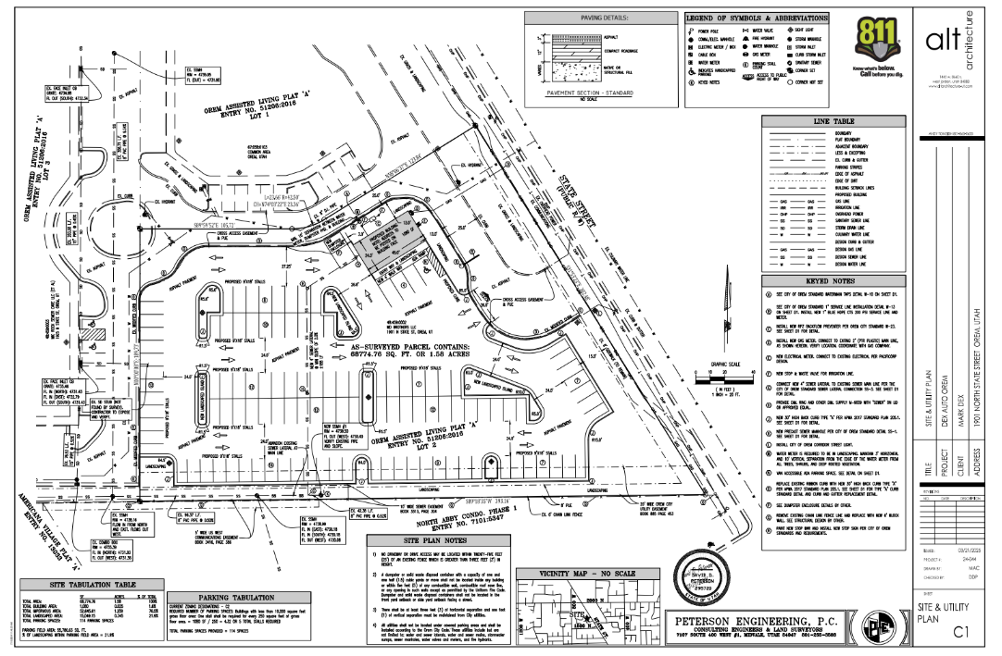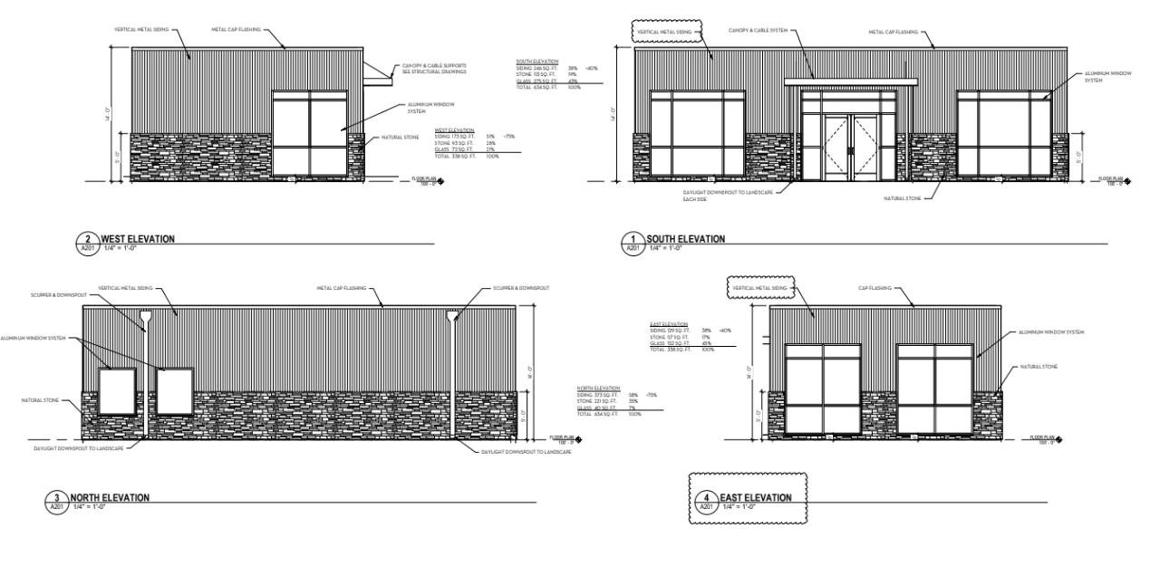

DRC Action: Rick Sabey moved to approve the Site Plan for the Dex Auto project, located generally at 1901 N. State Street. Chris Clements seconded the motion. The motion passed unanimously.

Minutes: The minutes for the previous meetings on March 10, 2025 were previously sent to the committee via email. Derek Spencer moved to approve the minutes; Derek Spencer seconded the motion. The motion passed unanimously.

Adjourn: Gary McGinn motioned to adjourn; Derek Spencer seconded the motion.
Yes: Jared Hall, Derek Spencer, Chris Clements, Glen Giles, Taylor Taggart, and Rick Sabey
No: Gary McGinn

Adjourn: 11:11 a.m.
Approved On: Draft

