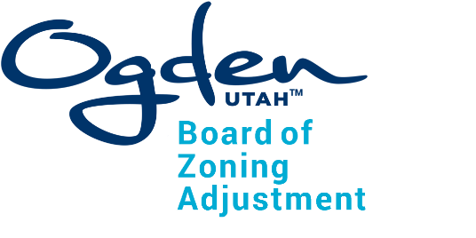
Board of Zoning Adjustment
Agenda
March 26, 2025 – 4:30pm
City Council Chambers, 3rd Floor
2549 Washington Blvd, Ogden, Utah 84401

The meeting will also be held electronically:
https://us02web.zoom.us/j/86465489145
1-346-248-7799, Meeting ID: 864 6548 9145

Notice is hereby given that the regularly scheduled Board of Zoning Adjustment meeting for March 26, 2025 has been cancelled.

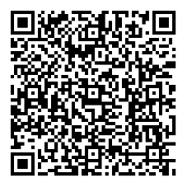
To view the agenda and packet for this meeting, scan the
QR code with
your smartphone.

In compliance with the Americans with Disabilities Act, persons needing auxiliary communicative aids and services for this meeting should contact the Management Services Department at 801-629-8701 (TTY/TDD: 711 or 888-735-5906) or by email: accessibility@ogdencity.com at least 48 hours in advance of the meeting.

CERTIFICATE OF POSTING
The undersigned, duly appointed City Recorder, does hereby certify that the above notice and/or agenda was posted in accordance with Utah State Code on this 24th day of March, 2025. Tracy Hansen, MMC/CRA, Ogden City Recorder

