Bear River Charter School Governing Board Meeting Minutes
Date: February 18, 2025
Time: 5:30 PM
Location: Bear River Charter School
Attendees:
- Kristen Rolf (President) – Present
- Christina Howell (SCA Representative) – Present
- David Forbush (Secretary) – Present
- Bryan Carlson (Member) – Absent
- Reagan Shaw (Treasurer) – Present
- Audrey Kirkman (Parent Rep) – Present

1. Call to Order
The meeting was called to order by Kristen Rolf at 5:36 PM.

2. Approval of Past Minutes
David Forbush distributed the past two meeting minutes for review. No comments or changes were noted, and the minutes were unanimously accepted and approved.

3. Public Comment
No members of the public were present. There were no public comments.

4. Financial Update – Red Apple
Steve from Red Apple provided the financial report:
- The budget report, covering up to the end of January, shows that the school is 56% through its state funds, primarily due to the inclusion of the safety grant.
- January revenues totaled $163,758, approximately $4,000 above expectations.
- The school’s cash flow remains stable, with a low of $636,000 before the latest state payment.
- Current enrollment is 163 students, one more than the October 1 count.
Legislative Updates:
- The base budget reflects a 4% increase, which is 2% lower than in previous years.
- The local replacement fund continues its growth at a 7% rate.

5. Facilities Update
Peter provided a detailed update on ongoing and proposed facilities projects:
- Safety Grant Projects:
  - Installation of special safety glass.
  - Fencing around the front playground.
  - Enhanced visitor management system.
  - ADA-compliant ramps and vestibules.
  - First aid kits, AED machines, and labeled doors with site maps for first responders.
- Additional Facility Needs:
  - Staff bathroom expansion is a priority due to current capacity issues.
  - Potential new classrooms and breakout rooms to accommodate future growth.
  - The school is exploring options for ADA access upstairs, including the installation of elevators or wheelchair-assisted devices.
  - Considerations for future construction projects include building over the cafeteria or developing the west side area.
- Funding and Compliance:
  - The total projected cost for safety projects is $552,000.
  - Compliance timelines vary, with some projects requiring completion by Fall 2025, while others have a five-year window.
  - The board discussed utilizing state-approved vendors to streamline the bidding process.

6. Time & Effort Policy – First Look
Peter introduced the draft Time & Effort Policy, highlighting:
- The policy aligns with new federal and state audit requirements.
- It simplifies procedures while ensuring full compliance.
- The board reviewed and approved the policy, with a motion carried unanimously.

7. School Mission Discussion
Kristen led a discussion on the school’s mission and purpose:
- The board emphasized the importance of broadening students’ experiences beyond their local community.
- Goals include fostering critical thinking, community engagement, and preparing students for a global society.
- Kristen expressed interest in several board members working on the mission statement and bringing the draft back to the full board.

8. Winter Math Benchmark Data
- Reviewed student performance data.
- Identified areas for instructional improvement and strategies for supporting student growth.
- The presented data is displayed here:
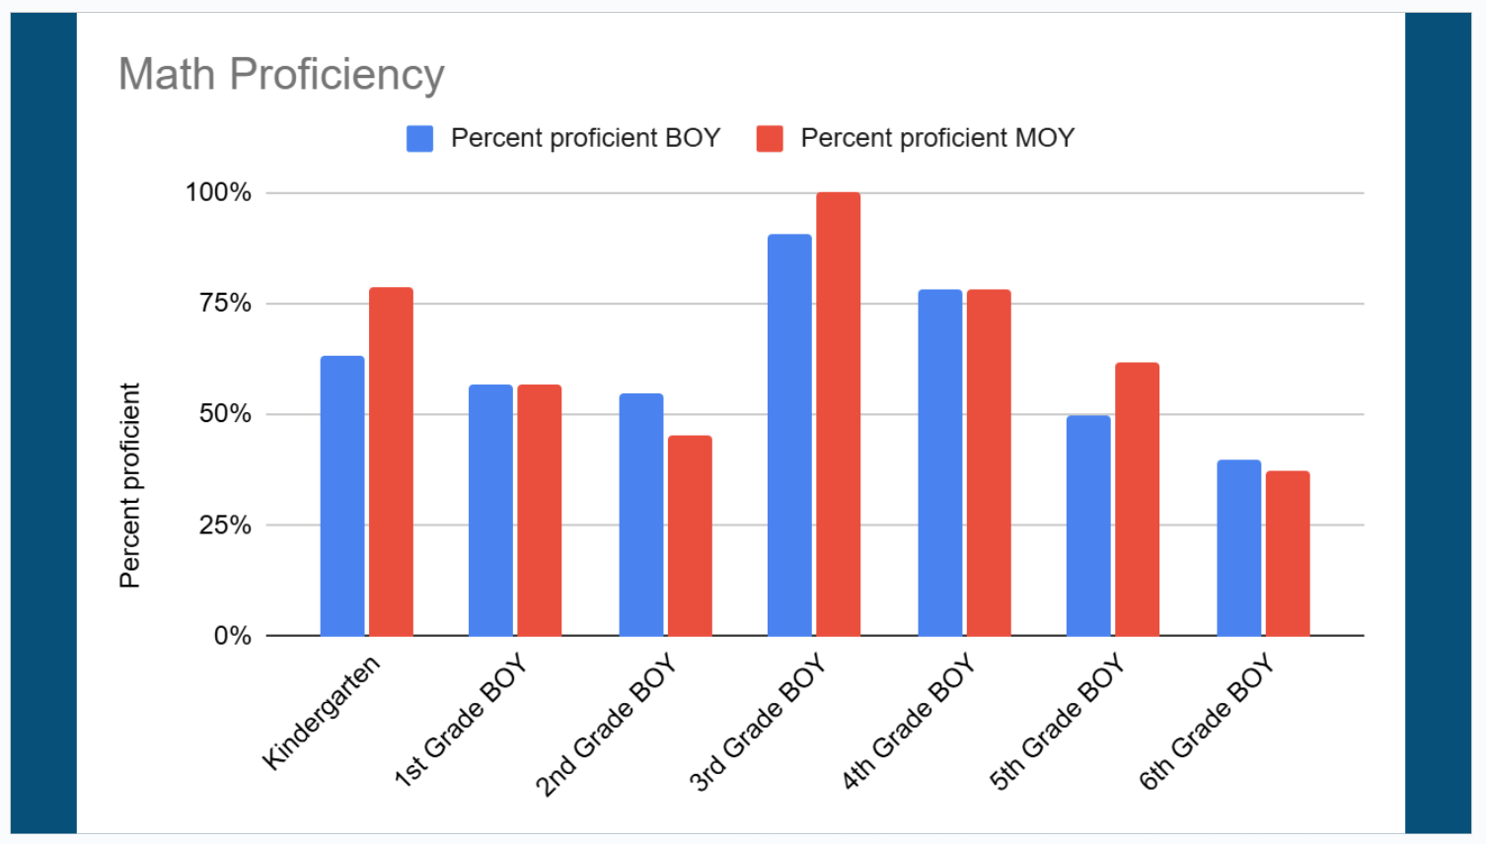

9. School Fees Approval
- Reviewed proposed fees for the upcoming academic year.
- The board approved the fee schedule as presented.

10. Director Evaluation Plan
- Discussed metrics and timelines for evaluating the school director’s performance.
- The evaluation framework includes academic achievement, leadership effectiveness, and community engagement.

11. Update from SCA
Christina Howell provided an update from the SCA:
- A recent movie night event had a strong turnout with 275 attendees.
- Future events and fundraising efforts are being planned.

12. Director’s Monthly Report
- Enrollment trends and student engagement activities were highlighted.
- Discussed upcoming events and initiatives.

13. Board Meeting Schedule
- The next board meeting is scheduled for March 18, 2025.

14. Other Business
- No additional business was discussed.

15. Closed Session (if needed)
- No closed session was held.

16. Adjournment
- The meeting was adjourned at [Insert Time].

Minutes respectfully submitted by David Forbush, Secretary.

