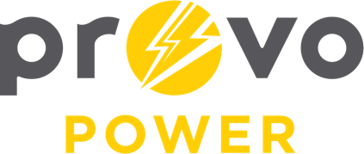
AGENDA
ENERGY BOARD MEETING
PROVO POWER
185 S 1470 E, St. George
Friday, March 21, 2025
8:00 A.M.

- Welcome & Introductions – Chairman Gary Winterton
- Review & Approval of Minutes – January 6, 2025
- Financial Report – Charlie Little
- KPI Report – Charlie Little
- Solar Report Update – Scott Bunker
- Manager Report – Scott Bunker
  - 2025 Energy Board calendar
- Calendar & Scheduling
  - Next Board Meeting: May 5th, 2025

A copy of the agenda was posted in the Civic Center, and the Provo City Library, on March 17, 2025, and also delivered to the Mayor,
City Council Members, required news media, and adjacent cities in
compliance with the Utah Code 52-4-202

