Great Salt Lake Salinity Advisory Committee
January 23, 2025
This meeting was held in person on January 23, 2025, at the Utah Department of Natural Resources with some members attending remotely via GoogleMeet. The following represents a summary of key points of discussion. It is not intended to represent meeting minutes. The meeting recording may be viewed at https://www.youtube.com/watch?v=hZGpX57ZQ3Q&t=1782s .

Attendees
Leila Ahmadi/Division of Water Resources (DWRe)**  Jake Alexander/ Division of Forestry Fire and State Lands (FFSL)  Travis Anderson/Morton Salt  Rob Baskin  Jennifer Biggs/ FFSL  Phil Brown/Great Salt Lake Brine Shrimp Cooperative (GSLBSC)**  Georgie Corkery/Westminster Univ**  Brian Crookston/Utah State University (Utah State University)  Tim Davis/Office of the GSL Commissioner  Jeff DenBleyker/Jacobs  Lynn DeFreitas/FRIENDS of Great Salt Lake  Eric Dixon/DWRe  Ryan Dougherty/Cargill**  Rob Dubuc/FRIENDS of Great Salt Lake  Angela Gong/FFSL**  Jim Harris/Division of Water Quality (DWQ)* (co-chair) | Joe Havasi/Compass Minerals *  Tim Hawkes/GSLBSC  Emily Hawley/FFSL  Justin Hipple/Morton Salt  Ben Holcomb/DWQ**  Elliott Jagniecki/Utah Geological Survey (UGS)**  Bill Johnson/University of Utah (UofU)*  Aspen Johnston/Office of the GSL Commissioner  John Luft/Division of Wildlife Resources (DWR)*  Craig Miller/DWRe*  Ryan Rowland/USGS*  Christine Rumsey/USGS**  Andrew Rupke/UGS*  Ben Stireman/FFSL* (co-chair)  Kyle Stone/DWR**  Eric Stucki/FFSL  Laura Vernon/DWRe  * Salinity Advisory Committee (SAC) member  ** SAC member alternate

Objectives
A key objective of the Salinity Advisory Committee (SAC) is to advise the State of Utah regarding how the salinity of Great Salt Lake (GSL) can best be managed and, more specifically, how the new Union Pacific causeway bridge may influence lake salinity. The objective of this meeting was to discuss lake conditions, updates on various efforts, and next steps.

Summary
A quorum was present for the meeting. Jeff DenBleyker opened the meeting with a review of the agenda for the meeting and facilitated introductions of people attending in person and online. Andrew Rupke made a motion to approve the October 24 meeting summary; Joe Havasi seconded the motion. The motion was passed unanimously.

Update on Lake Conditions
Ryan Rowland provided an overview of lake conditions. South Arm water levels have risen to 4192.6 ft; up 0.5 ft since November 2024. North Arm water levels have risen to 4191.8 ft; up 0.4 ft from November 2024. There is currently a 0.8 ft difference between the water level in the North Arm and South Arm. Inflow volume water year to date (October 1, 2024, through today) from the Bear River has been tracking just below the median values. Cumulative inflows from the Weber River are just below median. Farmington Bay outflow have been well above median near the 75th percentile. Goggin Drain inflows have been well above the median. Bill Johnson asked why the Farmington Bay flows appear to be so high. Tim Davis noted that Central Utah Water Conservancy District is moving water from Strawberry Reservoir down the Jordan River to GSL. That may explain the high flows from Farmington Bay and Goggin Drain.
The USGS was reporting near real time flow through the new breach in the UP causeway at Station 10010025 until August 2024 but had to stop because of changes in flow conditions over the berm. The USGS has continued monthly measurements of flow. The most recent measurements of flow were 803 cfs South to North and 36 cfs North to South. On January 10, the flow was 1080 cfs South to North and 22 cfs North to South. The USGS has also been measuring flow through the Lakeside Breach but lost flow measurements in August 2024 because the lake had dropped too low. Flow measurements in September and December 2024 confirmed zero flow. John Luft asked if there was any flow coming from the west and north flowing south through the Lakeside Breach. Ryan clarified that their gage only measures south to north flow; it really has a hard time with other flows when the lake level is low.
The USGS had been measuring the lake elevation at Station 10010027 just west of the New Breach; however, the pilings it was mounted to collapsed in August 2024. They are looking into funding to place new pilings to replace the station. Ben Stireman thought there may be some funding available to do this. The USGS has installed seven new stream gages in the watershed upstream of GSL. Seven more will be installed.
Christine Rumsey provided an update on lake salinity measurements. The salinity of the South Arm was measured on January 15, 2025, as 117-120 g/L in the main body of the South Arm and was within the desired range. Site 2267 near the Bear River inflow was lower at about 98 g/L. Other salinity measurements were at the new breach on January 8, 2025, as 118 g/L and at Saltair on January 16 as 118 g/L. The salinity of the North Arm flow flowing North to South is at about 270 g/L.

Update on GSLAC Mineral Extraction Study
Christine Rumsey provided an update on this study. The USGS recently met with Morton Salt to understand their operation and has been looking at the lake’s salt and water balance and how the regulatory and water rights structure works with it all. They are also looking at how flows through the New Breach impact the salt balance. Andrew Rupke asked whether US Magnesium was making any water withdrawals. Ben Stireman thought that they were last fall. Bill Johnson noted that US Magnesium’s closure plan may have an impact on the lake’s salt balance depending upon where they get salt for their salt cap.

FFSL Updates
Ben Stireman provided a brief update on FFSL’s work. They have been working diligently to develop voluntary agreements with a number of mineral companies. They have been working on the GSL Comprehensive Management Plan.

DWQ Rulemaking
Jim Harris provided an update on DWQ’s work to implement requirements from HB513 and consider HB453. DWQ has been asking for and considering input on the draft rules. The new draft rule will prohibit any new discharges to the lake when the salinity is higher than 150 g/L. The rule also provides DWQ with flexibility to regulate discharges if the salinity is nearing 150 g/L. The rule includes a de minimis clause that will allow for discharges if the discharge can be shown not to influence the lake salinity. DWQ is working on a guidance document that will go along with the rule to improve regulatory certainty. DWQ will be putting the draft out for formal public comment by April 1. Ben Stireman added that the SAC may be able to provide important input on whether discharges will have an impact upon the lake’s salinity. This would include looking at a current lake level, salt mass, and determine what a de minimis discharge might represent. Joe Havasi clarified that for Compass Minerals they have a very small discharge from their plant site; that might be considered de minimis. They also have an annual mineral return process to dissolve accumulated salt in their ponds and return the salts to GSL. That is something that they may have some flexibility with. The water they use to flush minerals back to GSL is typically from the Bear River and flow rates are often low when the lake is low. Thus, mineral return loads are usually low when the lake is low.
Ben Stireman asked if the SAC may be able to play a role to help with this. Joe suggested that a working group may be helpful. We know the bathymetry, lake level and thus the volume of the lake. With salinity, we can develop a salt mass and then determine if new salt loads are de minimis or not. Ben noted that Compass has offered to be flexible in managing their salt loads to the lake via their voluntary agreement. Joe noted that we will need to determine the method of estimating the salt mass of the lake and a representative salinity value for the South Arm. Jim added that the rule does rely heavily upon the SAC to help inform the decision process. Jeff DenBleyker noted that evaluating these values may require additional meetings. Ben agreed but suggested that we have a working group to do this instead of the full SAC. Jeff will send an email out to request interest in participating in a working group and try to meet in late-February or early March. Bill Johnson suggested that the guidance should consider the economics of discharging vs not discharging.

Salinity Estimates for 2025
Christine Rumsey has been considering the salt balance with the current berm in mind. How can we begin to look into the future to consider how we might affect the salinity trajectory of the South Arm? Christine reviewed the salinity, water volume and salt mass chart USGS developed (the iso-mass plot, Figure 1). How can we use these curves to try to manage the salinity to stay within the optimal range? We need to start thinking ahead to set ourselves up for success. We will need to extend the curves up to an elevation of 4205.
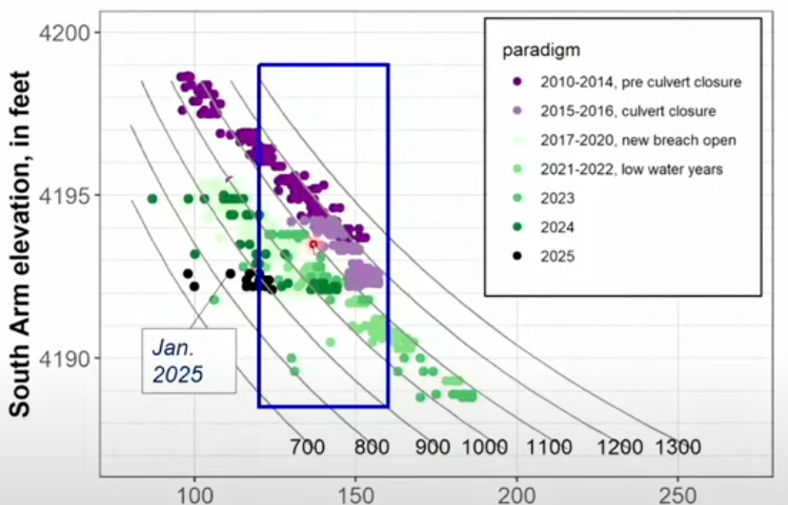
The USGS has estimated that there has been a decrease in South Arm salt mass of about 230 million tons (Mt). The estimated salt mass in January 2025 is 885 Mt but we are still exporting water and salt to the North Arm. We will need an average North-to-South (N-S) flow of 600 cfs to maintain that salt mass; we are currently only at 20-30 cfs. The peak N-S flow in the spring would have needed to be almost 1,400 cfs to offset what was being exported to the North Arm through the Lakeside Break and New Breach in spring 2024. That may be impossible, how can we balance the salt flux seasonally?
Andrew Rupke asked if anyone was working on updating the equation of state for the North Arm. UGS has been measuring salinities that could be in the 300 g/L range. The equation of state is only validated up to 270 g/L. Ryan Rowland noted it is very difficult to develop the equation when salinity is at or so close to saturation.
Figure 1 USGS Iso-mass Curves for the South Arm
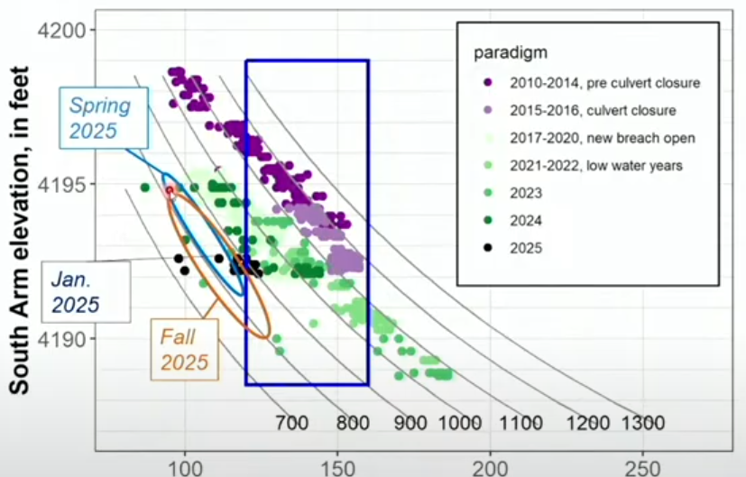
Christine reviewed her methods and assumptions in developing salinity estimates for 2025. These estimates all assume the berm remains in place. Various climatic scenarios indicate the salinity could range from 89 – 119 g/L in June 2025. Christine’s estimates for October ranged from 89 – 130 g/L. She did look at one scenario where the N-S flow was increased 4X. This only increased the salinity from 110 to 111 g/L over a 4 month period. Not very sensitive on a short time frame but does influence the salt mass over time. Bill Johnson agreed that this is a great tool for managing salinity; the biggest uncertainty is the climate. The berm was very helpful, we are in a good place but may need to import salt to the South Arm if the lake level rises. Ben Stireman asked what might happen if we see a lower salinity flowing through the breach due to spring Bear River flows. That may reduce the salt mass that is exported. We may need more monitoring of salinity including higher frequency and better vertical profile. Tim Hawkes asked how low we can go before we see an ecological shift. Phil Brown said that we do not have a lot of data at those low salinities. Data does indicate that we may see changes by 90 g/L. Ben asked how seasonality may affect that. Does it matter if we see low salinity in the spring vs fall? Do we need a range for the spring and another range for the fall? Tim noted that we usually don’t see brine shrimp in Farmington Bay but we did in 2022 when salinity was higher. Jeff summarized that these curves do provide a valuable tool to evaluate how salinity could change. Looking at where we are, we can see that it looks like salinity will be ok in both June and October 2025. We are still exporting salt to the North Arm and so may be moving down to the 800 Mt curve. If the lake level does rise, these curves indicate we will need to increase the salt mass to stay within the “blue box”. The SAC will need to consider how to prepare for 2026 during its meetings this summer. Joe Havasi added that the mineral voluntary agreements were focused upon lake level; we may need to more closely consider the salt mass. Ben agreed. We will need to consider if we leave the berm where it is, raise it up or remove it. Long term climate is the crux.
Figure 2 South Arm Iso-mass Curves with Estimated Salinities for 2025

Flow Control Structure
Jeff DenBleyker provided an overview of Jacobs’ effort to develop options for a flow control structure at the New Breach. Jeff had previously sent SAC members a draft of Jacobs’ report describing design criteria, options, and evaluation method. One of the most difficult tasks was to determine how the flow control structure should operate. Jacobs identified 12 different options to control flow. A key limitation or criteria was determined to be how to limit S-N flow and maximize N-S flow. We already know how to limit N-S flow via a berm. What structure would provide the maximum flexibility for the full range of lake levels, densities and goals for managing the salt flux? Jeff summarized the 12 options, how the final option was selected, and how the models were developed and calibrated. Wave forces, geotechnical conditions, corrosion, salt encrustation and desired flow conditions are all important considerations. Jeff explained the different features of the preferred concept.
Our current salt mass of about 900 Mt has been good for lake levels from 4188.5-4192.5 ft. If the lake rises above 4192.5 we may need up to 1200 Mt of salt in the South Arm. The Lakeside Breach adds additional export to the North Arm at lake levels above 4193. This confirmed our need to be able to move salt to the South Arm if we want and are able to raise the lake’s water level. The actual criteria will need to be developed with a lake salt and water balance model.
The cost estimate is heavily influenced by unknown soil conditions. Available data from Union Pacific indicates the foundation and pilings represent 60% of the cost. A geotechnical investigation of the site will enable refinement of the design. There are additional options to optimize the design as well. Bill Johnson noted that the concrete block option appears to have been eliminated too early. It is a simple concept that could work. Jeff agreed but a berm made of rock or blocks with or without culverts was not thought to be able to move enough North Arm water to the south. The gates maximize the flow; the question is how much water do we really need to move. Tim Hawkes added that we have looked at a number of options; $40M is a lot of money. Joe Havasi remembered that the bridge was placed where it is because the soils were much better at this location. Christine Rumsey added that we will need to balance when we move water from S-N and then from N-S; it will likely require seasonal changes in operation. A lake model would help better determine how much water we need to move in different conditions and when to enable further optimization of the design. This structure maximizes the capacity, response time and flexibility; perhaps that isn’t needed.
Jacobs will investigate the block and pump station concept further.
Jeff asked for comments on the draft report. Jacobs will be finalizing the report by mid-February.

Action Items
- Form a working group to discuss the new DWQ rules
- Review Jacobs draft report and send Jeff comments.
- Next SAC committee meeting March 13 or 20.

