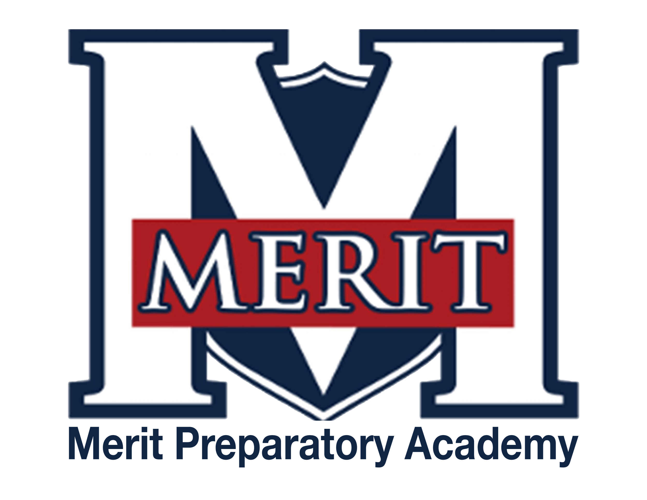
Merit Preparatory Academy
Board Meeting Agenda
March 18, 2025 at 6:30pm
Meeting at 1440 W. Center Street, The Keep

Join us on Zoom:
https://us06web.zoom.us/j/82560288867?pwd=WhOkcndQRcOb3K1UC9rhNbDcTZuKby.1

I. Welcome, Roll Call and Pledge

II. Good News from Around the School
- Meritorious Knight award for March– Mike Condie

III. Reports-
Fiscal and Enrollment Responsibilities
- Finance Report
  - Casey Holmes from Red Apple Financial
  - Finance Committee Report– Rachel Jay

- Marketing and QuestTime Reports
  - Marketing report– Stephanie Healey
  - QuestTime and Curriculum committee report– Jeri Mellor

Academic Outcomes and Other Strategic Plan Areas
- Director Report
  - Mike Condie
    - 2026 School Land Trust plan (due May 1)
    - Health Education Assurances
    - The board/we need an appeal process for health materials. Here is a draft of a policy that could work. Once we have an appeals policy in place, at the next board meeting the board needs to:
    - 1. Review Utah county data on teen pregnancy, child sexual abuse, sexually transmitted diseases and infections, and the number of pornography complaints or instances reported at Merit.
    - 2. Approve the instructional materials that we reviewed today (Health I, Health II)

Charter Fidelity & Adherence to Statute, Rule & Policy
- Policy Committee Report– Angela Bunker
  - Health Assurances Policy
  - Professional Standards and Training for Non-Licensed Employees and Volunteers
  - Board Members Code of Conduct Policy
  - Conflict of Interest Policy
  - Staff Conduct with Students Policy
  - Sex Education Instruction Materials

- Audit Committee Report
- Board Director Report– Jeanné Condie

IV. Public comment- 15 minutes
As per Board procedure, public comment will be limited to 3 minutes per person. Anyone who would like to make a public comment will need to sign up prior to the start of the public comment period. Grievances, complaints, or concerns with individual employees or board members will not be allowed during this time as they must be dealt with by following the Conflict Resolution Policy process, and defamatory statements regarding any individual will not be allowed during an open public meeting.

V. Action Items
- Vote to approve February 13, 2025 Board Meeting Minutes
- LEA Specific License for Earth & Space Science for David Buckley
- Health Assurances Policy
- Professional Standards and Training for Non-Licensed Employees and Volunteers
- Board Members Code of Conduct Policy
- Conflict of Interest Policy
- Staff Conduct with Students Policy
- Sex Education Instruction Materials

VI. Board Business
- Director performance evaluation
- Stakeholder survey– Jeri Mellor
- Expanding the board and preparing for the future
  - New board members
    - David Jensen
- Board Calendar
  - The next board meeting will be held on April 16, 2025, at 6:30pm in Merit’s library.
  - Board members are responsible to attend the end of year knighting ceremony on May 21, 2025 at 8:30am, and graduation on May 22,2025 at 4pm.

VII. Executive Session
- To discuss the character, professional competence, or physical or mental health of an individual.
  - Possible Action from Executive Session

VII. Adjourn

