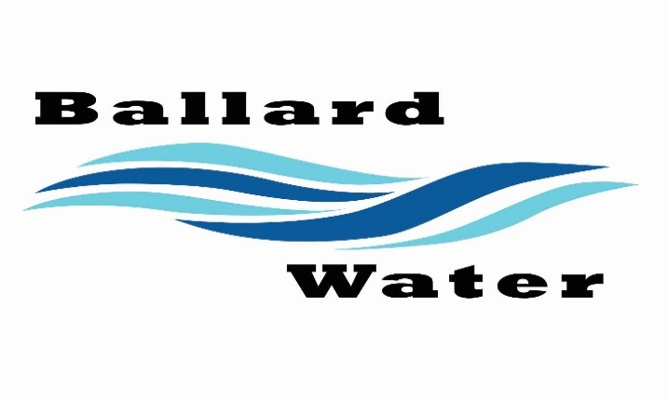

2381 E. 1000 S.

Ballard, UT 84066
Phone: (435) 722-3393
Email: amcdonald@ballardcityut.gov

Board Chairman

Mark Reidhead

Board Members

Bob Abercrombie

Andrew Ercanbrack

Ronny Rich

Jesse Danley

Water District Meeting
Visitors
Craig Nebeker
Jeffrey Baker
Chad Kettle
McKenzie Kettle
Russel Kettle
Shawn Wilkins

February 18, 2025, 5:30 pm

MEETING

Item

CALL WATER BOARD MEETING TO ORDER

Welcome and Roll Call – Chairman Mark Reidhead welcomed all in attendance and called roll. Those in attendance include Board Members Cory O’Driscoll, Andrew Ercanbrack, Jesse Danley, Secretary Anissa McDonald and Kaelyn Meyers. Board Member Ronny Rich was excused.

Prayer – Jesse Danley

Pledge of Allegiance- was said by all present.

- DRY GULCH IRRIGATION SHARES – Bid lease opening
Chairman Mark Reidhead stated that the bids need to be given to Dry Gulch no later than March 1. There were 2 bids brought into the office, Shawn Wilkins bid was for 5 to 10 shares at $312.50 each spring and fall assessment for class E water so this will be about $50 a share. CH & RM Farms bid was for $700.00 for all 28 shares plus fees this would be about $50 per share.
Shawn Wilkins asked Todd if they would cut out 5 shares that would benefit him.
It was decided that we go 5 years before another bid would be due. Board decided that 5 shares will be awarded to Shawn Wilkins and 23 shares awarded to CH&RM Farms.
Motion made by Board Member Jesse Danley to award 5 shares of Dry Gulch Irrigation Water to Shawn Wilkins and 23 shares will be awarded to CH&RM Farms. 2nd by Board Member Andrew Ercanbrack. All in favor.
Yea Nay
Board Members
Mark Reidhead
Cory O’Driscoll
Andrew Ercanbrack
Jesse Danley
Board Member Ronny Rich was excused.

- 1 & 2-5 YR CIB PROJECT LIST – Overview
The One-year list and the 2-5 year list was reviewed with changes maid mainly to the 1 year list. We will change the project from 3500 E. upper zone to 1500 E. from 1000 N to 2000 N. for Water Line Improvements. This list will need to be given to UBAOG soon with the changes.

- ENGINEERING UPDATE –
Water Pipeline – Engineer Jeff Baker explained that the survey was done on the route for the water piping for the upper zone, as was mentioned at the last meeting. The environmental permitting will help us get through the process faster. We can have a contractor ready to go mid to late Summer.

- REVIEW & CORRECT MINUTES –
- January 21, 2025
Motion was made by Board Member Andrew Ercanbrack to approve the minutes of January 21, 2025 as corrected, 2nd by Board Member Cory O’Driscoll. All in favor.
Yea Nay
Board Members
Mark Reidhead
Cory O’Driscoll
Andrew Ercanbrack
Jesse Danley
Board Member Ronny Rich was excused.

- FOLLOW-UP ON PAST MINUTES
Connection Rate Increase – Chairman Mark Reidhead will speak with Ben Mower to help come up with a solution for our connection rate increase that is needed for future projects. This will need to be a public hearing for the March 18, 2025 Water Board Meeting.

- FINANCES: Checks, Statements, Reports and Budget
Finances were gone over and approved.

- ADJOURN WATER BOARD MEETING
Motion was made by Board Member Jesse Danley to adjourn Water Board Meeting at 6:10 p.m. 2nd by Board Member Andrew Ercanbrack. All in favor.
Yea Nay
Board Members
Mark Reidhead
Cory O’Driscoll
Andrew Ercanbrack
Jesse Danley
Board Member Ronny Rich was excused.

___________________________________ _____________________
Chairman Mark Reidhead Date

___________________________________ _____________________
Secretary Anissa McDonald Date

