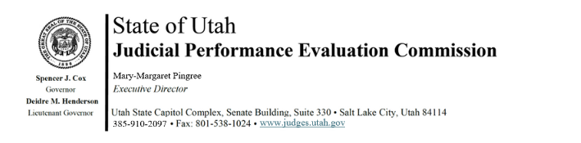
Judicial Performance Evaluation Commission
AGENDA
Tuesday, March 11, 2025
9:00 am-12:00
Hybrid Meeting *

Members: Lisa Watts Baskin, Mallory Bateman, Christine Durham, Christian Hansen, Blair Hodson, Ally Isom, Curtis M. Jensen, Sonya Martinez-Ortiz, Gil A. Miller, Mary Noonan, Bridget Romano, Tom Ross

Staff: Madison Klein, Jamie Nelson, Chris Russell, Mary-Margaret Pingree, Paul Tonks

9:00 a.m. Welcome Bridget Romano
Approval of Minutes – January 14, 2025

9:05 Announcements Mary-Margaret Pingree

9:10 Review of Performance Measures Paul Tonks

9:30 Adjectives Update Bridget Romano
Action Item

9:45 Retention Judge Survey Results Madison Klein

10:00 Appellate Pilot Mary-Margaret Pingree
Action Item

10:15 Legislative Update Mary-Margaret Pingree

10:30 Discussion Bridget Romano

11:10 Adjourn

Next Meeting: Tuesday, May 13, 2025
9:00 a.m. – 12 noon
Large Conference Room, 3rd Floor, Senate Building

*Anchor Location: Senate Building, Suite 330, CCJJ Large Conference Room

