
Board of Equalization
Meeting Minutes
January 28, 2025
Page 1 of 1

SALT LAKE COUNTY
2001 South State Street Salt Lake City, UT 84114
(385) 468-7500 TTY 711

Meeting Minutes

Tuesday, January 28, 2025
2:00 PM

Room N2-800

Board of Equalization
Board Member Suzanne Harrison Board Member Arlyn Bradshaw Board Member Aimee Winder Newton Board Member Sheldon Stewart Board Member Carlos Moreno
Chair Dea Theodore Vice Chair Laurie Stringham
Board Member Natalie Pinkney Board Member Ross Romero

Board of Equalization
Meeting Minutes
January 28, 2025
1.
CALL TO ORDER
Present
Board
Member Suzanne
Harrison,
Board
Member
Arlyn
Bradshaw, Board Member Carlos Moreno, Chair Dea Theodore,
Vice Chair Laurie Stringham, Board Member and Board Member Ross Romero
Natalie
Pinkney,
Call In
Board
Member
Aimee
Winder
Newton,
and
Board
Member
Sheldon Stewart
2.
PUBLIC COMMENT
There was no public comment.
3.
APPROVAL OF BOE MINUTES
3.1
Acceptance of BoE minutes for January 7, 2025
25-2486
Attachments:
010725 BoE Minutes
Presenter: Chris Harding, Auditor
Board Member Harrison and Board Member Winder Newton were absent for the vote.
A motion was made by Board Member Bradshaw, seconded by Vice Chair Stringham, that this agenda item be approved. The motion carried by a unanimous vote.
APPROVAL OF ASSESSOR AND HEARING OFFICER RECOMMENDATIONS
4.
4.1
Approval of Assessor and Hearing Officer Recommendations
25-2497
Attachments:
012825 Weekly Count 012825 BoE Weekly Report
012825 BoE Value Adjustments
012825 Tax Relief Adjustment - Redacted
Presenter: Brad Neff, Tax Administrator
Board Member Winder Newton was absent for the vote.
A motion was made by Board Member Bradshaw, seconded by Vice Chair Stringham, that this agenda item be approved. The motion carried by a unanimous vote.
LATE APPEALS
5.
Page 1 of 3

Board of Equalization
Meeting Minutes
January 28, 2025
5.1
Late Appeals
25-2482
Attachments:
012825 Late Appeals
Presenter: Brad Neff, Tax Administrator Action Requested: Approve attached list
Board Member Winder Newton was absent for the vote.
A motion was made by Board Member Bradshaw, Stringham, to approve the attached list. The motion vote.
EXEMPT PROPERTY RECOMMENDATIONS
seconded by Vice Chair carried by a unanimous
6.
6.1
Recommendations on Exempt Property for Tax Year 2024
25-2460
Attachments:
012825 Exempt Property
Presenter: Chris Harding, Auditor Action Requested: Approve attached list
A motion was made by Board Member Harrison, seconded by Vice Chair
Stringham, to approve the attached vote.
GREENBELT BOE ROLLBACK APPEALS
list.
The
motion
carried
by
a
unanimous
7.
Page 2 of 3

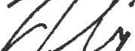
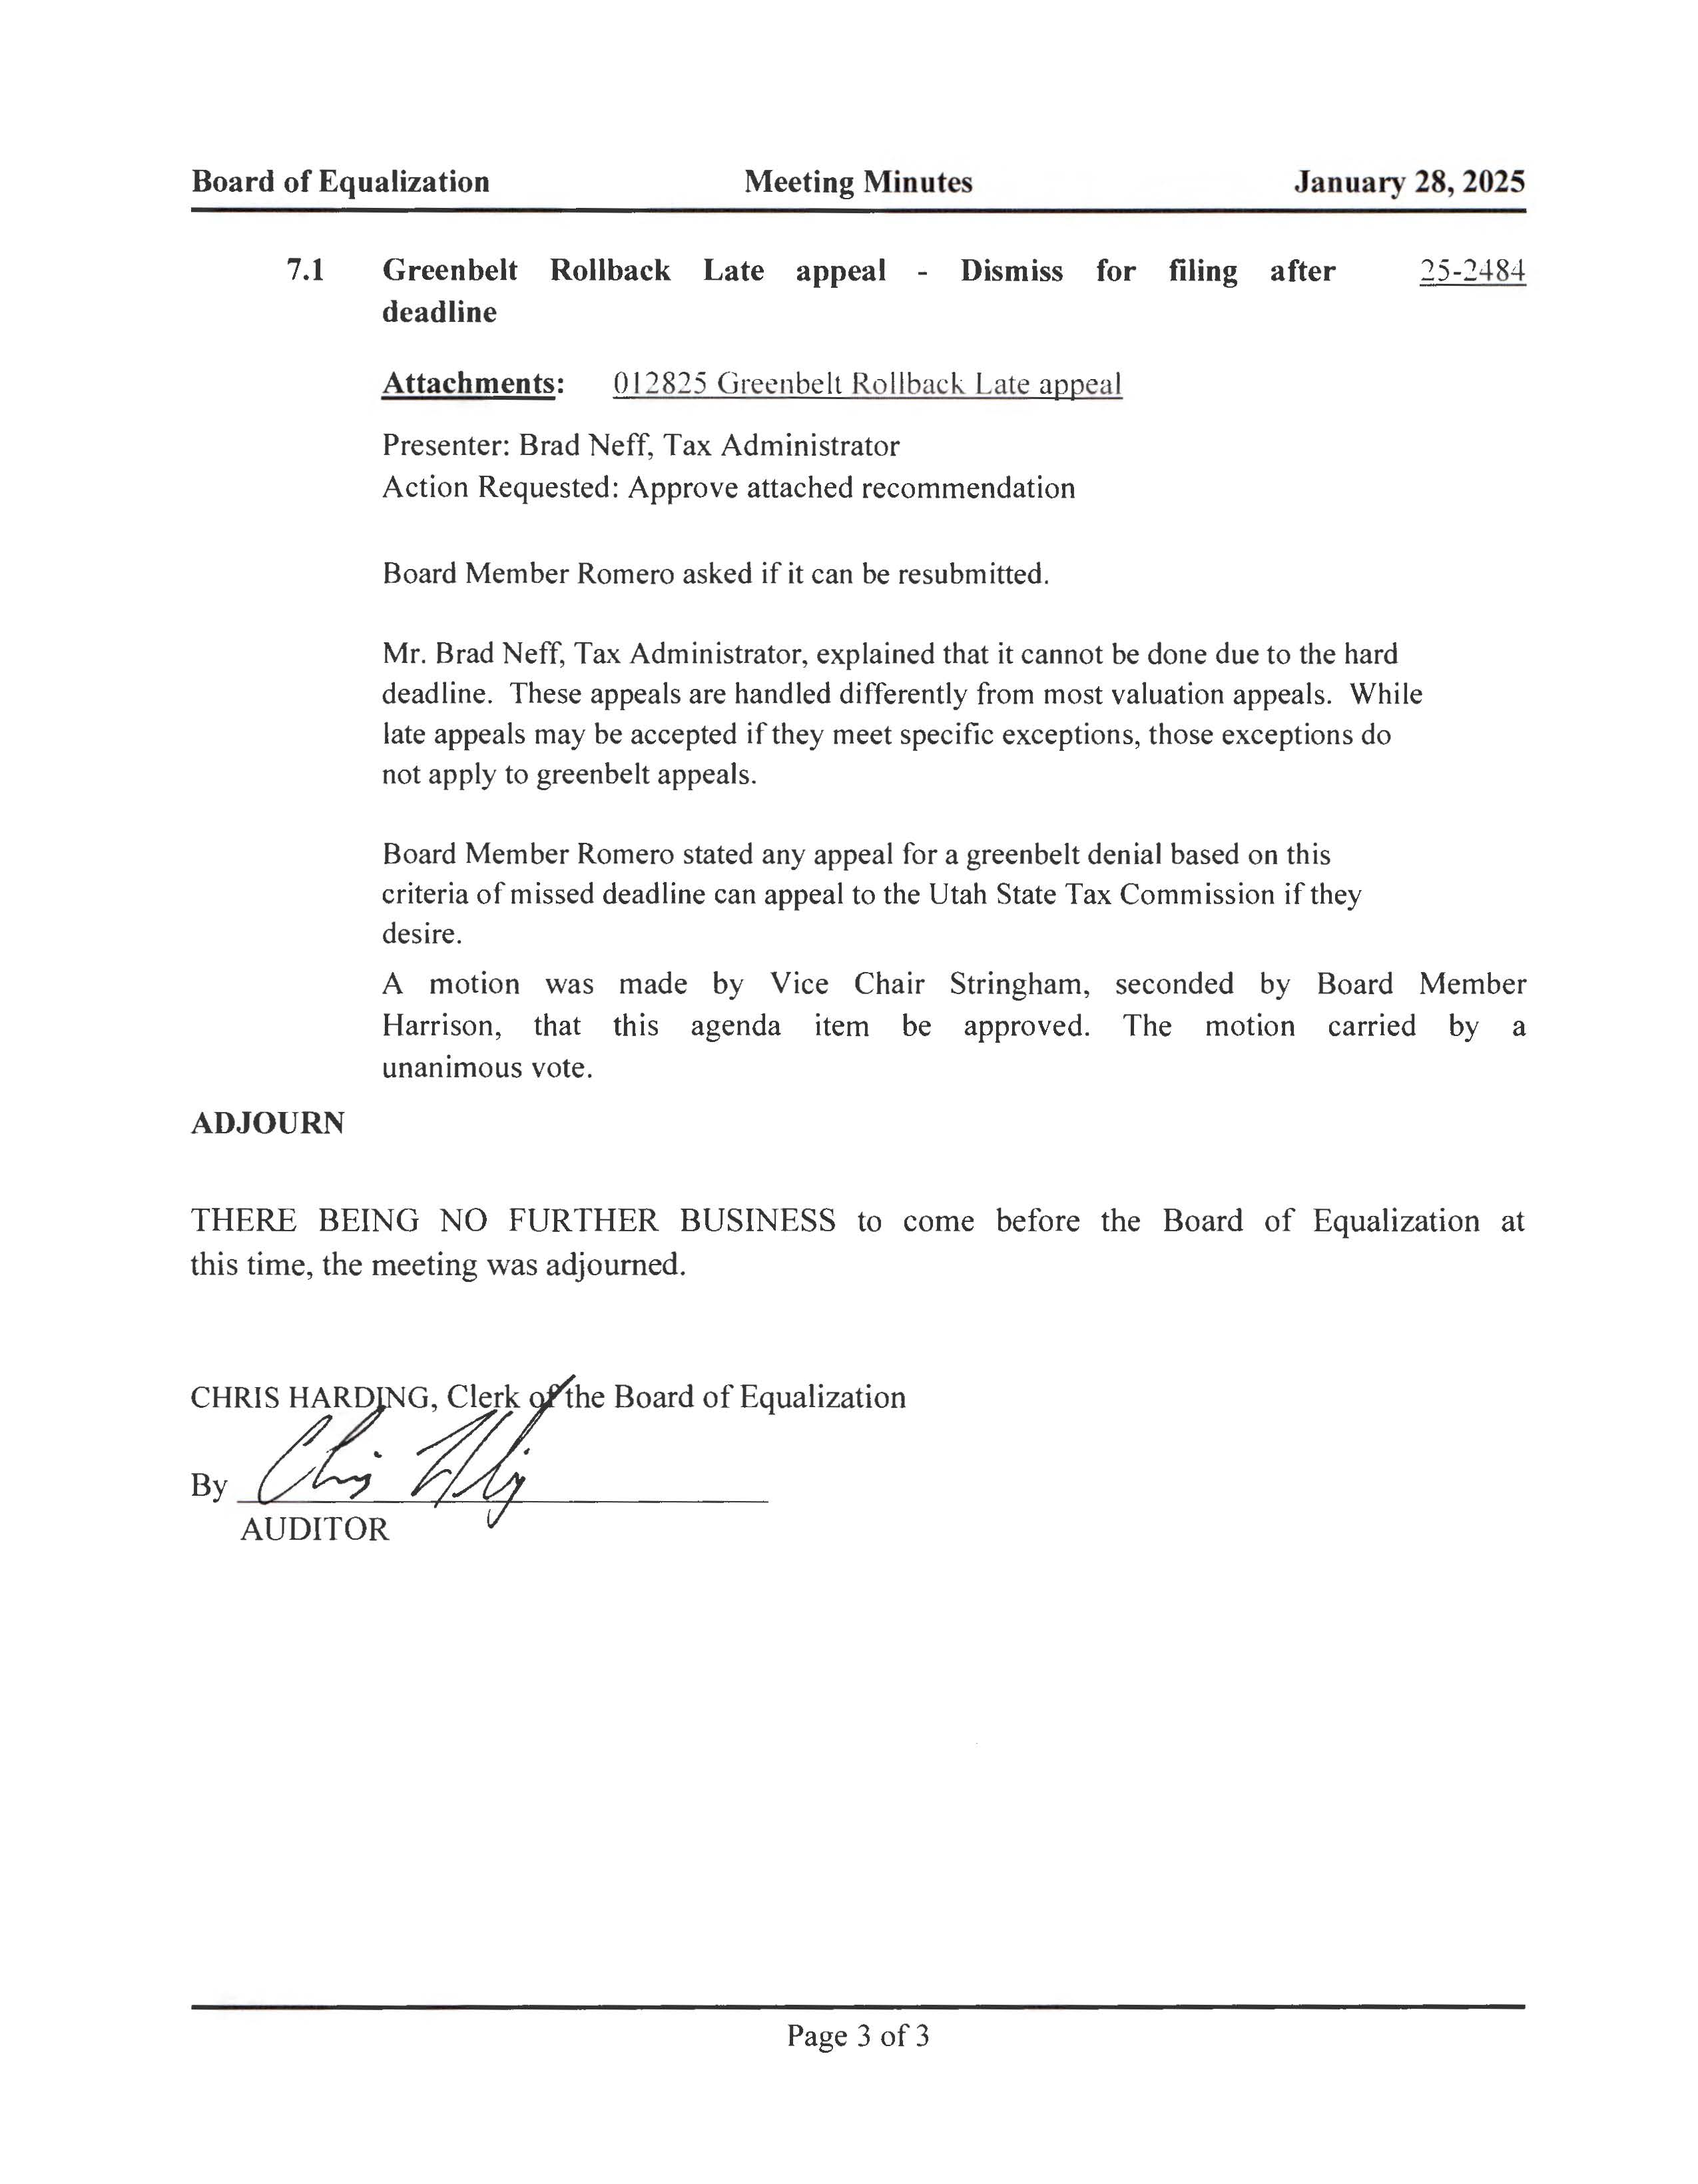
Board of Equalization
Meeting Minutes
January 28, 2025
7.1
Greenbelt deadline
Rollback
Late appeal
- Dismiss for filing after
'15-2484
Attachments:
012825 Greenbelt Rollback Late appeal
Presenter: Brad Neff, Tax Administrator
Action Requested: Approve attached recommendation
Board Member Romero asked if it can be resubmitted.
Mr. Brad Neff, Tax Administrator, explained that it cannot be done due to the hard deadline. These appeals are handled differently from most valuation appeals. While late appeals may be accepted if they meet specific exceptions, those exceptions do not apply to greenbelt appeals.
Board Member Romero stated any appeal for a greenbelt denial based on this criteria of missed deadline can appeal to the Utah State Tax Commission if they desire.
A motion was made by Vice Chair Stringham, seconded by
Board Member
Harrison, that this agenda
unanimous vote.
item be approved. The
motion
carried
by
a
ADJOURN
THERE BEING NO FURTHER BUSINESS to come
this time, the meeting was adjourned.
before
the
Board
of
Equalization
at
CHRIS HARD G, Cle
the Board of Equalization
,
By
AUDITOR
Page 3 of 3

