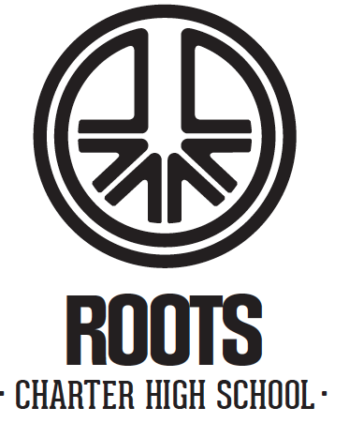
Board Meeting Agenda
Roots High School
2250 S 1300 West, WVC 84119

February 20, 2025, 4:00 pm
____________________________________________________________________________________

Item:

Call To Order/Roll Call/Welcome

Public Comments (10 minutes)

Review Minutes of Previous Board Meeting Discussion/Approval

School Business
-Financial Review (January) Discussion/Approval
-Adoption of School Improvement Plan Discussion/ Approval
-2025-26 YAG Calendar Discussion/Approval
-Discussion Executive Committee Discussion
-Discussion fundraising committee Discussion
-Discussion Finance committee Discussion
-School Update Discussion

Closed Session to Discuss the character, competence, or physical or mental health of an individual.

Discussion of the next Board Meeting

Adjournment

