WHEN RECORDED, RETURN TO:

Randall M. Larsen
Gilmore & Bell, P.C.
15 West South Temple, Suite 1400
Salt Lake City, Utah 84101

TECH RIDGE PUBLIC INFRASTRUCTURE DISTRICT
TECH RIDGE ASSESSMENT AREA

DESIGNATION RESOLUTION

DATED AS OF FEBRUARY 10, 2025

WHEREAS, the Board of Trustees (the “Board”) of the Tech Ridge Public Infrastructure District (the “District”), adopted Resolution No. 2025-05 on February 10, 2025, pursuant to which the Board authorized and approved the form of this Designation Resolution; and
BE IT RESOLVED by the Board of Trustees of the Tech Ridge Public Infrastructure District, as follows:

The Board hereby determines that it will be in the best interest of the District to designate an area to finance the costs of publicly owned infrastructure, facilities or systems more specifically described in Section 4 herein, along with other necessary miscellaneous improvements, and to complete said improvements in a proper and workmanlike manner (collectively, the “Improvements”). The Board hereby determines that it is in the best interest of the District to levy assessments against properties benefited by the Improvements to finance the costs of said Improvements. The Board hereby finds that pursuant to the Act, the Improvements constitute a publicly owned infrastructure, facility or system that (i) the District is authorized to provide or (ii) is necessary or convenient to enable the District to provide a service that the District is authorized to provide.

Pursuant to the Assessment Area Act, Title 11, Chapter 42, Utah Code Annotated 1953, as amended (“Utah Code”), and the Public Infrastructure District Act, Title 17D, Chapter 4 of the Utah Code (together, the “Act”), the owners (the “Owners”) of all properties to be assessed within the designated assessment area have voluntarily waived, among other things, all notice and hearing requirements, the right to contest or protest, and the right to have a board of equalization appointed as set forth in the Act, and have consented to the levy of an assessment against their property for the benefits to be received from the Improvements, the designation of the assessment area as herein described, the financing of the Improvements by the District through the issuance of assessment bonds, including the payment of installments over a period of not to exceed 30 years, the acquisition and/or construction of the Improvements, and the method and estimated amount of assessment as set forth herein in accordance with the Acknowledgment, Waiver and Consent Agreement attached hereto as Exhibit A. The properties to be assessed are identified by legal description in Exhibit B attached hereto.

The District hereby designates an assessment area which shall be known as the “Tech Ridge Assessment Area” (the “Assessment Area”). A map and depiction of the Assessment Area is attached hereto as Exhibit C. The District received an appraisal of the unimproved property (from an appraiser who is a member of the Appraisal Institute) which was addressed to the District, verifying that the market value of the property, after completion of the Improvements, is at least three times the amount of the assessments proposed to be levied against the unimproved property.

The Improvements shall be generally located in and around the map and depiction area attached hereto as Exhibit C. The District plans to finance the costs of publicly owned infrastructure, facilities or systems as part of an approximately 130-acre commercial, mixed-use and residential development (the “Development”). The District plans to levy the assessments to finance the Improvements within the Development. The Improvements generally include the following:
-Sewer improvements, including, but not limited to, lines, manholes and laterals (various sizes).
-Water improvements, including, but not limited to, mains, valves, lines, tees/crosses, bends, thrust bonds, fire hydrants, meters, blow offs and appurtenances (various sizes).
-Roads and roadway improvements including, but not limited to, rights of way, grading, earthwork, paving, erosion control, asphalt, curbs, gutters, sidewalks, crosswalks, ramps, demolition, road base, landscaping, traffic control, signage and striping, streetlights
-Park and open space improvements including, but not limited to, trails, bridges, handrails, concrete, excavation and earthwork, shade structures, electrical, landscaping, hardscape and irrigation, sidewalk and edging, stairs, benches, tables, trash, shelter, pavilions, sports courts, parking lot improvements, bathrooms, seeding and playground amenities.
-Storm drain improvements, including, but not limited to, drain pipes, junction boxes, inlets, end sections and basins.
As further engineering, costs, efficiencies, or any other issues present themselves, the District hereby reserves the right to approve reasonable changes to the allocation of expenditures described above and the location and specifications of the Improvements (but not to the Improvements) without obtaining the consent of the property owners within the Assessment Area.

Pursuant to the Act, the Board has determined to levy assessments to pay the cost of the Improvements. The assessments are assessed against properties in a manner that reflects an equitable portion of the benefit of the Improvements as required by the Act (and in any event the Owners have consented to such manner without reservation) and shall be payable in annual installments as set forth in the Assessment Ordinance. The District has determined that the reasonable useful life of the Improvements is at least thirty-six (36) years and that it is in the District and the Owners’ best interest for certain property owner installments to be paid for over up to thirty (30) years.

The total acquisition and/or construction cost of the Improvements as determined by a professional engineer is $64,469,504.12, of which $35,702,687.57 is anticipated to be paid by assessments to be levied against the properties within the Assessment Area to be benefited by such Improvements, which benefits need not actually increase the fair market value of the properties to be assessed. The District expects to finance a portion of the cost of the Improvements by issuing assessment bonds (the “Bonds”). The District currently estimates selling the Bonds at a true interest cost interest rate of approximately 5.75% per annum, maturing within thirty (30) years of their date of issuance. Inasmuch as bonds have not yet been issued, the District notes that the interest rate and annual payment are only as estimated and not a cap or maximum amount. It is anticipated that the reserve fund will be initially funded with proceeds of the Bonds. The estimated cost of Improvements to be assessed against the benefited properties within the Assessment Area will initially be assessed within two classifications. Classification 1 and Classification 2 will both be assessed using a per acre methodology, as follows:
Classification 1
Assessment | Assessment Methodology | Total Acres | Assessment Per Acre
$3,143,198.40 | Per Acre | 3.83 | $820,678.43

Classification 2
Assessment | Assessment Methodology | Total Acres | Assessment Per Acre
$45,846,801.60 | Per Acre | 113.56 | $403,723.16

As set forth in the Assessment Ordinance, the assessment methodology may, under certain circumstances, be altered in the future.

The Board intends to levy assessments as provided in the Act on all parcels and lots of real property within the Assessment Area to be benefited by the Improvements, and the Owners of which have executed the Acknowledgment, Waiver and Consent Agreement described in Section 2 herein. The purpose of the assessment and levy is to finance the cost of the Improvements, which the District will not assume or pay. The existing planning and zoning conditions of the District shall govern the development in the Assessment Area.
The Owners have waived the right to prepay the assessment without interest within twenty-five (25) days after the ordinance levying the assessments becomes effective. A property owner may prepay the assessment as provided in the Assessment Ordinance. The assessments shall be levied against properties in a manner that reflects an equitable portion of the benefit of the Improvements as required by the Act, and in any case, the Owners have consented to such methodology as provided in Section 11-42-409(5) of the Act. Other payment provisions and enforcement remedies shall be in accordance with the Act.
A map of the Assessment Area and the location of the Improvements and other related information are on file in the office of the Clerk/Secretary who will make such information available to all interested persons.

The District will collect the Assessments by directly billing each property owner rather than inclusion on a property tax notice.

A professional engineer has prepared a “Certificate of Project Engineer,” attached hereto as Exhibit D, which, among other things, identifies the Improvements to be constructed and installed and is available upon request from the District. The findings and determinations set forth in this Resolution are based, in part, upon said Certificate of Project Engineer.

The provisions of the Assessment Ordinance shall govern the levy, payment and applicable provisions regarding the assessments notwithstanding anything contained herein to the contrary. As required by Section 11-42-206(3) of the Act, within fifteen (15) days of the completion of this Resolution, the Clerk/Secretary shall record an original or certified copy of this designation resolution with Washington County and where applicable, file with the Washington County Recorder a notice of proposed assessment.

Dated as of February 10, 2025.

TECH RIDGE PUBLIC INFRASTRUCTURE DISTRICT
[SEAL]

By:
Chair, Board of Trustees

ATTEST:

By:
Clerk/Secretary

STATE OF UTAH )
: ss.
WASHINGTON COUNTY )

The foregoing instrument was acknowledged before me this February ___, 2025, by Isaac Barlow, the Chair of the Board of Trustees of the Tech Ridge Public Infrastructure District (the “District”), who represented and acknowledged that s/he signed the same for and on behalf of the District.

NOTARY PUBLIC

STATE OF UTAH )
: ss.
WASHINGTON COUNTY )

The foregoing instrument was acknowledged before me this February ___, 2025, by Brad Buhanan, the Clerk/Secretary of the Tech Ridge Public Infrastructure District (the “District”), who represented and acknowledged that s/he signed the same for and on behalf of the District.

NOTARY PUBLIC

EXHIBIT A
ACKNOWLEDGMENT, WAIVER AND CONSENT AGREEMENT

EXHIBIT B
LEGAL DESCRIPTION AND TAX ID NUMBERS OF
PROPERTIES TO BE ASSESSED
Parcels to be Assessed

Parcel Identification Number | Owner Entity
SG-6-2-25-201123* | City of St. George
SG-6-2-36-4201* | Tech Ridge, LLC
SG-TECH-1-6-1-T1C | One.Six, LLC
SG-TECH-1-6-2-T1C | One.Six, LLC
SG-TECH-1-6-3-T1C | One.Six, LLC
SG-TECH-1-6-4-T1C | One.Six, LLC
SG-TECH-1-6-5-T1C | One.Six, LLC
SG-TECH-1-6-6-T1C | One.Six, LLC
SG-TECH-1-6-7-T1C | One.Six, LLC
SG-TECH-1-6-8-T1C | One.Six, LLC
SG-TECH-1-6-9-T1C | One.Six, LLC
SG-TECH-1-6-10-T1C | One.Six, LLC
SG-TECH-1-6-11-T1C | One.Six, LLC
SG-TECH-1-6-12-T1C | One.Six, LLC
SG-TECH-1-6-13-T1C | One.Six, LLC
SG-TECH-1-6-14-T1C | One.Six, LLC
SG-TECH-1-6-15-T1C | One.Six, LLC

* Only a portion of these parcels are included in the Assessment Area.

Legal Description

The Assessment Area is more particularly described as follows:

Beginning at a point which is North 88°45'38” West 997.658 feet along the North section line from the Northeast corner of Section 36 Township 42 South Range 16 West of the Salt Lake Base Meridian and running thence along said North section line North 88°45'38” West 97.058 feet; thence South 00°00'04” West 13.331 feet; thence South 58°45'56” East 71.90 feet; thence South 30°10'40” East 43.12 feet; thence South 81°37'45” East 27.22 feet; thence South 33°49'05” East 43.61 feet; thence South 17°31'24” East 93.46 feet; thence South 03°53'11” East 117.31 feet; thence South 33°45'55” West 91.82 feet; thence North 89°28'11” West 174.53 feet; thence South 32°35'31” West 102.88 feet; thence South 43°05'16” West 366.36 feet to the point of curvature of a curve to the left having a radius of 379.76 feet; thence Southwesterly 261.97 feet along the arc of said curve through a central angle of 39°31'28”, the chord of which bears South 23°19'32” West for a distance of 256.81 feet, to the point of compound curvature of a curve to the left having a radius of 2363.47 feet; thence Southwesterly 213.94 feet along the arc of said curve through a central angle of 05°11'11”, the chord of which bears South 00°58'13” West for a distance of 213.87 feet, to the point of compound curvature of a curve to the left having a radius of 290.00 feet; thence Southeasterly 222.23 feet along the arc of said curve through a central angle of 43°54'23”, the chord of which bears South 23°34'34” East for a distance of 216.83 feet, to the point of reverse curvature of a curve to the right having a radius of 483.39 feet; thence Southeasterly 147.01 feet along the arc of said curve through a central angle of 17°25'30”, the chord of which bears South 36°49'01” East for a distance of 146.44 feet, to a point of non-tangency; thence South 89°28'11” East 42.68 feet; thence South 00°37'38” West 1356.102 feet to a point on the arc of a non-tangent curve to the right having a radius of 1120.38 feet; thence Southwesterly 283.68 feet along the arc of said curve through a central angle of 14°30'25”, the chord of which bears South 17°01'20” West for a distance of 282.92 feet, to a point on the arc of a non-tangent curve to the left having a radius of 5321.41 feet; thence Southwesterly 328.16 feet along the arc of said curve through a central angle of 03°32'00”, the chord of which bears South 26°01'06” West for a distance of 328.11 feet, to a point of non-tangency; thence South 02°11'38” East 263.982 feet; thence South 16°26'52” West 119.033 feet; thence South 12°42'15” East 338.266 feet; thence South 17°25'19” West 185.63 feet; thence South 00°42'37” West 128.289 feet; thence South 09°19'45” West 217.084 feet; thence South 00°53'12” East 274.171 feet; thence South 08°45'04” West 85.642 feet; thence South 02°08'21” East 203.281 feet; thence South 14°48'03” East 261.789 feet; thence South 01°23'04” West 208.355 feet; thence South 78°02'36” West 141.141 feet; thence North 88°37'13” West 141.167 feet; thence North 57°43'21” West 193.165 feet; thence North 34°55'27” West 172.902 feet; thence North 00°24'46” East 332.805 feet; thence North 29°50'04” West 289.32 feet; thence North 07°46'29” East 126.241 feet; thence North 10°43'44” West 313.614 feet; thence North 05°53'46” East 367.559 feet; thence North 09°05'27” East 129.98 feet; thence North 05°37'38” West 362.876 feet; thence North 17°36'31” West 152.702 feet; thence North 02°59'26” West 109.872 feet; thence North 13°21'41” East 206.906 feet; thence North 02°31'04” East 144.384 feet; thence North 17°01'00” West 108.082 feet; thence North 29°29'41” West 130.031 feet; thence North 06°42'17” West 248.893 feet; thence North 26°21'49” West 259.242 feet; thence North 39°35'28” West 517.225 feet; thence North 15°34'06” East 97.543 feet; thence North 32°29'04” East 69.232 feet; thence North 47°48'51” East 368.579 feet; thence North 15°23'00” West 251.51 feet; thence North 16°22'25” East 181.753 feet; thence North 13°00'07” West 218.824 feet; thence North 09°42'58” West 145.617 feet; thence North 22°01'01” West 197.399 feet; thence North 00°40'01” East 222.122 feet; thence North 58°35'41” East 315.347 feet; thence North 13°05'01” East 413.998 feet; thence North 34°06'31” East 137.808 feet; thence North 11°04'48” West 241.48 feet; thence North 08°43'53” East 215.744 feet; thence North 01°04'21” West 248.706 feet; thence North 45°23'59” West 105.60 feet; thence South 88°49'36” East 237.118 feet to a point on the arc of a non-tangent curve to the left having a radius of 965.00 feet; thence Northeasterly 86.51 feet along the arc of said curve through a central angle of 05°08'12”, the chord of which bears North 03°54'19” East for a distance of 86.48 feet, to the point of tangency; thence North 01°20'13” East 202.851 feet; thence South 88°38'43” East 179.43 feet; thence South 01°21'09” West 225.00 feet; thence North 88°38'51” West 18.00 feet; thence South 01°21'09” West 1657.765 feet; thence South 88°52'31” East 625.509 feet; thence North 43°30'21” East 51.881 feet; thence North 17°25'31” East 105.192 feet to a point on the Westerly Right of Way of Tech Ridge Drive; thence along said Westerly Right of Way through the following seven (7) courses: North 17°25'31” East 231.75 feet to the point of curvature of a non-tangent curve to the left having a radius of 240.00 feet; thence Northeasterly 136.81 feet along the arc of said curve through a central angle of 32°39'40”, the chord of which bears North 01°05'38” East for a distance of 134.97 feet, to the point of reverse curvature of a curve to the right having a radius of 1040.00 feet; thence Northwesterly 191.94 feet along the arc of said curve through a central angle of 10°34'28”, the chord of which bears North 09°56'58” West for a distance of 191.67 feet to the point of tangency; thence North 04°39'44” West 48.64 feet to the point of curvature of a curve to the right having a radius of 1540.00 feet; thence Northwesterly 179.97 feet along the arc of said curve through a central angle of 06°41'45”, the chord of which bears North 01°18'51” West for a distance of 179.87 feet, to the point of tangency; thence North 02°02'01” East 407.09 feet to the point of curvature of a curve to the left having a radius of 960.00 feet; thence Northwesterly 181.94 feet along the arc of said curve through a central angle of 10°51'31”, the chord of which bears North 03°23'45” West for a distance of 181.67 feet, to a point of non-tangency; thence North 80°29'18” East 215.724 feet; thence North 03°41'13” West 170.881 feet; thence North 40°51'26” West 137.372 feet; thence North 00°51'19” East 18.99 feet; thence South 88°41'40” East 127.025 feet; thence South 00°41'09” West 1331.961 feet to the point of beginning.
LESS AND EXCEPTING THEREFROM:

Beginning at a point which is South 00°40'01" West 370.10 feet along the Center section line from the North 1/4 corner of Section 36, Township 42 South, Range 16 West of the Salt Lake Base and Meridian and running thence North 58°35'41" East 315.35 feet; thence North 13°05'01" East 414.00 feet; thence North 34°06'31" East 137.81 feet; thence North 11°04'48" West 241.48 feet; thence North 08°43'53" East 215.74 feet; thence North 01°04'21" West 248.71 feet; thence North 45°23'59" West 105.60 feet; thence South 88°49'36" East 237.12 feet to a point on the arc of a non-tangent curve to the left having a radius of 965.00 feet; thence Northeasterly 86.51 feet along the arc of said curve through a central angle of 05°08'12", the radial direction bears North 83°31'35" West, to a point of non-tangency; thence North 01°20'05" East 202.85 feet; thence South 88°38'43" East 179.44 feet to the Northwest corner of the DXATC property; thence along the Westerly boundary of said DXATC property through the following three (3) courses: South 01°21'09" West 225.00 feet; thence North 88°38'51" West 18.00 feet; thence continuing along said Westerly boundary and its extension South 01°21'09" West 1732.77 feet; thence North 90°00'00" West 712.10 feet; thence North 00°40'01" East 222.12 feet to the point of beginning.

TOGETHER WITH:

Lots 1 through 15 Tech Ridge Plan Area 1.6 Subdivision, according to the official plat thereof on file and of record in the Office of the County Recorder, Washington County, Utah.

EXHIBIT C
MAP AND DEPICTION OF BOUNDARY OF THE ASSESSMENT AREA AND LOCATION OF IMPROVEMENTS

Classification 1

Classification 1 includes all of the highlighted parcels depicted below.

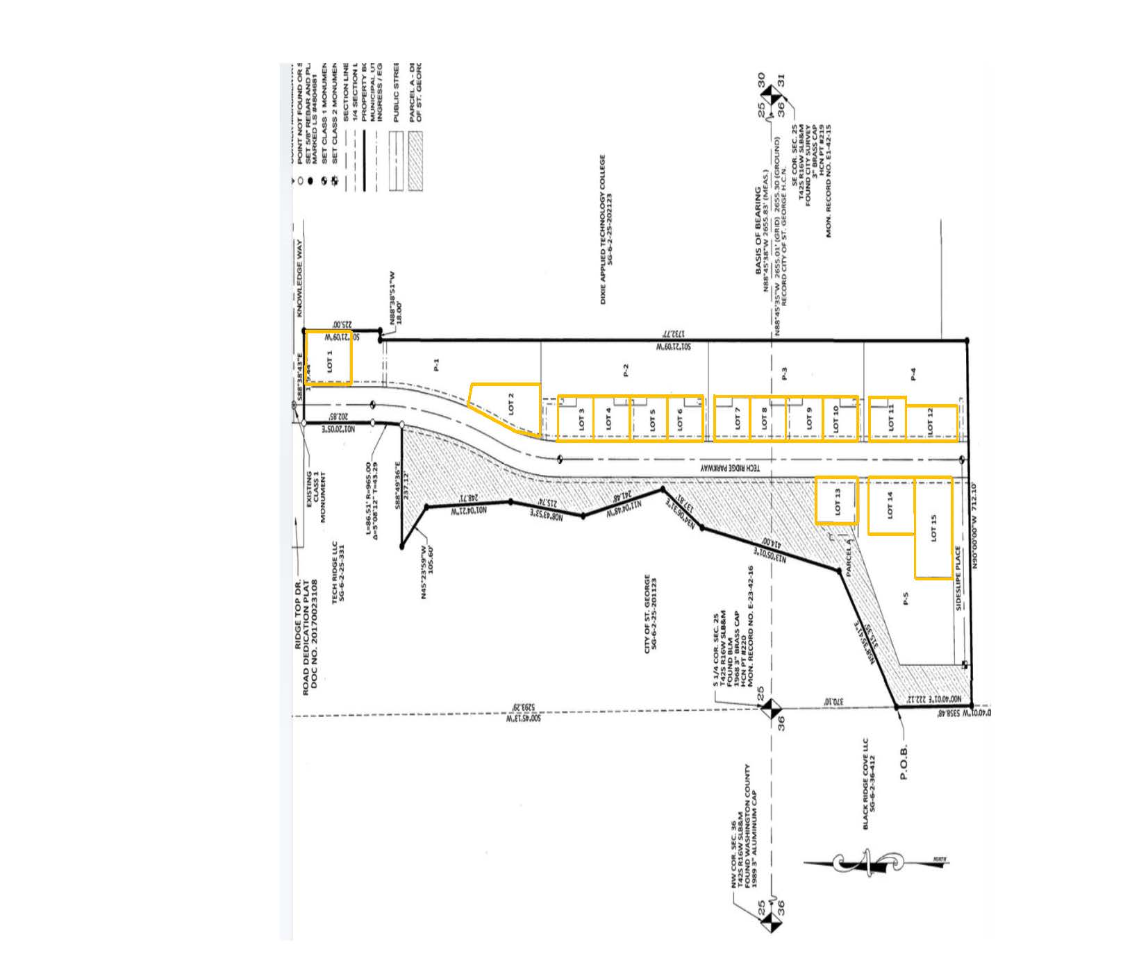

Classification 2

Classification 2 includes those portions of parcels SG-6-2-25-201123 and SG-6-2-36-4201 shown on the following page that fall within the boundaries of the Tech Ridge Public Infrastructure District.

EXHIBIT D
CERTIFICATE OF PROJECT ENGINEER

