Grantsville City Planning Commission

February 20, 2025
Public Hearing

Notice is hereby given that the City of Grantsville will hold a public hearing to address an order to show cause letter that was sent to the applicant regarding multiple violation letter and the proposed amendment to the conditional use permit for USA RV & Storage to expand the storage and equipment rentals from 3 acres to 7.72 acre at 1361 N. Old Lincoln Hwy, in the MD zone.

Notice is hereby given that in accordance with the provisions of Section §10-9A-205 and §10-9a-502 of the Utah Code, the Grantsville Planning Commission will hold a discussion and public hearing on February 20, 2025 at 7:00 p.m. at Grantsville City Hall. The meeting will also be broadcast on Zoom. The discussion, public hearing and meeting are to receive public input and consider action on the Public Hearing of the order to show cause and the proposed amendment to the conditional use permit for USA RV & Storage to expand the storage and equipment rentals from 3 acres to 7.72 acre at 1361 N. Old Lincoln Hwy. in the MD zone.

You can view a copy of the agenda and packet online by 5:00pm on February 14, 2025 at the link below: https://grantsvilleut.gov/departments/community___economic_development/planning_commission.php

Or by emailing pzcommission@grantsvilleut.gov. All comments and concerns need to be sent in writing through email or mail and received no later than 12:00pm on February 12, 2025.

Dated this 7th day of February, 2025
BY ORDER OF THE GRANTSVILLE PLANNING COMMISSION
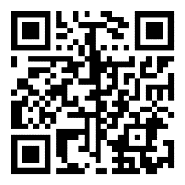
Shelby Moore
Zoning Administrator

Scan QR code above or use the link below to join Zoom meeting.
https://us02web.zoom.us/j/86157767307
Meeting ID: 861 5776 7307

