DRAFT CITY OF OREM
DEVELOPMENT REVIEW COMMITTEE MINUTES
December 30, 2024

The following items are detailed in these minutes:
- Administrative Site Plan – Boyd Viehwig, Don Joaquin Tacos, located generally at 1032 South Geneva Road in the CM zone – Approved
- Map Amendment/Rezone – Brayden Allsop and Chris Bick for Kimley-Horn, Ken Garff, located generally at 134 East 1200 South in the R8 zone - Approved
- Review and approval of December 16th, 2024 meeting - Approved

Place: Exec Staff Conference Room 107

11:02 a.m. Jared Hall called the meeting to order.

Those present: Chelsea Lindsey, Gary McGinn, Robert (Glen) Giles, Brandon Valley, and Jared Hall DRC members; and Rebecca Gourley, Associate Planner

Those excused: Taggart Bowen, Chris Clements, Rick Sabey, Derek Spencer,

- The administrative site plan for Don Joaquin Tacos is a kitchen addition with a 279 S/f walk in fridge, a sidewalk, a converted ADA parking spot, and an enclosed dumpster. This project was originally larger in nature but the project size was reduced to meet administrative review requirements. All comments during the DRC review have been met.

DRC Action: Robert (Glen) Giles moved to approve the site plan for Don Joaquin Tacos, located generally at 1032 South Geneva in the CM zone. Brandon Valley seconded the motion. Those voting yes: Chelsea Lindsey, Gary McGinn, Robert (Glen) Giles, Brandon Valley, and Jared Hall. The motion passed unanimously.
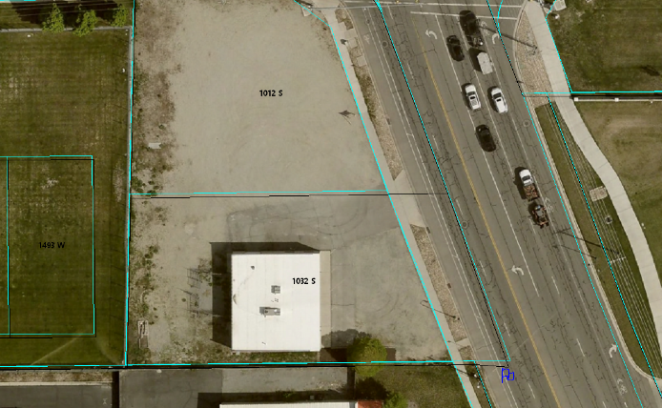

- The map amendment/rezone for Ken Garff is a proposed change from R8 to become C2. Ken Garff recently acquired two adjacent properties and they plan on turning those properties into more parking for their cars. They have struggled over the years with enough parking and the delivery of new vehicles. With a zoning change to C2 there is a possibility that they could put an entrance to their dealership off of 1200 South. All comments during the DRC review have been met.

DRC Action: Gary McGinn moved to approve the rezone map amendment for Ken Garff, located generally at 134 East 1200 South from the R8 to the C2 zone. Chelsea Lindsey seconded the motion. Those voting yes: Chelsea Lindsey, Gary McGinn, Robert (Glen) Giles, Brandon Valley, and Jared Hall. The motion passed unanimously.

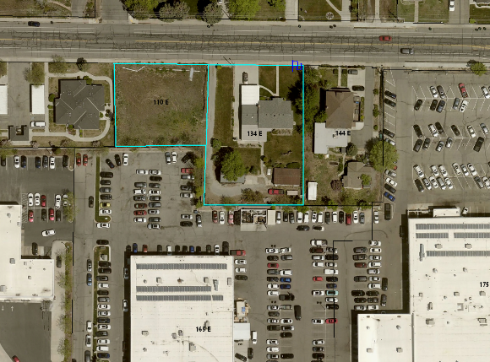

Minutes: Mrs. Gourley presented a paper copy of the minutes from the December 16, 2024 meeting. Robert (Glen) Giles motioned to approved the minutes. Brandon Valley seconded the motion. Those voting yes: Chelsea Lindsey, Gary McGinn, Robert (Glen) Giles, Brandon Valley, and Jared Hall. The motion passed unanimously.

Adjourn: Brandon Valley motioned to adjourn; Chelsea Lindsey seconded the motion. Those voting yes: Chelsea Lindsey, Robert (Glen) Giles, Brandon Valley, and Jared Hall. Those voting no: Gary McGinn.

Adjourn: 11:10 a.m.

Approved on: DRAFT

