



Subdivision Plan Review
Saddleback Commercial SR-36 Planned Unit Development Phase 5

Meeting Date Feb. 3, 2025, 7:00 pm 1528 Sunset Road, Lake Point, UT 84074
Applicant Dave Hatch, WHEN PIGS FLY, LLC
Application Date 11.12.2024
Request Preliminary Subdivision Application Review
Property Address Lake Point Utah 84074
Subdivision Name Saddleback Commercial SR-36 Planned Unit Development Phase 5
Parcel 01-505-0-0045
Acreage 4.09
Zone Commercial General
Prepared by Jamie Olson
Presented by Jamie Olson

Scope of Decision- This is a legislative matter to be decided by the Planning and Zoning Commission and a review from the DRT Committee
Request Summary
- The applicant requests a Preliminary Subdivision Approval
- The Zoning is CG- Commercial General and is an allowed use under Subdivision Ordinance 2024-13
- Parcel size 4.09 acres divided into 5 parcels

General Plan Considerations
This application does not go against anything in the Lake Point General Plan adopted in
Ordinance 2024-05 on April 10, 2024.

DRT Committee Review and Findings
- Building Official approved and any comments or corrections made
  - Kelly just wanted to make sure there was a geotechnical study done.
- Engineering approved and any comments or corrections made
  - Corrections were made
- Fire Marshal approved and any comments or corrections made
  - Confirmed the turnaround for the circle was sufficient.
- Staff approved and any comments or corrections
  - a few corrections to the coversheet and requesting the will-serve letters for utilities
  - I requested and received the Plat Name Approval from the County.
- Any public feedback
  - No public feedback to report
- Traffic Report not needed
- Geotechnical Study independently provided by the applicant for this parcel done by Western Technologies
- Subdivision Plat reviewed by Jones and DeMille Surveyor
- Jamie Olson mailed out the required public notice to the surrounding 17 property owners (within 500 feet) on January 17, 2025

Development Review Team (DRT) Approvals

The following departments have reviewed the site plan application which provides the subject for this staff report, and it has been found to be appropriate for review by the Lake Point City Planning Commission and/or City Council.

Fire Marshal (Buck Peck)
Recorder (Jamie Olson)
Engineering (Dan Fechner)
Building Official (Kelly Brown)
Rocky Mountain Power
Questar Gas
Lake Point Improvement District
Oquirrh Mountain Water Company

Conclusion
- Dave Hatch, Jeremy Schaffer (engineer) and Dan Brubaker have been great to work with, his application is complete and been reviewed and approved by all required departments.
- Is it in harmony with the General Plan

Recommendation

Based on the findings and conclusion listed in this report, staff recommends the Planning and Zoning review the request and approve the Preliminary Subdivision Application for applicant Dave Hatch, When Pigs Fly, LLC

Supporting Document

Parcel Location and CG Zone Boundary
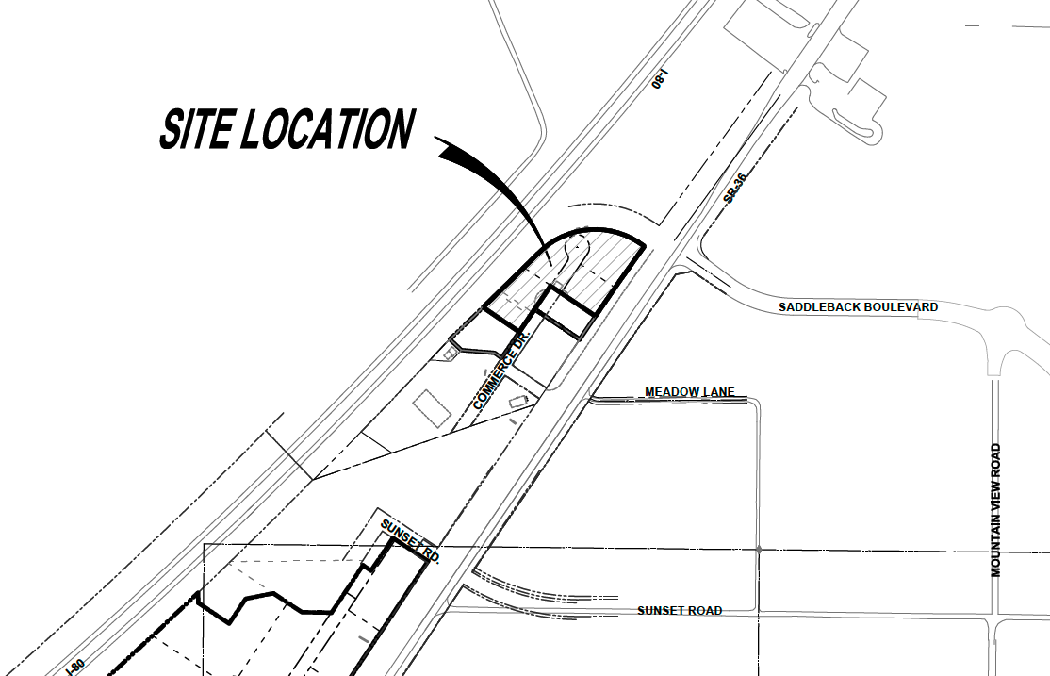
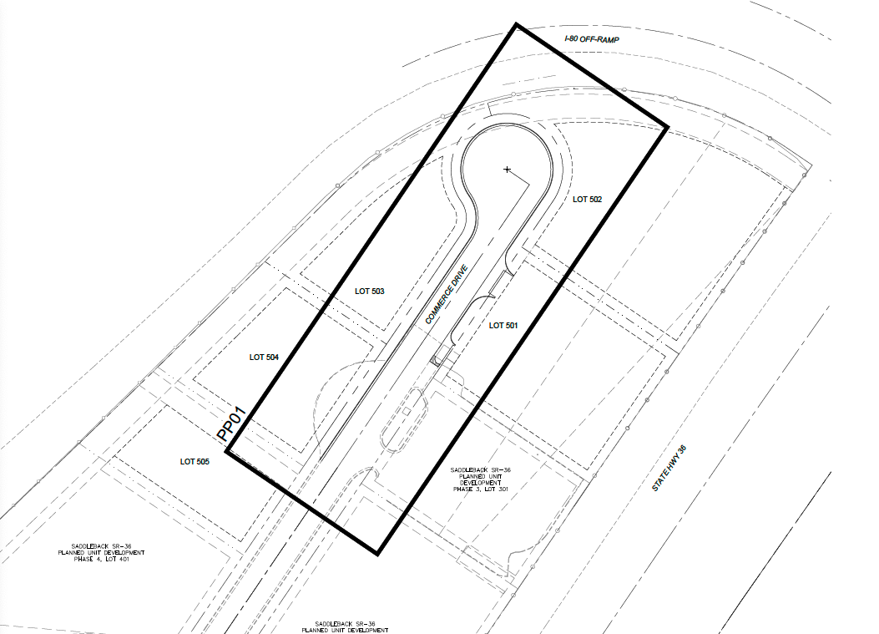
Snip of Preliminary Plat
