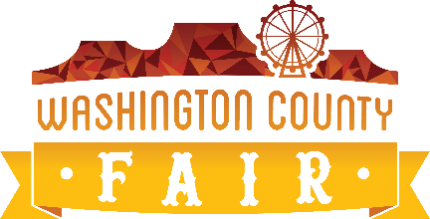
NOTICE OF 2025 MEETING SCHEDULE
WASHINGTON COUNTY FAIR ADVISORY BOARD

PUBLIC NOTICE is hereby given that the 2025 MEETING SCHEDULE of the ADVISORY BOARD FOR WASHINGTON COUNTY FAIR, WASHINGTON COUNTY, UT is as follows:

Advisory Board Meeting Dates:
January 6
February 3
March 3
April 7
May 5
September 8
October 6
November 3

Regular meetings of the Advisory Board of the Washington County Fair are held in the Shonesburg Conference Room of the Washington County Legacy Park Grafton Building, 5500 W. 700 S, Hurricane, Utah commencing at 6:00 p.m. (unless otherwise stated).
Notice of Special Accommodations (ADA)
Washington County will make efforts to provide reasonable accommodations to disabled members of the public in accessing county programs. Please contact the Washington County Commission Office at 435.301.7000 in advance if you have special needs.

