AMENDED AND RESTATED

GOVERNING DOCUMENT

FOR

VIRIDIAN FARM PUBLIC INFRASTRUCTURE DISTRICT NOS. 1, 2, and 3

Salem City, UTAH
________________, 2025
Originally approved September 20, 2023

Prepared by:
Snow Jensen & Reece, PC
St. George, Utah

TABLE OF CONTENTS
I. INTRODUCTION 1
A. Purpose and Intent. 1
B. Need for the District. 1
C. Objective of the City Regarding District’s Governing Document. 1
D. Applicability. 2
II. DEFINITIONS 2
III. BOUNDARIES 4
IV. PROPOSED LAND USE/POPULATION PROJECTIONS/ASSESSED VALUATION 4
V. DESCRIPTION OF PROPOSED POWERS, IMPROVEMENTS AND SERVICES 4
A. Powers of the District and Governing Document Amendment. 4
1. Improvements 5
2. Construction Standards Limitation. 6
3. Procurement 6
4. Privately Placed Debt Limitation 6
5. Annexation and Withdrawal. 6
6. Overlap Limitation. 7
7. Initial Debt Limitation 7
8. Total Debt Issuance Limitation 7
9. Bankruptcy Limitation 7
10. Eminent Domain 7
11. Governing Document Amendment Requirement 7
B. Preliminary Engineering Survey. 8
VI. THE BOARD OF TRUSTEES 8
A. Board Composition 8
B. Transition to Elected Board 8
C. Reelection and Reappointment 9
D. Vacancy 9
E. Compensation 9
F. Conflicts of Interest 9
VII. RESERVED 9
VIII. FINANCIAL PLAN 9
A. General. 9
B. Maximum Interest Rate and Maximum Underwriting Discount. 9
C. Maximum Debt Mill Levy. 10
D. Maximum Debt Mill Levy Imposition Term. 10
E. Debt Repayment Sources. 10
F. Debt Instrument Disclosure Requirement. 10
G. Security for Debt. 11
H. District’s Operating Costs. 11
I. Bond and Disclosure Counsel; Municipal Advisor. 11
IX. ANNUAL REPORT 11
A. General. 11
B. Reporting of Significant Events. 11
X. DISSOLUTION 12
XI. DISCLOSURE TO PURCHASERS; ANNUAL NOTICE 13
XII. INTERLOCAL AGREEMENT 14

LIST OF EXHIBITS

EXHIBIT A Legal Descriptions
EXHIBIT B Salem City Vicinity Map
EXHIBIT C Initial District Boundary Map and Annexation Area Boundary Map
EXHIBIT D Form of Interlocal Agreement between the Districts and Salem City

INTRODUCTION

Purpose and Intent.
The District is an independent unit of local government, separate and distinct from the City, and, except as may otherwise be provided for by State or local law or this Governing Document, its activities are subject to review by the City only insofar as they may deviate in a material matter from the requirements of the Governing Document. It is intended that the District will provide a part or all of the Public Improvements for the use and benefit of all anticipated inhabitants and taxpayers of the District. The primary purpose of the District will be to finance the construction of these Public Improvements. The District is not being created to provide any ongoing operations and maintenance services.

Need for the District.
There are currently no other governmental entities, including the City, located in the immediate vicinity of the District that consider it desirable, feasible or practical to undertake the planning, design, acquisition, construction installation, relocation, redevelopment, and financing of the Public Improvements needed for the Project. Formation of the District is therefore necessary in order for the Public Improvements required for the Project to be provided in the most economic manner possible.

Objective of the City Regarding District’s Governing Document.
The City’s objective in approving the Governing Document for the District is to authorize the District to provide for the planning, design, acquisition, construction, installation, relocation and redevelopment of the Public Improvements from the proceeds of Debt to be issued by the District. All Debt is expected to be repaid by taxes imposed and collected for no longer than the Maximum Debt Mill Levy Imposition Term for residential properties and at a tax mill levy no higher than the Maximum Debt Mill Levy, and/or repaid by Assessments. Debt which is issued within these parameters, as further described in the Financial Plan, will insulate property owners from excessive tax burdens to support the servicing of the Debt and will result in a timely and reasonable discharge of the Debt.
This Governing Document is intended to establish a limited purpose for the District and explicit financial constraints that are not to be violated under any circumstances. The primary purpose is to provide for the Public Improvements associated with development and regional needs. Although the District has authority to directly provide public improvements, the District also has the authority to pledge tax revenues to an interlocal entity that provides public improvements.
It is the intent of the District to dissolve upon payment or defeasance of all Debt incurred or upon a determination that adequate provision has been made for the payment of all Debt.
The District shall be authorized to finance the Public Improvements that can be funded from Debt to be repaid from Assessments or from tax revenues collected from a mill levy which shall not exceed the Maximum Debt Mill Levy on taxable properties and which shall not exceed the Maximum Debt Mill Levy Imposition Term on taxable properties (or repaid from any combination of Assessments and a mill levy). It is the intent of this Governing Document to assure to the extent possible that no taxable property bear an economic burden that is greater than that associated with the Maximum Debt Mill Levy in amount and that no taxable property bear an economic burden that is greater than that associated with the Maximum Debt Mill Levy Imposition Term in duration even under bankruptcy or other unusual situations. Generally, the cost of Public Improvements that cannot be funded within these parameters are not costs to be paid by the District.

Applicability.
This Governing Document amends and entirely restates the governing document originally approved by the City for the Districts. This Governing Document is not intended to and does not create any rights in favor of any party other than the City. The failure of the District to comply with any terms or conditions of this Governing Document shall not relieve any property owner of an obligation to pay taxes, fees other charges that are adopted or imposed by the District.

DEFINITIONS
In this Governing Document, the following terms shall have the meanings indicated below, unless the context hereof clearly requires otherwise:
Annexation Area Boundaries: means the boundaries of the area described in the Annexation Area Boundary Map which have been approved by the City for annexation into the Districts upon the meeting of certain requirements. Generally, each District shall have the right to annex property from each of the other Districts to adjust the boundaries between them, but not to annex property from outside the Districts without the approval of the City Council.
Annexation Area Boundary Map: means the map attached hereto as Exhibit C, describing the property proposed for annexation within the Districts. Generally, the Annexation Area Boundary for each District shall incorporate the Initial District Boundary of each other District.
Assessment: means (i) the levy of an assessment secured by a lien on property within a District to pay for the costs of Public Improvements benefitting such property or (2) an assessment by a District levied on private property within such District to cover the costs of an energy efficient upgrade, a renewable energy system, or an electric vehicle charging infrastructure, each as may be levied pursuant to the Assessment Act.
Assessment Act: means Title 11, Chapter 42, Utah Code as may be amended from time to time.
Board: means the board of trustees of each District.
Bond, Bonds or Debt: means bonds or other obligations for the payment of which a District has promised to impose an ad valorem property tax mill levy, and/or collect Assessments.
City: means Salem City, Utah.
City Code: means the City Code of Salem City, Utah.
City Council: means the City Council of Salem City, Utah.
Development Agreement: means the Development Agreement between the City and ____________ dated ____________.
District: means the Viridian Farm Public Infrastructure District No. 1, No. 2, or No. 3, respectively; “Districts” means two or more of said Districts as the context requires.
District Area: means the property within the Initial District Boundary Map and the Annexation Area Boundary Map for each District.
End User: means any owner, or tenant of any owner, of any taxable improvement within the District, who is intended to become burdened by the imposition of ad valorem property taxes subject to the Maximum Debt Mill Levy. By way of illustration, a resident homeowner, renter, commercial property owner, or commercial tenant is an End User. The business entity that constructs homes or commercial structures is not an End User.
Fees: means any fee imposed by the District for administrative services provided by the District.
General Obligation Debt: means a Debt that is directly payable from and secured by ad valorem property taxes that are levied by a District and does not include Limited Tax Debt.
Governing Document: means this Governing Document approved by the City Council, which shall be the Governing Document for each of the Districts.
Governing Document Amendment: means an amendment to this Governing Document approved by the City Council in accordance with the City’s ordinance and the applicable state law and approved by the Board in accordance with applicable state law.
Initial District Boundaries: means the boundaries of a District as described in the Initial District Boundary Map.
Initial District Boundary Map: means the map(s) attached hereto as Exhibit C, describing each District’s initial boundaries.
Limited Tax Debt: means a debt that is directly payable from and secured by ad valorem property taxes that are levied by a District which may not exceed the Maximum Debt Mill Levy.
Local District Act: means Title 17B of the Utah Code, as amended from time to time.
Maximum Debt Mill Levy: means the maximum mill levy each District is permitted to impose for payment of Debt as set forth in Section VIII.C below.
Maximum Debt Mill Levy Imposition Term: means the maximum term for imposition of a mill levy for any given series of bonds as set forth in Section VIII.D below.
Municipal Advisor: means a consultant that: (i) advises Utah governmental entities on matters relating to the issuance of securities by Utah governmental entities, including matters such as the pricing, sales and marketing of such securities and the procuring of bond ratings, credit enhancement and insurance in respect of such securities; (ii) shall be a municipal advisor with a registered municipal advisory firm as recognized by the Securities and Exchange Commission and Municipal Securities Rulemaking Board; and (iii) is not an officer or employee of the District.
Project: means the development or property commonly referred to as Viridian Farm.
PID Act: means Title 17D, Chapter 4 of the Utah Code, as amended from time to time and any successor statute thereto.
Public Improvements: means a part or all of the improvements authorized to be planned, designed, acquired, constructed, installed, relocated, redeveloped and financed as generally described in the Local District Act, as specifically limited in Section V below and as permitted in or required by the Development Agreement, to serve the future taxpayers and inhabitants of the District Areas.
State: means the State of Utah.
Taxable Property: means real or personal property within a District Area subject to ad valorem taxes imposed by a District.
Trustee: means a member of the Board.
Utah Code: means the Utah Code Annotated 1953, as amended.

BOUNDARIES
The total area of the Initial District Boundaries includes approximately 557.077 acres, with the area of each of the Districts as follows: District No. 1, 194.64 acres; District No. 2, 183.40 acres; and District No. 3, 179.037 acres. The total area to be included in the Annexation Area Boundaries for each of the Districts, is the Initial District Boundaries for the other two Districts. A legal description of each of the Initial District Boundaries and the Annexation Area is attached hereto as Exhibit A. A vicinity map is attached hereto as Exhibit B. A map of the Initial District Boundaries is attached hereto as Exhibit C. It is anticipated that each District’s boundaries may change from time to time as it undergoes annexations and withdrawals pursuant to Section 17D-4-201, Utah Code, subject to Article V below.

ASSESSED VALUATION; PROPOSED LAND USE
The District Areas consist of mostly undeveloped land. The current assessed valuation of the District Areas at build out, is expected to be sufficient to reasonably discharge the Debt under the Financial Plan. Upon build out, the District Areas are anticipated to contain approximately 1,754 residential units.
Approval of this Governing Document by the City does not imply approval of the development of a specific area within any District, nor does it imply approval of the number of residential units or the total site/floor area of commercial or industrial buildings identified in this Governing Document or any of the exhibits attached thereto, unless the same is contained within an Approved Improvement Plan.

DESCRIPTION OF PROPOSED POWERS, IMPROVEMENTS AND SERVICES

Powers of the District and Governing Document Amendment.
Each District shall have the power and authority to provide the Public Improvements within and without the boundaries of such District, as such power and authority is described in the Local District Act, PID Act, and other applicable statutes, common law and the Constitution, subject to the limitations set forth herein.

Improvements
. Each District shall have authority to provide for the planning, design, acquisition, construction, installation, relocation, redevelopment, maintenance, and financing of the Public Improvements within and without the boundaries of the District. The determination of which Public Improvements, or portions thereof, shall be financed by which District shall be left to the discretion of the Districts.
Each District shall dedicate the Public Improvements to the City or other appropriate public entity in a manner consistent with the Approved Improvement Plan and other rules and regulations of the City and applicable provisions of the City Code. Trails which are interconnected with a city or regional trail system shall be open to the public free of charge and on the same basis as residents and owners of taxable property within the District.
Each District shall be permitted to pay for Public Improvements identified herein irrespective of any increase or decrease in the actual cost, provided that such District complies with this Section V and other requirements of this Governing Document, including but not limited to the debt limit provided in Section V.A(8) and the Maximum Debt Mill Levy provided in Section VIII.C. If the District desires to pay for the costs associated with improvements which are outside the description of the authorized Public Improvements herein, then it must first obtain approval from the City in an Approved Improvement Plan.

Reimbursement for Improvements. Any impact fee reimbursements or credits which become available due to the financing of Public Improvements by a District shall be for the benefit of the District and not any developer. The specifics of the scope and availability of impact fee credits or reimbursements shall be reserved and will be addressed in a future interlocal agreement between the City and a District.

Ownership of Improvements. Notwithstanding the provisions of this Section V.A.1, without written authorization of the City, a District shall not be authorized to finance the costs of any improvements or facilities which are to be ultimately owned by the District.

Construction Standards. Each District will ensure that the Public Improvements are designed and constructed in accordance with the customary standards and specifications of the City and of other governmental entities having proper jurisdiction. Each District will require the developer of Public Improvements to obtain the City’s approval of civil engineering plans and applicable permits for construction and installation of Public Improvements prior to such work being performed. Consistent with Section 3 below, each District will obtain a surveyor or engineer’s certification that Public Improvements are completed, or partially completed, consistent with City-approved plans and applicable City standards before paying or reimbursing the costs of such construction.

Procurement
. Each District shall be subject to the Utah Procurement Code, Title 63G, Chapter 6a. Notwithstanding this requirement, a District may acquire completed or partially completed improvements for fair market value, or pay or reimburse the approved costs of such improvements, as reasonably determined by a surveyor or engineer that is selected or approved in writing by the City (which may include a surveyor or engineer employed by the City).

Privately Placed Debt Limitation
. Prior to the issuance of any privately placed Debt, the District shall obtain the certification of a Municipal Advisor substantially as follows:
We are [I am] a Municipal Advisor within the meaning of the District’s Governing Document.
We [I] certify that (1) the net effective interest rate to be borne by [insert the designation of the Debt] does not exceed a reasonable current [tax-exempt] [taxable] interest rate, using criteria deemed appropriate by us [me] and based upon our [my] analysis of comparable high yield securities; and (2) the structure of [insert designation of the Debt], including maturities and early redemption provisions, is reasonable considering the financial circumstances of the District.

Annexation and Withdrawal.

      - No District shall include within any of their boundaries any property outside the District Area without the prior written consent of the City. The City, by resolution and this Governing Document, has consented to the annexation of any area within the Annexation Area Boundaries into a District. Such area may only be annexed upon 1) the District obtaining consent of all property owners and registered voters, if any, within the area proposed to be annexed and the passage of a resolution of the Board approving such annexation, and 2) if the parcel is not currently located in the City, the annexation of such parcel into the City or adoption of a resolution of the County approving such annexation into the District.
      - Any annexation or withdrawal shall be in accordance with the requirements of the PID Act.
      - Upon any annexation or withdrawal, the District shall provide the City a description of the revised District Boundaries.
      - Annexation or withdrawal of any area in accordance with V.A.5(a) and (b) shall not constitute an amendment of this Governing Document.

Overlap Limitation.
No District shall consent to any annexation or withdrawal hereunder, or to the organization of any other public infrastructure district organized under the PID Act within the District Area which will overlap the boundaries of the District, unless the aggregate mill levy for payment of Debt of such proposed boundaries or districts will not at any time exceed the Maximum Debt Mill Levy of the Districts.

Total Debt Issuance Limitation
. The Districts shall not in the aggregate issue Debt in excess of the amount of Thirty-Five Million Dollars ($35,000,000). This amount excludes any portion of bonds issued to refund a prior issuance of debt by a District.

Bankruptcy Limitation
. All of the limitations contained in this Governing Document, including, but not limited to, those pertaining to the Maximum Debt Mill Levy, Maximum Debt Mill Levy Imposition Term and the Fees, have been established under the authority of the City to approve a Governing Document with conditions pursuant to Section 17D-4-201(5), Utah Code. It is expressly intended that such limitations:
      - Shall not be subject to set-aside for any reason or by any court of competent jurisdiction, absent a Governing Document Amendment; and
      - Are, together with all other requirements of Utah law, included in the “political or governmental powers” reserved to the State under the U.S. Bankruptcy Code (11 U.S.C.) Section 903, and are also included in the “regulatory or electoral approval necessary under applicable nonbankruptcy law” as required for confirmation of a Chapter 9 Bankruptcy Plan under Bankruptcy Code Section 943(b)(6).
      - Any Debt, issued with a pledge or which results in a pledge, that exceeds the Maximum Debt Mill Levy and the Maximum Debt Mill Levy Imposition Term, shall be deemed a material modification of this Governing Document and shall not be an authorized issuance of Debt unless and until such material modification has been approved by the City as part of a Governing Document Amendment.

Eminent Domain
. In no event shall a District have authority to exercise eminent domain or utilize any funds of the District to support any eminent domain action or proceeding without the prior approval of the City Council.

Governing Document Amendment Requirement

      - . This Governing Document has been designed with sufficient flexibility to enable the Districts to provide the Public Improvements under evolving circumstances without the need for numerous amendments. Actions of the District which violate the limitations set forth in V.A.1-8 above or in VIII.B-G. shall be deemed to be material modifications to this Governing Document and the City shall be entitled to all remedies available under State and local law to enjoin such actions of the District.
      - Subject to the limitations and exceptions contained herein, this Governing Document may be amended by passage of resolutions of the City and the District approving such amendment.

Public Improvement Estimated Costs and Design.
The District shall have authority to provide for the planning, design, acquisition, construction, installation, relocation, redevelopment, maintenance, and financing of the Public Improvements within and without the boundaries of the Districts, to be more specifically defined in an Approved Improvement Plan. An estimate of the costs of the Public Improvements which may be planned for, designed, acquired, constructed, installed, relocated, redeveloped, maintained or financed was prepared based upon a preliminary engineering survey and estimates derived from the zoning on the property in the District Area and is approximately Twenty-Five Million Dollars ($25,000,000).
All of the Public Improvements will be designed in such a way as to assure that the Public Improvement standards will be compatible with those of the City and/or any other applicable public entity and shall be in accordance with the requirements of the Approved Improvement Plan. All construction cost estimates are based on the assumption that construction conforms to applicable local, State or Federal requirements.

THE BOARD OF TRUSTEES

Board Composition
. The Board shall be composed of three (3) Trustees who shall be appointed by the City Council pursuant to the PID Act. Trustees 1, 2, and 3 shall initially be at large. Trustee terms shall be staggered with initial terms as follows: Trustee 2 shall serve an initial term of four (4) years; Trustees 1 and 3 shall each serve an initial term of six (6) years. All terms shall commence on the date of issuance of a certificate of creation by the Office of the Lieutenant Governor of the State of Utah. In accordance with the PID Act, appointed Trustees shall not be required to be residents of the District.

Transition to Elected Board
. Respective board seats shall transition from appointed to elected seats according to the following milestones:
1. Trustee 1. Trustee 1 shall transition to an elected seat after the end of a full term during which 50% of the Anticipated Units have received certificates of occupancy.
2. Trustee 2. Trustee 2 shall transition to an elected seat after the end of a full term during which 70% of the Anticipated Units have received certificates of occupancy.
3. Trustee 3. Trustee 3 shall transition to an elected seat after the end of a full term during which 90% of the Anticipated Units have received certificates of occupancy.
No transition pursuant to this Section on the basis of the number of building permits issued shall become effective until the next scheduled regular election of the District. Seats set to transition on January 1 of a given year shall hold an election for such seats at the regular election immediately preceding such January 1.

Reelection and Reappointment
. Upon the expiration of a Trustee’s respective term, any seat which has not transitioned to an elected seat shall be appointed by the City Council pursuant to the PID Act and any seat which has transitioned to an elected seat shall be elected at the next municipal election pursuant to an election held for such purpose. In the event that no qualified candidate files to be considered for appointment or files a declaration of candidacy for a seat, such seat may be filled in accordance with the Local District Act.

Vacancy
. Any vacancy on the Board shall be filled pursuant to the Local District Act.

Compensation
. Only Trustees who are residents of the District may be compensated for services as Trustee. Such compensation shall be in accordance with State Law.

Conflicts of Interest
. Trustees shall disclose all conflicts of interest. Any Trustee who discloses such conflicts in accordance with 17D-4-202 and 67-16-9, Utah Code, shall be entitled to vote on such matters.

REGIONAL IMPROVEMENTS

The Districts shall be authorized to provide for the planning, design, acquisition, construction, installation, relocation and/or redevelopment and a contribution to the funding of such regional improvements as fall within the description of Public Improvements herein, and fund the administration and overhead costs related to such regional improvements.

FINANCIAL PLAN

General.
The Districts shall be authorized to provide for the planning, design, acquisition, construction, installation, relocation and/or redevelopment of the Public Improvements from their revenues and by and through the proceeds of Debt to be issued by the Districts. In addition, the Districts shall be permitted to finance the prepayment of impact fees for the Project. The Financial Plan for the District shall be to issue such Debt as the Districts can reasonably pay within the Maximum Debt Mill Levy Imposition Term from revenues derived from the Maximum Debt Mill Levy, Assessments, impact fees remitted by the City, and other legally available revenues. The total aggregate Debt that the Districts shall be permitted to issue shall not exceed Thirty-Five Million Dollars ($35,000,000) and shall be permitted to be issued on a schedule and in such year or years as the Districts determine shall meet the needs of the Financial Plan referenced above and phased to serve development as it occurs. Any portion of bonds issued to refund a prior issuance of debt by the Districts shall not count against the permitted total Debt. All bonds and other Debt issued by the Districts may be payable from any and all legally available revenues of the Districts, including general ad valorem taxes to be imposed upon all Taxable Property within the Districts and Assessments. The Districts will also rely upon various other revenue sources authorized by law. These will include the power to assess Fees, penalties, or charges, including as provided in Section 17D-4-304, Utah Code, as amended from time to time.

Maximum Interest Rate and Maximum Underwriting Discount.
The interest rate on any Debt is expected to be the market rate at the time the Debt is issued. In the event of a default, the proposed maximum interest rate on any Debt is not expected to exceed fifteen percent (15%). The proposed maximum underwriting discount will be five percent (5%). Debt, when issued, will comply with all relevant requirements of this Governing Document, State law and Federal law as then applicable to the issuance of public securities.

Maximum Debt Mill Levy.
      - The “Maximum Debt Mill Levy” shall be the maximum mill levy the District is permitted to impose upon the taxable property within the District for payment of Limited Tax Debt and administrative expenses and such maximum shall be 0.003 per dollar of taxable value of taxable property in the District; provided that such levy shall be subject to adjustment as provided in Section 17D-4-301(8), Utah Code.
      - Such Maximum Debt Mill Levy may only be amended pursuant to a Governing Document Amendment and as provided in Section 17D-4-202, Utah Code.

Maximum Debt Mill Levy Imposition Term.
Each bond issued by the District shall mature within Thirty-One (31) years from the date of issuance of such bond. In addition, no mill levy may be imposed for the repayment of a series of bonds after a period exceeding forty (40) years from the first date of imposition of the mill levy for such bond (the “Maximum Debt Mill Levy Imposition Term”).

Debt Repayment Sources.
The Districts may impose a mill levy on taxable property within their respective boundaries as a primary source of revenue for repayment of debt service. The Districts shall also pledge any impact fees remitted by the City for the repayment of debt service. Each District may also rely upon various other revenue sources authorized by law. At each District’s discretion, these may include the power to assess Assessments, penalties, or charges, including as provided in Section 17D-4-304, Utah Code, as amended from time to time. Except as described in Section VIII.C(a), the debt service mill levy in the Districts shall not exceed the Maximum Debt Mill Levy or, the Maximum Debt Mill Levy Imposition Term, except for repayment of General Obligation Debt.
No District shall be permitted to charge an End User the costs of any portion of a Public Improvement for which such End User has already paid or is presently obligated to pay through any combination of mill levy, Assessment, or impact fee. This provision shall not prohibit the division of costs between mill levies, Assessments, or impact fees, but is intended to prevent double taxation of End Users for the costs of Public Improvements.

Debt Instrument Disclosure Requirement.
In the text of each Bond and any other instrument representing and constituting Debt of a District, the District shall set forth a statement in substantially the following form:
By acceptance of this instrument, the owner of this Bond agrees and consents to all of the limitations in respect of the payment of the principal of and interest on this Bond contained herein, in the resolution of the District authorizing the issuance of this Bond and in the Governing Document for creation of the District.
Similar language describing the limitations in respect of the payment of the principal of and interest on Debt set forth in this Governing Document shall be included in any document used for the offering of the Debt for sale to persons, including, but not limited to, a developer of property within the boundaries of a District.

Security for Debt.
No District shall pledge any revenue or property of the City as security for the indebtedness set forth in this Governing Document. Approval of this Governing Document shall not be construed as a guarantee by the City of payment of any of a District’s obligations; nor shall anything in the Governing Document be construed so as to create any responsibility or liability on the part of the City in the event of default by a District in the payment of any such obligation.

Districts’ Operating Costs.
The estimated cost of engineering services, legal services and administrative services, together with the estimated costs of each District’s organization and initial operations, are anticipated to be Seventy-Five Thousand Dollars ($75,000), which will be eligible for reimbursement from Debt proceeds.
In addition to the capital costs of the Public Improvements, each District will require operating funds for administration and to plan and cause the Public Improvements to be financed. The first year’s operating budget of each District is estimated to be approximately Fifty Thousand Dollars ($50,000) which is anticipated to be derived from property taxes and other revenues, and may also be financed for a period of time until District revenues are anticipated to be sufficient to bear such costs. Each District may also enter into a reimbursement agreement with the developer of the Project to reimburse such developer for any such administrative costs paid by developer.

Bond and Disclosure Counsel; Municipal Advisor.
It is the intent of the City that each District shall use competent and nationally recognized bond and disclosure counsel and Municipal Advisor with respect to District Bonds to ensure proper issuance and compliance with this Governing Document. The Districts have agreed to utilize the City’s counsel, Gilmore & Bell, P.C., as bond and disclosure counsel with respect to District Bonds as permitted by law, and will bear the reasonable costs of the City’s retention of Zions Public Finance (“Zions”) to advise the City with respect to prospective bond issuance by the Districts. Zions shall at a minimum certify to the City prior to posting any offering document or entering into any bond purchase agreement or similar agreement that the proposed pricing and structure of any bonds or obligations of the Districts represent a reasonable offering and do not unduly disadvantage future residents of the City. The foregoing requirements may be waived in writing by the City. Nothing in the foregoing will prevent the Board of each District from retaining a municipal advisor of their own choosing to represent and advise the Districts in a similar capacity.

ANNUAL REPORT TO CITY

General.
Each District shall be responsible for submitting an annual report to the City Manager’s Office no later than one hundred eighty (180) days following the end of the District’s fiscal year.

Reporting of Significant Events.
The annual report shall include information as to any of the following:

Boundary changes made or proposed to the District’s boundary as of December 31 of the prior year.

List of current interlocal agreements, if changed (to be delivered to the City upon request);

Names and terms of Board members and officers, and progress towards milestones required for transition to elected Board;

District office contact information;

Rules and regulations of the District regarding bidding, conflict of interest, contracting, and other governance matters, if changed;

A summary of any litigation which involves the District Public Improvements as of the last day of the prior fiscal year;

Status of construction of the Public Improvements as of last day of the prior fiscal year and listing all facilities and improvements constructed by developer that have been dedicated to and accepted by the City as of the last day of the prior fiscal year;

A table summarizing total debt authorized and total debt issued by the District as well as any presently planned debt issuances;

Official statements of current outstanding bonded indebtedness, if not previously provided to the City;

Current year budget including a description of the Public Improvements anticipated to be constructed in such year;

The District’s financial statements for the previous fiscal year; such statements shall be audited if required pursuant to State law or relevant bond documents (such statements shall be submitted within 30 days of completion if completed after 180 days following the end of the fiscal year);

Notice of any uncured events of default by the District, which continue beyond a ninety (90) day period, under any Debt instrument; and

Any inability of the District to pay its obligations as they come due, in accordance with the terms of such obligations, which continue beyond a ninety (90) day period.

DISSOLUTION
Upon an independent determination of the City Council that the purposes for which a District was created have been accomplished, such District agrees to file petitions for dissolution, pursuant to the applicable State statutes. In no event shall a dissolution occur until a District has provided for the payment or discharge of all of its outstanding indebtedness and other financial obligations as required pursuant to State statutes.

NOTICE TO PROPERTY OWNERS; DISCLOSURE TO PURCHASERS
A. Recorded Notice of District Creation. Within thirty (30) days of the issuance of a certificate of incorporation by the Office of the Lieutenant Governor of the State for each District, the Board shall cause to be recorded a notice of such creation with the recorder of Utah County. Such notice shall (i) contain a description of the boundaries of the District, (ii) state that a copy of this Governing Document is on file at the office of the City, (iii) state that the District may finance and repay infrastructure and other improvements through the levy of a property tax; (iv) state the Maximum Debt Mill Levy of the District; and (v) if applicable, stating that the debt may convert to general obligation debt and outlining the provisions relating to conversion. A copy of the notice shall further be provided to the City.
B. Notice to Buyers and Lessees. In addition, the Board of each District shall make commercially reasonable efforts to ensure that the Project developer, homebuilders, sub-developers, and commercial lessors, as applicable, disclose the following information to initial resident homeowners, renters, commercial property owners, and/or commercial tenants in such District:
- All of the information in the first paragraph of this XI.A.;
- A disclosure outlining the impact of any applicable property tax, in substantially the following form:
“Under the maximum property tax rate of the District, for every $100,000 of taxable value, there would be an additional annual property tax of $300 for the duration of the District’s Bonds.”
- Such disclosures shall be contained on a separate-colored page of the applicable closing or lease documents and shall require a signature of such End User acknowledging the foregoing.
- The Developer and the Board shall ensure that the Developer, homebuilders, and commercial developers, and commercial lessors, as applicable post a notice, in the same form and size (or larger) as the form attached as Exhibit E in a conspicuous area on bright-colored paper within all model homes and sales offices within the Districts.
- The Developer shall obligate any homebuilder, commercial developer, or bulk lot purchaser to provide the notices contained in 1 and 2 above as part of any purchase agreement to such homebuilder, commercial developer, or bulk lot purchaser.

C. Annual Notice to Property Owners. Not later than one hundred eighty (180) days following the end of the District’s fiscal year, commencing in the first calendar year following the year in which a District issues Debt, such District shall mail a notice to all owners of property within the boundaries of the District a notice providing:
- A disclosure outlining the impact of any applicable property tax, in substantially the following form:
“Under the maximum property tax rate of the District, for every $100,000 of taxable value, there would be an additional annual property tax of $300 for the duration of the District’s Bonds.”
- The applicable tax rate of the District for the then current year;
- That budgets and financial information for the District may be found on the State Auditor’s Website (currently https://reporting.auditor.utah.gov/searchreports/s/);
- A tentative annual meeting schedule for the District an information on where Board meeting information may be found; and
- Name and contact information for members of the Board.

INTERLOCAL AGREEMENT
The form of the Interlocal Agreement required by the City Code, relating to the limitations imposed on each District’s activities, is attached hereto as Exhibit D. The City Council shall approve the Interlocal Agreement in the form attached as Exhibit D at the public hearing approving the Governing Document. Each District approved the original interlocal agreement at its first board meeting, and also approved the amended and restated Interlocal Agreement in the form attached as Exhibit D at the Board meeting at which this Governing Document was approved. Failure of the District to execute the Interlocal Agreement as required herein shall constitute a material modification and shall require a Governing Document Amendment.

EXHIBIT A
LEGAL DESCRIPTIONS

INITIAL BOUNDARY LEGAL DESCRIPTIONS:

VIRIDIAN FARM PUBLIC INFRASTRUCTURE DISTRICT #1
PARCEL A
A PORTION OF SECTION 5, AND A PORTION OF THE EAST HALF OF SECTION 6, TOWNSHIP 9 SOUTH, RANGE 3 EAST, SALT LAKE BASE & MERIDIAN, MORE PARTICULARLY DESCRIBED BY SURVEY AS FOLLOWS:
BEGINNING AT A POINT LOCATED N0°22’15”W ALONG THE QUARTER SECTION LINE 1503.72 FEET AND EAST 33.00 FEET FROM THE SOUTH QUARTER CORNER OF SECTION 6, TOWNSHIP 9 SOUTH, RANGE 3 EAST, SALT LAKE BASE & MERIDIAN; THENCE N0°22'15"W (ALONG A LINE PARALLEL WITH AND 33.00 FEET PERPENDICULARLY DISTANCE EAST FROM THE QUARTER SECTION LINE) 2483.82 FEET TO THE SOUTH LINE OF THAT FENCE LINE AGREEMENT DESCRIBED IN DEED ENTRY NO. 80651:1999 IN THE OFFICIAL RECORDS OF THE UTAH COUNTY RECORDER; THENCE N89°09'38"E ALONG SAID FENCE LINE AGREEMENT 666.07 FEET; THENCE N89°23'48"E 280.01 FEET; THENCE N89°24'46"E 58.00 FEET; THENCE S00°35'14"E 44.87 FEET; THENCE N89°24'46"E 507.62 FEET; THENCE N00°35'14"W 107.00 FEET; THENCE N89°24'42"E 58.00 FEET; THENCE N89°25'04"E 360.00 FEET; THENCE N89°08'50"E 63.00 FEET; THENCE S00°35'14"E 106.71 FEET; THENCE N89°38'32"E 371.91 FEET; THENCE N00°21'28"W 25.46 FEET; THENCE N89°38'32"E 242.00 FEET; THENCE S00°21'28"E 47.59 FEET; THENCE N87°19'41"E 82.36 FEET; THENCE N67°28'27"E 179.46 FEET; THENCE S24°31'40"E 29.27 FEET; THENCE S26°31'47"E 39.56 FEET; THENCE N63°28'13"E 116.73 FEET; THENCE S21°41'32"E 20.82 FEET; THENCE S30°09'46"E 30.88 FEET; THENCE N59°50'14"E 120.00 FEET; THENCE N59°50'14"E 58.00 FEET; THENCE N64°28'35"E 122.10 FEET; THENCE S25°21'02"E 20.30 FEET; THENCE S30°09'46"E 196.39 FEET; THENCE S32°08'23"E 48.02 FEET; THENCE S59°26'56"W 18.23 FEET; THENCE S30°33'04"E 111.00 FEET; THENCE N59°26'56"E 82.96 FEET; THENCE ALONG THE ARC OF A CURVE TO THE LEFT 15.12 FEET WITH A RADIUS OF 15.00 FEET THROUGH A CENTRAL ANGLE OF 57°44'44", CHORD: N30°34'34"E 14.49 FEET; THENCE ALONG THE ARC OF A CURVE TO THE RIGHT 164.28 FEET WITH A RADIUS OF 81.50 FEET THROUGH A CENTRAL ANGLE OF 115°29'29", CHORD: N59°26'56"E 137.85 FEET; THENCE ALONG THE ARC OF A CURVE TO THE LEFT 15.12 FEET WITH A RADIUS OF 15.00 FEET THROUGH A CENTRAL ANGLE OF 57°44'44", CHORD: N88°19'18"E 14.49 FEET; THENCE N59°26'56"E 1313.72 FEET; THENCE ALONG THE ARC OF A CURVE TO THE RIGHT 373.94 FEET WITH A RADIUS OF 2603.50 FEET THROUGH A CENTRAL ANGLE OF 08°13'46", CHORD: N63°33'49"E 373.62 FEET; THENCE N67°40'42"E 178.62 FEET; THENCE ALONG THE ARC OF A CURVE TO THE LEFT 651.72 FEET WITH A RADIUS OF 4921.50 FEET THROUGH A CENTRAL ANGLE OF 07°35'14", CHORD: N63°53'05"E 651.24 FEET; THENCE ALONG THE ARC OF A CURVE TO THE LEFT 15.21 FEET WITH A RADIUS OF 15.00 FEET THROUGH A CENTRAL ANGLE OF 58°05'50", CHORD: N31°02'33"E 14.57 FEET; THENCE ALONG THE ARC OF A CURVE TO THE RIGHT 164.12 FEET WITH A RADIUS OF 81.50 FEET THROUGH A CENTRAL ANGLE OF 115°22'39", CHORD: N59°40'57"E 137.76 FEET; THENCE ALONG THE ARC OF A CURVE TO THE LEFT 15.12 FEET WITH A RADIUS OF 15.00 FEET THROUGH A CENTRAL ANGLE OF 57°44'44", CHORD: N88°29'55"E 14.49 FEET; THENCE N59°37'32"E 258.11 FEET; THENCE ALONG THE ARC OF A CURVE TO THE RIGHT 105.80 FEET WITH A RADIUS OF 826.50 FEET THROUGH A CENTRAL ANGLE OF 07°20'04", CHORD: N63°17'34"E 105.73 FEET; THENCE N66°57'36"E 159.70 FEET; TO THE NORTH LINE OF SAID SECTION 5; THENCE N89°08'08"E ALONG THE SECTION LINE 162.13 FEET; THENCE EAST 31.99 FEET; THENCE S59°00'06"W 21.58 FEET; THENCE ALONG THE ARC OF A CURVE TO THE RIGHT 105.22 FEET WITH A RADIUS OF 757.50 FEET THROUGH A CENTRAL ANGLE OF 07°57'30", CHORD: S62°58'51"W 105.13 FEET; THENCE S66°57'36"W 213.03 FEET; THENCE ALONG THE ARC OF A CURVE TO THE LEFT 95.05 FEET WITH A RADIUS OF 742.50 FEET THROUGH A CENTRAL ANGLE OF 07°20'04", CHORD: S63°17'34"W 94.98 FEET; THENCE S59°37'32"W 264.54 FEET; THENCE ALONG THE ARC OF A NON-TANGENT CURVE TO THE LEFT 3.34 FEET WITH A RADIUS OF 15.00 FEET THROUGH A CENTRAL ANGLE OF 12°44'57", CHORD: S10°25'04"W 3.33 FEET; THENCE ALONG THE ARC OF A CURVE TO THE RIGHT 171.91 FEET WITH A RADIUS OF 88.50 FEET THROUGH A CENTRAL ANGLE OF 111°17'38", CHORD: S59°41'24"W 146.13 FEET; THENCE ALONG THE ARC OF A CURVE TO THE LEFT 3.26 FEET WITH A RADIUS OF 15.00 FEET THROUGH A CENTRAL ANGLE OF 12°26'06", CHORD: N70°52'50"W 3.25 FEET; THENCE ALONG THE ARC OF A NON-TANGENT CURVE TO THE RIGHT 669.92 FEET WITH A RADIUS OF 5005.50 FEET THROUGH A CENTRAL ANGLE OF 07°40'06", CHORD: S63°50'39"W 669.42 FEET; THENCE S67°40'42"W 178.62 FEET; THENCE ALONG THE ARC OF A CURVE TO THE LEFT 361.88 FEET WITH A RADIUS OF 2519.50 FEET THROUGH A CENTRAL ANGLE OF 08°13'46", CHORD: S63°33'49"W 361.57 FEET; THENCE S59°26'56"W 726.38 FEET; THENCE S30°33'04"E 159.00 FEET; THENCE N59°26'56"E 12.57 FEET; THENCE S30°09'46"E 614.03 FEET; THENCE S59°50'14"W 23.70 FEET; THENCE S30°09'46"E 120.00 FEET; THENCE N59°50'14"E 411.20 FEET; THENCE S30°09'46"E 120.00 FEET; THENCE N59°50'14"E 40.68 FEET; THENCE S30°09'46"E 312.81 FEET; THENCE N36°08'57"E 393.23 FEET; THENCE N51°53'47"E 58.17 FEET; THENCE N48°22'16"E 167.73 FEET; THENCE S42°18'16"E 179.88 FEET; THENCE N47°19'17"E 115.24 FEET; THENCE S42°42'08"E 423.05 FEET; THENCE S36°33'44"W 500.10 FEET; THENCE S49°47'00"W 299.72 FEET; THENCE S39°17'42"W 345.84 FEET; THENCE S39°17'42"W 208.72 FEET TO THE NORTHERLY LINE OF THE STRAWBERRY HIGHLINE CANAL; THENCE ALONG SAID NORTHERLY LINE THE FOLLOWING THREE COURSES: ALONG THE ARC OF A NON-TANGENT CURVE TO THE LEFT 141.67 FEET WITH A RADIUS OF 291.12 FEET THROUGH A CENTRAL ANGLE OF 27°52'57", CHORD: S42°28'31"W 140.28 FEET; THENCE S28°32'03"W 97.35 FEET; THENCE ALONG THE ARC OF A NON-TANGENT CURVE TO THE LEFT 98.15 FEET WITH A RADIUS OF 195.00 FEET THROUGH A CENTRAL ANGLE OF 28°50'16", CHORD: S64°08'55"W 97.11 FEET TO THE NORTH LINE OF THAT REAL PROPERTY DESCRIBED IN DEED ENTRY NO. 12055:2018 BEING MORE PARTICULARLY DEFINED ON THAT RECORD OF SURVEY NO. 08-349; THENCE S89°58'27"W ALONG SAID SURVEY LINE AND IN PART ALONG AN EXISTING FENCE LINE 951.92 FEET; THENCE N05°38'55"E 543.93 FEET; THENCE N37°10'00"W 177.51 FEET; THENCE ALONG THE ARC OF A NON-TANGENT CURVE TO THE LEFT 4.88 FEET WITH A RADIUS OF 423.00 FEET THROUGH A CENTRAL ANGLE OF 0°39'37", CHORD: S30°18'39"W 4.88 FEET; THENCE N60°01'09"W 171.92 FEET; THENCE N28°11'29"E 68.62 FEET; THENCE N43°59'20"E 87.26 FEET; THENCE N45°07'30"W 125.02 FEET; THENCE N45°07'11"W 63.00 FEET; THENCE ALONG THE ARC OF A NON-TANGENT CURVE TO THE RIGHT 60.90 FEET WITH A RADIUS OF 784.00 FEET THROUGH A CENTRAL ANGLE OF 04°27'03", CHORD: N47°06'20"E 60.89 FEET; THENCE N40°40'09"W 57.49 FEET; THENCE N30°09'46"W 550.16 FEET; THENCE N59°26'56"E 47.05 FEET; THENCE N30°33'04"W 111.00 FEET; THENCE S59°26'56"W 164.47 FEET; THENCE ALONG THE ARC OF A CURVE TO THE RIGHT 502.76 FEET WITH A RADIUS OF 1047.50 FEET THROUGH A CENTRAL ANGLE OF 27°29'58", CHORD: S73°11'55"W 497.94 FEET; THENCE S03°03'06"E 101.68 FEET; THENCE S02°03'10"E 48.00 FEET; THENCE ALONG THE ARC OF A NON-TANGENT CURVE TO THE RIGHT 30.59 FEET WITH A RADIUS OF 1196.50 FEET THROUGH A CENTRAL ANGLE OF 01°27'54", CHORD: S88°40'46"W 30.59 FEET; THENCE S89°24'43"W 243.27 FEET; THENCE S00°35'32"E 86.40 FEET; THENCE S88°54'25"W 40.16 FEET; THENCE S00°48'47"E 84.61 FEET; THENCE S89°11'13"W 185.55 FEET; THENCE S00°48'47"E 96.08 FEET; THENCE S89°11'13"W 151.18 FEET; THENCE S00°48'47"E 391.09 FEET TO THE QUARTER SECTION LINE; THENCE S89°11'13"W ALONG THE QUARTER SECTION LINE 321.53 FEET TO AN EXISTING FENCE LINE AS DESCRIBED IN THAT FENCE LINE AGREEMENT DESCRIBED IN DEED ENTRY NO. 101395:2015; THENCE ALONG SAID FENCE LINE AND FENCE LINE AGREEMENT THE FOLLOWING THREE (3) COURSES: S0°31'58"E 22.66 FEET; THENCE S88°42'14"W 35.58 FEET; THENCE S0°34'16"E 620.40 FEET; THENCE S89°24'46"W 967.16 FEET; THENCE N00°35'14"W 60.30 FEET; THENCE S89°24'46"W 29.00 FEET; THENCE S59°26'40"W 596.86 FEET; THENCE N89°59'39"W 109.12 FEET; THENCE S00°22'03"E 295.00 FEET; THENCE N89°55'48"W 328.17 FEET TO THE POINT OF BEGINNING.
CONTAINS: ±191.91 ACRES
±8,359,713 SQ. FT.
TOGETHER WITH THE FOLLOWING DESCRIBED PARCEL:

PARCEL B
A PARCEL OF LAND LOCATED IN THE NORTHEAST QUARTER OF SECTION 6, TOWNSHIP 9 SOUTH, RANGE 3 EAST, SALT LAKE BASE & MERIDIAN, DESCRIBED AS FOLLOWS:
BEGINNING AT A POINT LOCATED S89°14'02"W ALONG THE SECTION LINE 1613.70 FEET AND SOUTH 18.93 FEET FROM THE NORTHEAST CORNER OF SECTION 6, TOWNSHIP 9 SOUTH, RANGE 3 EAST, SALT LAKE BASE & MERIDIAN (BASIS OF BEARING: N00°24’27”W ALONG THE SECTION LINE FROM THE EAST QUARTER CORNER TO THE NORTHEAST CORNER OF SAID SECTION 6, TOWNSHIP 9 SOUTH, RANGE 3 EAST); THENCE ALONG AN EXISTING FENCE S00°30'39"E 330.58 FEET; THENCE S89°24'46"W 360.97 FEET TO THAT FENCE LINE AGREEMENT DESCRIBED IN DEED ENTRY NO. 80651:1999 IN THE OFFICIAL RECORDS OF THE UTAH COUNTY RECORDER; THENCE ALONG SAID FENCE LINE AGREEMENT THE FOLLOWING TWO (2) COURSES: THENCE N00°54'23"W 120.98 FEET; THENCE N00°10'46"W 206.48 FEET TO THE SOUTH LINE OF 8800 SOUTH STREET ALSO BEING THE NORTH LINE OF THAT REAL PROPERTY DESCRIBED IN DEED ENTRY NO. 782:1959 IN THE OFFICIAL RECORDS OF THE UTAH COUNTY RECORDER; THENCE ALONG SAID REAL PROPERTY N88°55'00"E 360.63 FEET TO THE POINT OF BEGINNING.
CONTAINS: ±2.73 ACRES
118,865 SQ. FT.

COMBINED AREA CONTAINS: ±194.64 ACRES

VIRIDIAN FARM PUBLIC INFRASTRUCTURE DISTRICT #2
PARCEL A
A PARCEL OF LAND LOCATED IN THE NORTHEAST QUARTER OF SECTION 6, TOWNSHIP 9 SOUTH, RANGE 3 EAST, SALT LAKE BASE & MERIDIAN, DESCRIBED AS FOLLOWS:
BEGINNING AT A POINT LOCATED S89°14'02"W ALONG THE SECTION LINE 625.51 FEET AND SOUTH 16.50 FEET FROM THE NORTHEAST CORNER OF SECTION 6, TOWNSHIP 9 SOUTH, RANGE 3 EAST, SALT LAKE BASE & MERIDIAN (BASIS OF BEARING: N00°24’27”W ALONG THE SECTION LINE FROM THE EAST QUARTER CORNER TO THE NORTHEAST CORNER OF SAID SECTION 6, TOWNSHIP 9 SOUTH, RANGE 3 EAST); THENCE S00°35'14"E 193.77 FEET; THENCE N89°24'46"E 25.07 FEET; THENCE S00°35'14"E 58.00 FEET; THENCE S00°39'04"E 312.89 FEET; THENCE S05°36'11"E 215.26 FEET; THENCE N89°24'46"E 16.29 FEET; THENCE S00°35'14"E 178.09 FEET; THENCE N89°25'04"E 20.75 FEET; THENCE S00°35'14"E 120.21 FEET; THENCE N89°23'48"E 12.05 FEET; THENCE S00°21'28"E 284.60 FEET; THENCE S89°38'32"W 113.91 FEET; THENCE N00°35'14"W 106.71 FEET; THENCE S89°08'50"W 63.00 FEET; THENCE S89°25'04"W 360.00 FEET; THENCE S89°24'42"W 58.00 FEET; THENCE S00°35'14"E 107.00 FEET; THENCE S89°24'46"W 507.62 FEET; THENCE N00°35'14"W 44.87 FEET; THENCE S89°24'46"W 58.00 FEET; THENCE S89°23'48"W 280.01 FEET TO THE EAST LINE OF THAT FENCE LINE AGREEMENT DESCRIBED IN DEED ENTRY NO. 80651:1999 IN THE OFFICIAL RECORDS OF THE UTAH COUNTY RECORDER; THENCE ALONG SAID FENCE LINE AGREEMENT THE FOLLOWING TWO (2) COURSES: N0°33'37"W 695.82 FEET; THENCE N0°54'23"W 285.40 FEET; THENCE N89°24'46"E 360.97 FEET TO AN EXISTING FENCE LINE; THENCE ALONG SAID FENCE LINE THE FOLLOWING THREE (3) COURSES: S00°30'39"E 273.00 FEET; THENCE N89°06'34"E 298.48 FEET; THENCE N0°39'04"W 605.35 FEET TO THE SOUTH LINE OF 8800 SOUTH STREET (BEING 16.50 FEET SOUTH OF THE NORTH LINE OF SAID SECTION 6); THENCE N89°14'02"E (ALONG A LINE PARALLEL WITH AND 16.5 FEET PERPENDICULARLY DISTANCE SOUTH FROM SAID SECTION LINE) 691.22 FEET TO THE POINT OF BEGINNING.
CONTAINS: ±35.14 ACRES
±1,530,898 SQ. FT.
TOGETHER WITH THE FOLLOWING DESCRIBED PARCEL:

PARCEL B
A PARCEL OF LAND LOCATED IN THE NORTHEAST QUARTER AND NORTHWEST QUARTER OF SECTION 5, TOWNSHIP 9 SOUTH, RANGE 3 EAST, SALT LAKE BASE & MERIDIAN, DESCRIBED AS FOLLOWS:
BEGINNING AT A POINT LOCATED N89°08'08"E ALONG THE SECTION LINE 1388.56 FEET AND SOUTH 0.48 FEET FROM THE NORTH QUARTER CORNER OF SECTION 5, TOWNSHIP 9 SOUTH, RANGE 3 EAST, SALT LAKE BASE & MERIDIAN; THENCE EAST 1206.80 FEET ALONG THE SOUTH LINE OF THAT REAL PROPERTY DESCRIBED IN DEED ENTRY NO. 119489:2021 IN THE OFFICIAL RECORDS OF THE UTAH COUNTY RECORDER TO THE NORTHERLY LINE OF THE STRAWBERRY HIGHLINE CANAL DESCRIBED IN ENTRY NO. 3477:1910 IN THE OFFICIAL RECORDS OF THE UTAH COUNTY RECORDER; THENCE ALONG THE NORTHERLY LINE OF SAID CANAL THE FOLLOWING EIGHT (8) COURSES: THENCE S40°05'30"W 411.71 FEET; THENCE ALONG THE ARC OF A CURVE TO THE LEFT 199.94 FEET WITH A RADIUS OF 386.57 FEET THROUGH A CENTRAL ANGLE OF 29°38'01", CHORD: S25°16'30"W 197.71 FEET; THENCE ALONG THE ARC OF A CURVE TO THE RIGHT 47.69 FEET WITH A RADIUS OF 105.49 FEET THROUGH A CENTRAL ANGLE OF 25°54'01", CHORD: S23°24'30"W 47.28 FEET; THENCE S36°21'30"W 553.05 FEET; THENCE ALONG THE ARC OF A CURVE TO THE RIGHT 0.77 FEET WITH A RADIUS OF 2.57 FEET THROUGH A CENTRAL ANGLE OF 17°16'00", CHORD: S44°59'30"W 0.77 FEET; THENCE S53°37'30"W 64.71 FEET; THENCE ALONG THE ARC OF A CURVE TO THE LEFT 93.84 FEET WITH A RADIUS OF 386.57 FEET THROUGH A CENTRAL ANGLE OF 13°54'30", CHORD: S46°40'15"W 93.61 FEET; THENCE S39°43'00"W 328.60 FEET TO THE NORTH LINE OF THE SOUTHEAST QUARTER OF THE NORTHEAST QUARTER OF SAID SECTION 5; THENCE S89°22'44"W ALONG SAID NORTH LINE 227.54 FEET TO THE NORTHWEST CORNER THEREOF; THENCE S0°40'10"W ALONG THE WEST LINE OF SAID SOUTHEAST QUARTER OF THE NORTHEAST QUARTER 49.48 FEET; THENCE S31°10'29"W 641.96 FEET; THENCE S39°19'38"W 224.08 FEET; THENCE N42°42'08"W 423.05 FEET; THENCE S47°19'17"W 115.24 FEET; THENCE N42°18'16"W 179.88 FEET; THENCE S48°22'16"W 167.73 FEET; THENCE S51°53'47"W 58.17 FEET; THENCE S36°08'57"W 393.23 FEET; THENCE N30°09'46"W 312.81 FEET; THENCE S59°50'14"W 40.68 FEET; THENCE N30°09'46"W 120.00 FEET; THENCE S59°50'14"W 411.20 FEET; THENCE N30°09'46"W 120.00 FEET; THENCE N59°50'14"E 23.70 FEET; THENCE N30°09'46"W 614.03 FEET; THENCE S59°26'56"W 12.57 FEET; THENCE N30°33'04"W 159.00 FEET; THENCE N59°26'56"E 726.38 FEET; THENCE ALONG THE ARC OF A CURVE TO THE RIGHT 361.88 FEET WITH A RADIUS OF 2519.50 FEET THROUGH A CENTRAL ANGLE OF 08°13'46", CHORD: N63°33'49"E 361.57 FEET; THENCE N67°40'42"E 178.62 FEET; THENCE ALONG THE ARC OF A CURVE TO THE LEFT 669.92 FEET WITH A RADIUS OF 5005.50 FEET THROUGH A CENTRAL ANGLE OF 07°40'06", CHORD: N63°50'39"E 669.42 FEET; THENCE ALONG THE ARC OF A NON-TANGENT CURVE TO THE RIGHT 3.26 FEET WITH A RADIUS OF 15.00 FEET THROUGH A CENTRAL ANGLE OF 12°26'06", CHORD: S70°52'50"E 3.25 FEET; THENCE ALONG THE ARC OF A CURVE TO THE LEFT 171.91 FEET WITH A RADIUS OF 88.50 FEET THROUGH A CENTRAL ANGLE OF 111°17'38", CHORD: N59°41'24"E 146.13 FEET; THENCE ALONG THE ARC OF A CURVE TO THE RIGHT 3.34 FEET WITH A RADIUS OF 15.00 FEET THROUGH A CENTRAL ANGLE OF 12°44'57", CHORD: N10°25'04"E 3.33 FEET; THENCE N59°37'32"E 264.54 FEET; THENCE ALONG THE ARC OF A CURVE TO THE RIGHT 95.05 FEET WITH A RADIUS OF 742.50 FEET THROUGH A CENTRAL ANGLE OF 07°20'04", CHORD: N63°17'34"E 94.98 FEET; THENCE N66°57'36"E 213.03 FEET; THENCE ALONG THE ARC OF A CURVE TO THE LEFT 105.22 FEET WITH A RADIUS OF 757.50 FEET THROUGH A CENTRAL ANGLE OF 07°57'30", CHORD: N62°58'51"E 105.13 FEET; THENCE N59°00'06"E 21.58 FEET TO THE POINT OF BEGINNING.
CONTAINS: ±90.96 ACRES
±3,962,066 SQ. FT.

PARCEL C
A PARCEL OF LAND LOCATED IN THE NORTHEAST QUARTER OF SECTION 6 AND THE WEST HALF OF SECTION 5, TOWNSHIP 9 SOUTH, RANGE 3 EAST, SALT LAKE BASE & MERIDIAN, DESCRIBED AS FOLLOWS:
BEGINNING AT THE EAST QUARTER CORNER OF SECTION 6, TOWNSHIP 9 SOUTH, RANGE 3 EAST, SALT LAKE BASE & MERIDIAN (BASIS OF BEARING: N00°24’27”W ALONG THE SECTION LINE FROM THE EAST QUARTER CORNER TO THE NORTHEAST CORNER OF SAID SECTION 6, TOWNSHIP 9 SOUTH, RANGE 3 EAST); THENCE S89°11'13"W ALONG THE QUARTER SECTION LINE 332.27 FEET; THENCE N00°48'47"W 391.09 FEET; THENCE N89°11'13"E 151.18 FEET; THENCE N00°48'47"W 96.08 FEET; THENCE N89°11'13"E 185.55 FEET; THENCE N00°48'47"W 84.61 FEET; THENCE N88°54'25"E 40.16 FEET; THENCE N00°35'32"W 86.40 FEET; THENCE N89°24'43"E 243.27 FEET; THENCE ALONG THE ARC OF A CURVE TO THE LEFT 30.59 FEET WITH A RADIUS OF 1196.50 FEET THROUGH A CENTRAL ANGLE OF 01°27'54", CHORD: N88°40'46"E 30.59 FEET; THENCE N02°03'10"W 48.00 FEET; THENCE N03°03'06"W 101.68 FEET; THENCE ALONG THE ARC OF A NON-TANGENT CURVE TO THE LEFT 502.76 FEET WITH A RADIUS OF 1047.50 FEET THROUGH A CENTRAL ANGLE OF 27°29'58", CHORD: N73°11'55"E 497.94 FEET; THENCE N59°26'56"E 164.47 FEET; THENCE S30°33'04"E 111.00 FEET; THENCE S59°26'56"W 47.05 FEET; THENCE S30°09'46"E 550.16 FEET; THENCE S40°40'09"E 57.49 FEET; THENCE ALONG THE ARC OF A NON-TANGENT CURVE TO THE LEFT 165.00 FEET WITH A RADIUS OF 784.00 FEET THROUGH A CENTRAL ANGLE OF 12°03'30", CHORD: S43°18'06"W 164.69 FEET; THENCE ALONG THE ARC OF A NON-TANGENT CURVE TO THE LEFT 22.37 FEET WITH A RADIUS OF 15.00 FEET THROUGH A CENTRAL ANGLE OF 85°26'22", CHORD: N05°26'50"W 20.35 FEET; THENCE ALONG THE ARC OF A CURVE TO THE RIGHT 33.31 FEET WITH A RADIUS OF 329.00 FEET THROUGH A CENTRAL ANGLE OF 05°48'05", CHORD: N45°15'58"W 33.30 FEET; THENCE S47°38'04"W 23.51 FEET; THENCE S63°05'56"W 99.03 FEET; THENCE S67°13'09"W 129.23 FEET; THENCE S71°15'01"W 118.02 FEET; THENCE S74°47'41"W 99.39 FEET; THENCE S78°01'47"W 99.05 FEET; THENCE S81°15'33"W 99.05 FEET; THENCE S84°29'19"W 99.05 FEET; THENCE S87°45'20"W 101.35 FEET; THENCE S89°24'28"W 107.29 FEET; THENCE S00°18'48"E 19.43 FEET; THENCE S89°41'12"W 63.00 FEET; THENCE S00°18'48"E 78.97 FEET; THENCE S89°41'12"W 115.00 FEET TO THE POINT OF BEGINNING.
CONTAINS: ±20.99 ACRES
±914,391 SQ. FT.

PARCEL D
A PARCEL OF LAND LOCATED IN THE SOUTHEAST QUARTER OF SECTION 6, TOWNSHIP 9 SOUTH, RANGE 3 EAST, SALT LAKE BASE & MERIDIAN, DESCRIBED AS FOLLOWS:
BEGINNING AT A POINT LOCATED N0°22’15”W ALONG THE QUARTER SECTION LINE 56.07 FEET AND EAST 1382.59 FEET FROM THE SOUTH QUARTER CORNER OF SECTION 6, TOWNSHIP 9 SOUTH, RANGE 3 EAST, SALT LAKE BASE & MERIDIAN; THENCE N00°29'26"W 725.12 FEET; THENCE ALONG THE ARC OF A NON-TANGENT CURVE TO THE RIGHT 12.16 FEET WITH A RADIUS OF 529.00 FEET THROUGH A CENTRAL ANGLE OF 01°19'01", CHORD: S88°45'15"W 12.16 FEET; THENCE S89°24'46"W 198.84 FEET; THENCE N00°35'14"W 78.27 FEET; THENCE ALONG THE ARC OF A CURVE TO THE LEFT 479.96 FEET WITH A RADIUS OF 1525.00 FEET THROUGH A CENTRAL ANGLE OF 18°01'57", CHORD: N09°36'12"W 477.98 FEET; THENCE ALONG THE ARC OF A CURVE TO THE RIGHT 56.67 FEET WITH A RADIUS OF 1525.00 FEET THROUGH A CENTRAL ANGLE OF 02°07'44", CHORD: N17°33'19"W 56.66 FEET; THENCE ALONG THE ARC OF A CURVE TO THE RIGHT 423.29 FEET WITH A RADIUS OF 1525.00 FEET THROUGH A CENTRAL ANGLE OF 15°54'12", CHORD: N08°32'20"W 421.93 FEET; THENCE N00°35'14"W 242.02 FEET; THENCE N89°24'46"E 967.16 FEET TO AN EXISTING FENCE LINE AS DESCRIBED IN THAT FENCE LINE AGREEMENT IN DEED ENTRY NO. 101395:2015; THENCE S00°34'16"E ALONG SAID FENCE LINE AGREEMENT 1995.44 FEET TO THE NORTH LINE OF THAT REAL PROPERTY DESCRIBED IN DEED ENTRY NO. 38786:2012 IN THE OFFICIAL RECORDS OF THE UTAH COUNTY RECORDER; THENCE S89°58'54"W 607.04 FEET TO THE POINT OF BEGINNING.
CONTAINS: ±36.31 ACRES
±1,581,762 SQ. FT.

COMBINED AREA CONTAINS: ±183.40 ACRES

VIRIDIAN FARM PUBLIC INFRASTRUCTURE DISTRICT #3
PARCEL A
A PARCEL OF LAND LOCATED IN THE NORTHEAST QUARTER OF SECTION 6, AND THE NORTH HALF OF SECTION 5, TOWNSHIP 9 SOUTH, RANGE 3 EAST, SALT LAKE BASE & MERIDIAN, DESCRIBED AS FOLLOWS:
BEGINNING AT A POINT LOCATED S89°14'02"W ALONG THE SECTION LINE 625.51 FEET AND SOUTH 16.50 FEET FROM THE NORTHEAST CORNER OF SECTION 6, TOWNSHIP 9 SOUTH, RANGE 3 EAST, SALT LAKE BASE & MERIDIAN (BASIS OF BEARING: N00°24’27”W ALONG THE SECTION LINE FROM THE EAST QUARTER CORNER TO THE NORTHEAST CORNER OF SAID SECTION 6, TOWNSHIP 9 SOUTH, RANGE 3 EAST); THENCE N89°14'02"E (ALONG A LINE PARALLEL WITH AND 16.5 FEET PERPENDICULARLY DISTANCE SOUTH FROM SAID SECTION LINE) 625.62 FEET; THENCE N89°09'50"E (ALONG A LINE PARALLEL WITH AND 16.50 FEET PERPENDICULARLY DISTANCE SOUTH FROM THE NORTH LINE OF SECTION 5) 1986.13 FEET; THENCE N0°13’24”E 16.50 FEET TO THE SECTION LINE; THENCE N89°09'50"E ALONG THE SECTION LINE 676.62 FEET TO THE NORTH QUARTER CORNER OF SECTION 5; THENCE N89°08'08"E ALONG THE SECTION LINE 1194.44 FEET; THENCE S66°57'36"W 159.70 FEET; THENCE ALONG THE ARC OF A CURVE TO THE LEFT 105.80 FEET WITH A RADIUS OF 826.50 FEET THROUGH A CENTRAL ANGLE OF 07°20'04", CHORD: S63°17'34"W 105.73 FEET; THENCE S59°37'32"W 258.11 FEET; THENCE ALONG THE ARC OF A CURVE TO THE RIGHT 15.12 FEET WITH A RADIUS OF 15.00 FEET THROUGH A CENTRAL ANGLE OF 57°44'44", CHORD: S88°29'55"W 14.49 FEET; THENCE ALONG THE ARC OF A CURVE TO THE LEFT 164.12 FEET WITH A RADIUS OF 81.50 FEET THROUGH A CENTRAL ANGLE OF 115°22'39", CHORD: S59°40'57"W 137.76 FEET; THENCE ALONG THE ARC OF A CURVE TO THE RIGHT 15.21 FEET WITH A RADIUS OF 15.00 FEET THROUGH A CENTRAL ANGLE OF 58°05'50", CHORD: S31°02'33"W 14.57 FEET; THENCE ALONG THE ARC OF A CURVE TO THE RIGHT 651.72 FEET WITH A RADIUS OF 4921.50 FEET THROUGH A CENTRAL ANGLE OF 07°35'14", CHORD: S63°53'05"W 651.24 FEET; THENCE S67°40'42"W 178.62 FEET; THENCE ALONG THE ARC OF A NON-TANGENT CURVE TO THE LEFT 373.73 FEET WITH A RADIUS OF 4567.08 FEET THROUGH A CENTRAL ANGLE OF 04°41'19", CHORD: S63°33'49"W 373.62 FEET; THENCE S59°26'56"W 1313.72 FEET; THENCE ALONG THE ARC OF A CURVE TO THE RIGHT 15.12 FEET WITH A RADIUS OF 15.00 FEET THROUGH A CENTRAL ANGLE OF 57°44'44", CHORD: S88°19'18"W 14.49 FEET; THENCE ALONG THE ARC OF A CURVE TO THE LEFT 164.28 FEET WITH A RADIUS OF 81.50 FEET THROUGH A CENTRAL ANGLE OF 115°29'29", CHORD: S59°26'56"W 137.85 FEET; THENCE ALONG THE ARC OF A CURVE TO THE RIGHT 15.12 FEET WITH A RADIUS OF 15.00 FEET THROUGH A CENTRAL ANGLE OF 57°44'44", CHORD: S30°34'34"W 14.49 FEET; THENCE S59°26'56"W 82.96 FEET; THENCE N30°33'04"W 111.00 FEET; THENCE N59°26'56"E 18.23 FEET; THENCE N32°08'23"W 48.02 FEET; THENCE N30°09'46"W 196.39 FEET; THENCE N25°21'02"W 20.30 FEET; THENCE S64°28'35"W 122.10 FEET; THENCE S59°50'14"W 58.00 FEET; THENCE S59°50'14"W 120.00 FEET; THENCE N30°09'46"W 30.88 FEET; THENCE N21°41'32"W 20.82 FEET; THENCE S63°28'13"W 116.73 FEET; THENCE N26°31'47"W 39.56 FEET; THENCE N24°31'40"W 29.27 FEET; THENCE S67°28'27"W 179.46 FEET; THENCE S87°19'41"W 82.36 FEET; THENCE N00°21'28"W 47.59 FEET; THENCE S89°38'32"W 242.00 FEET; THENCE S00°21'28"E 25.46 FEET; THENCE S89°38'32"W 258.00 FEET; THENCE N00°21'28"W 284.60 FEET; THENCE S89°23'48"W 12.05 FEET; THENCE N00°35'14"W 120.21 FEET; THENCE S89°25'04"W 20.75 FEET; THENCE N00°35'14"W 178.09 FEET; THENCE S89°24'46"W 16.29 FEET; THENCE N05°36'11"W 215.26 FEET; THENCE N00°39'04"W 312.89 FEET; THENCE N00°35'14"W 58.00 FEET; THENCE S89°24'46"W 25.07 FEET; THENCE N00°35'14"W 193.77 FEET TO THE POINT OF BEGINNING.
CONTAINS: ±96.06 ACRES
±4,184,574 SQ. FT.

TOGETHER WITH THE FOLLOWING DESCRIBED PARCEL:

PARCEL B
A PARCEL OF LAND LOCATED IN THE WEST HALF OF SECTION 5, TOWNSHIP 9 SOUTH, RANGE 3 EAST, SALT LAKE BASE & MERIDIAN, DESCRIBED AS FOLLOWS:
BEGINNING AT THE EAST QUARTER CORNER OF SECTION 6, TOWNSHIP 9 SOUTH, RANGE 3 EAST, SALT LAKE BASE & MERIDIAN (BASIS OF BEARING: N00°24’27”W ALONG THE SECTION LINE FROM THE EAST QUARTER CORNER TO THE NORTHEAST CORNER OF SAID SECTION 6, TOWNSHIP 9 SOUTH, RANGE 3 EAST); THENCE N89°41'12"E 115.00 FEET; THENCE N00°18'48"W 78.97 FEET; THENCE N89°41'12"E 63.00 FEET; THENCE N00°18'48"W 19.43 FEET; THENCE N89°24'28"E 107.29 FEET; THENCE N87°45'20"E 101.35 FEET; THENCE N84°29'19"E 99.05 FEET; THENCE N81°15'33"E 99.05 FEET; THENCE N78°01'47"E 99.05 FEET; THENCE N74°47'41"E 99.39 FEET; THENCE N71°15'01"E 118.02 FEET; THENCE N67°13'09"E 129.23 FEET; THENCE N63°05'56"E 99.03 FEET; THENCE N47°38'04"E 23.51 FEET; THENCE ALONG THE ARC OF A NON-TANGENT CURVE TO THE LEFT 33.31 FEET WITH A RADIUS OF 329.00 FEET THROUGH A CENTRAL ANGLE OF 05°48'05", CHORD: S45°15'58"E 33.30 FEET; THENCE ALONG THE ARC OF A CURVE TO THE RIGHT 22.37 FEET WITH A RADIUS OF 15.00 FEET THROUGH A CENTRAL ANGLE OF 85°26'22", CHORD: S05°26'50"E 20.35 FEET; THENCE ALONG THE ARC OF A NON-TANGENT CURVE TO THE RIGHT 104.10 FEET WITH A RADIUS OF 784.00 FEET THROUGH A CENTRAL ANGLE OF 07°36'28", CHORD: N41°04'35"E 104.02 FEET; THENCE S45°07'11"E 63.00 FEET; THENCE S45°07'30"E 125.02 FEET; THENCE S43°59'20"W 87.26 FEET; THENCE S28°11'29"W 68.62 FEET; THENCE S60°01'09"E 171.92 FEET; THENCE ALONG THE ARC OF A NON-TANGENT CURVE TO THE RIGHT 4.88 FEET WITH A RADIUS OF 423.00 FEET THROUGH A CENTRAL ANGLE OF 00°39'37", CHORD: N30°18'39"E 4.88 FEET; THENCE S37°10'00"E 177.51 FEET; THENCE S05°38'55"W 543.93 FEET TO THE NORTH LINE OF THAT REAL PROPERTY DESCRIBED IN DEED ENTRY NO. 12055:2018 BEING MORE PARTICULARLY DEFINED ON THAT RECORD OF SURVEY NO. 08-349; THENCE S89°58'27"W ALONG SAID SURVEY LINE AND IN PART ALONG AN EXISTING FENCE LINE 133.93 FEET TO THE WEST LINE OF THE EAST HALF OF THE SOUTHWEST QUARTER OF SAID SECTION 5; THENCE S0°02'31"E ALONG SAID WEST LINE 2010.01 FEET TO THE SOUTHWEST CORNER THEREOF; THENCE N88°58'46"W ALONG THE SECTION LINE 904.26 FEET TO THE EAST LINE OF THAT REAL PROPERTY DESCRIBED IN ENTRY NO. 75263:2014 IN THE OFFICIAL RECORDS OF THE UTAH COUNTY RECORDER; THENCE ALONG SAID REAL PROPERTY THE FOLLOWING FOUR (4) COURSES: NORTH 589.11 FEET; THENCE S81°30'00"W 115.00 FEET; THENCE S45°30'00"W 206.00 FEET; THENCE S79°00'00"W 144.19 FEET TO THE WEST LINE OF SAID SECTION 5; THENCE N0°18'48"W ALONG THE SECTION LINE 2255.20 FEET TO THE POINT OF BEGINNING.
CONTAINS: ±82.97 ACRES
±3,614,281 SQ. FT.

COMBINED AREA CONTAINS: ±179.037 ACRES

ANNEXATION AREA LEGAL DESCRIPTION:
The Annexation Area is defined as the area contained within the combined initial boundaries of all three Districts, so the legal description of the Annexation Area is the combined legal descriptions of the Initial Boundaries of all three Districts as set forth above.

EXHIBIT B
Salem City Vicinity Map

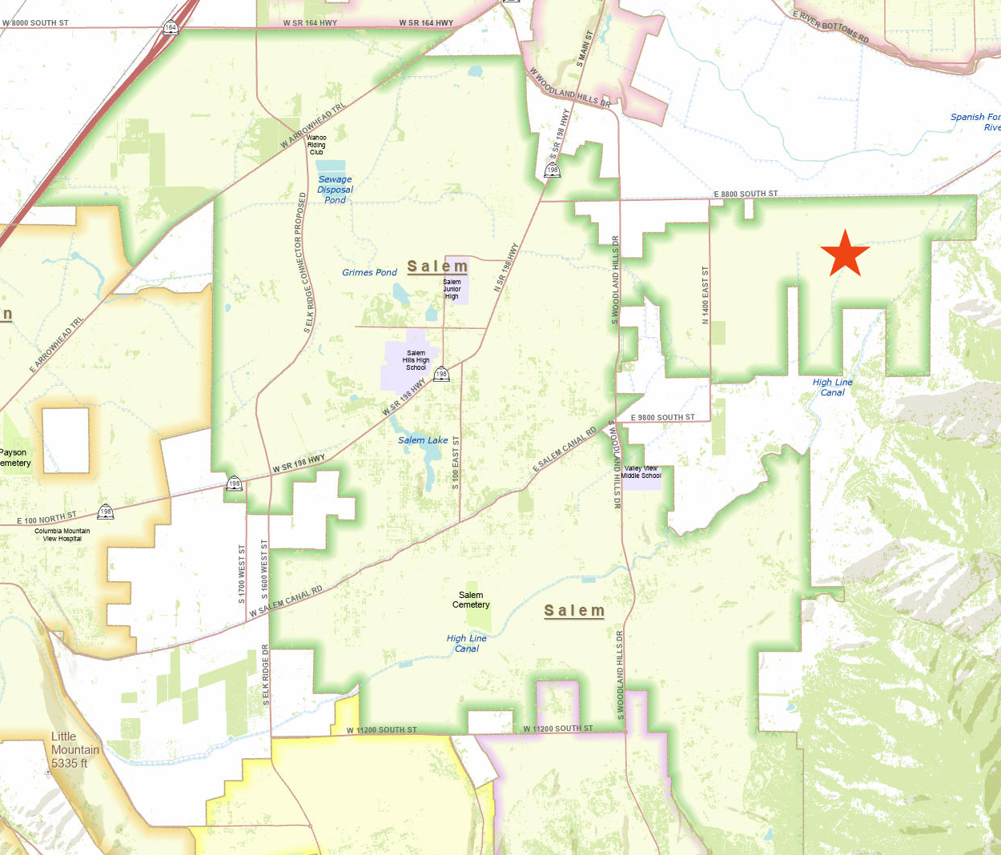

EXHIBIT C
Initial District Boundary Maps

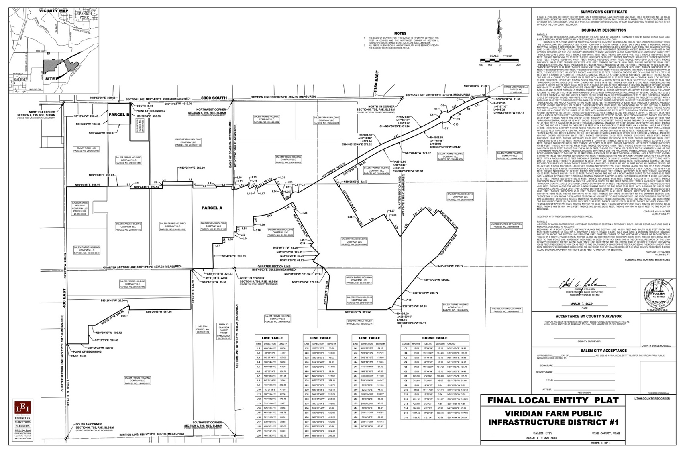

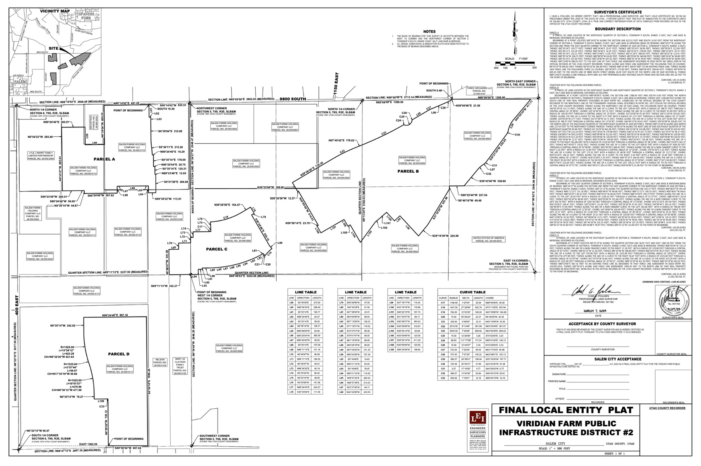

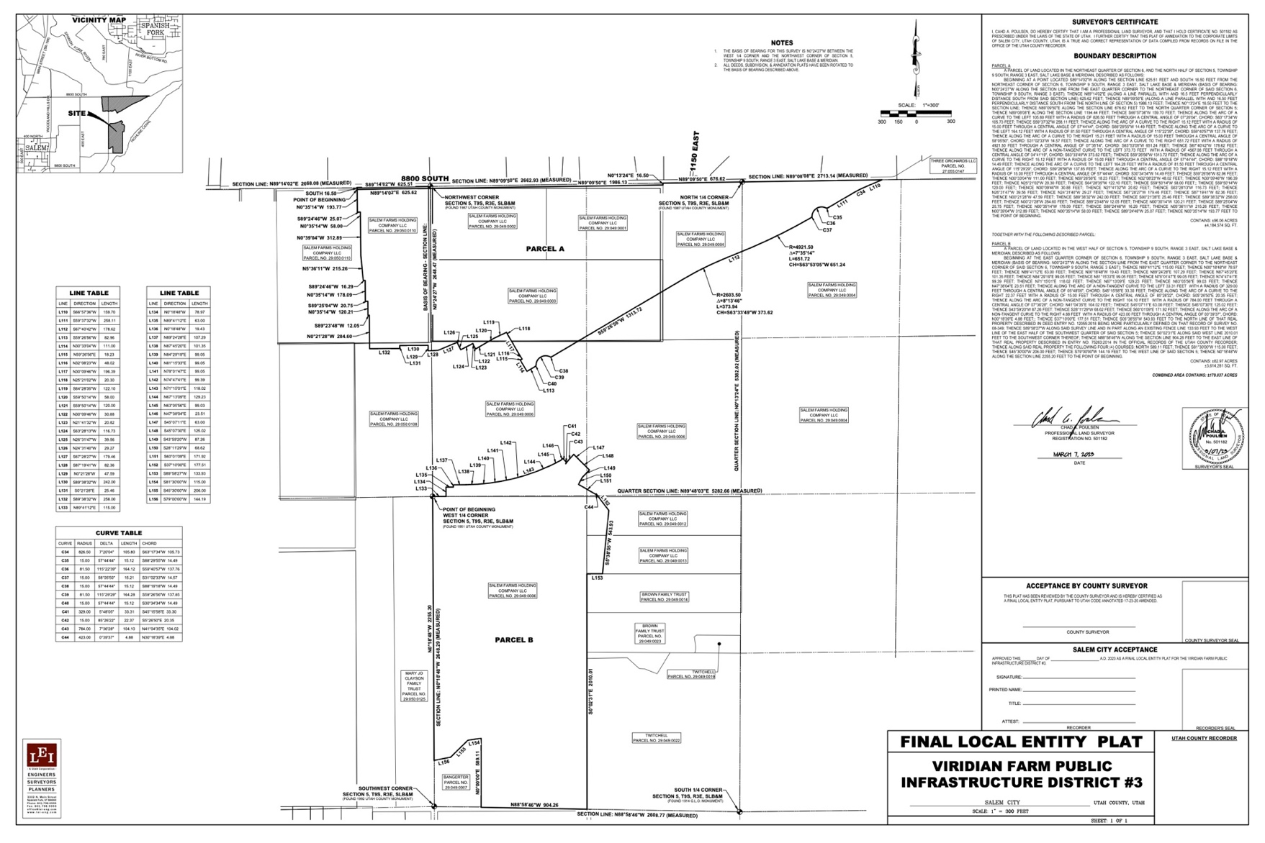

Annexation Area Map

(Note that the Districts are authorized to annex to or withdraw from their boundaries any properties within the Annexation Area, subject to property owner and registered voter consent.)

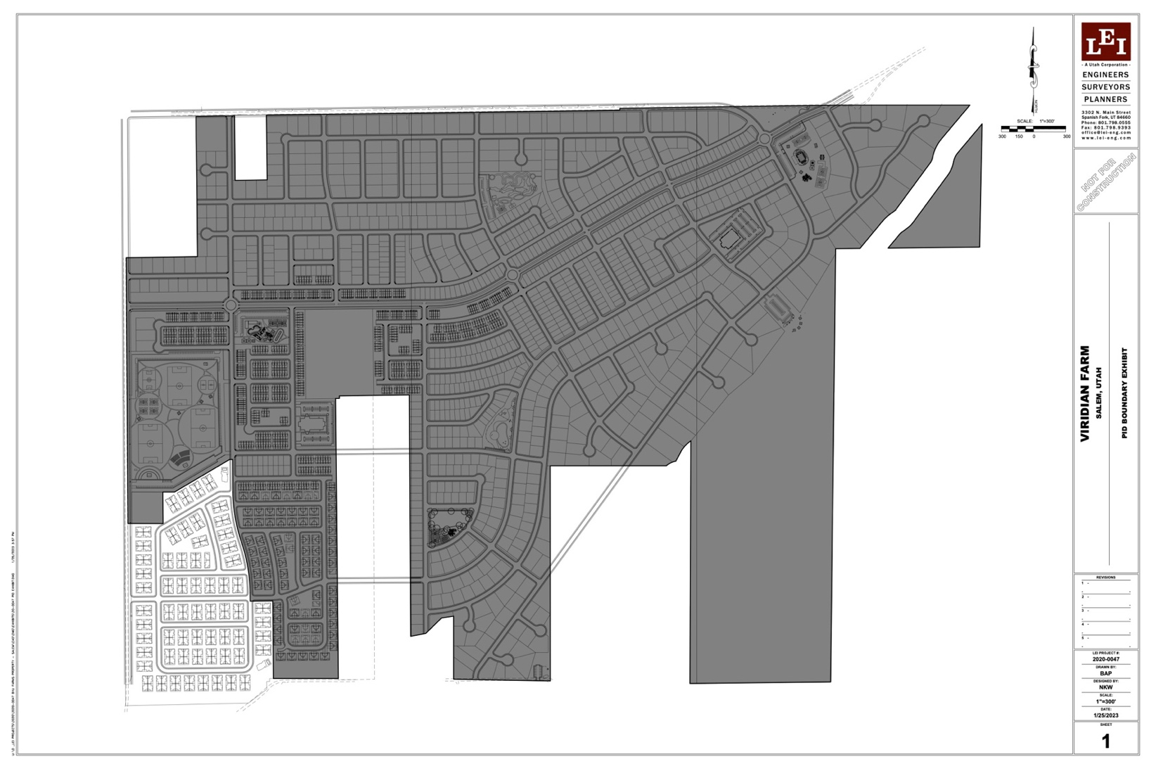

EXHIBIT D
AMENDED AND RESTATED
INTERLOCAL AGREEMENT BETWEEN
SALEM CITY, UTAH
AND
VIRIDIAN FARM PUBLIC INFRASTRUCTURE DISTRICT NO. ___
THIS AGREEMENT is made and entered into as of this ___ day of __________, 20___, by and between the SALEM CITY, a home-rule municipal corporation of the State of Utah (“City”), and VIRIDIAN PUBLIC INFRASTRUCTURE DISTRICT NO. ___, a political subdivision of the State of Utah (the “District”). The City and the District are collectively referred to as the Parties. This Agreement is intended to amend and entirely restate the interlocal agreement previously entered by the parties as to the subject matter hereof.
RECITALS
WHEREAS, the District was organized to provide to exercise powers as are more specifically set forth in the District’s Governing Document approved by the City on September 20, 2023, an amendment and entire restatement of which was approved by the District on January 24, 2025, and by the City on __________________, 2025 (“Governing Document”); and
WHEREAS, the Governing Document makes reference to the execution of an Interlocal Agreement between the City and the District; and
WHEREAS, the City and the District have determined it to be in the best interests of their respective taxpayers, residents and property owners to enter into this Interlocal Agreement (“Agreement”).
NOW, THEREFORE, in consideration of the covenants and mutual agreements herein contained, and for other good and valuable consideration, the receipt and sufficiency of which are hereby acknowledged, the Parties hereto agree as follows:
COVENANTS AND AGREEMENTS
- Operations and Maintenance. The District shall dedicate the Public Improvements (as defined in the Governing Document) to the City or other appropriate jurisdiction in a manner consistent with the Approved Improvement Plan and other rules and regulations of the City and applicable provisions of the City Code. Trails which are interconnected with a city or regional trail system shall be open to the public free of charge and on the same basis as residents and owners of taxable property within the District.
- Improvements Limitation. The District shall have authority to provide for the planning, design, acquisition, construction, installation, relocation, redevelopment, maintenance, and financing of the Public Improvements within and without the boundaries of the District, as described in the Governing Document. Without the written consent of the City, a District shall not be authorized to finance any improvements which do not fall within the categories listed in the Governing Document (as may be modified and shall be more fully set forth in the Approved Improvement Plan). Without written authorization of the City, the District shall not be authorized to finance the costs of any improvements or facilities which are to be ultimately owned by the District.
- Construction Standards. The District will ensure that the Public Improvements are designed and constructed in accordance with the customary standards and specifications of the City and of other governmental entities having proper jurisdiction, as applicable. The District will require the developer of Public Improvements to obtain the City’s approval of civil engineering plans and applicable permits for construction and installation of Public Improvements prior to such work being performed. The District will obtain a surveyor or engineer’s certification that Public Improvements are completed, or partially completed, consistent with City-approved plans and applicable City standards before paying or reimbursing the costs of such construction.
- Issuance of Privately Placed Debt. Prior to the issuance of any privately placed Debt, the District shall obtain the certification of a Municipal Advisor substantially as follows:
We are [I am] a Municipal Advisor within the meaning of the District’s Governing Document.
We [I] certify that (1) the net effective interest rate to be borne by [insert the designation of the Debt] does not exceed a reasonable current [tax-exempt] [taxable] interest rate, using criteria deemed appropriate by us [me] and based upon our [my] analysis of comparable high yield securities; and (2) the structure of [insert designation of the Debt], including maturities and early redemption provisions, is reasonable considering the financial circumstances of the District.
- Inclusion Limitation. The District shall not include within its boundaries any property outside the District Area without the prior written consent of the City. By approving the Governing Document, the City has consented to the annexation of any area within the Annexation Area into or from the District Boundaries. Such area may only be annexed upon 1) the District obtaining consent of all property owners and registered voters, if any, within the area proposed to be annexed and the passage of a resolution of the Board approving such annexation, and 2) if the parcel is not currently located in the City, the annexation of such parcel into the City or adoption of a resolution of the County approving such annexation into the District.
- Overlap Limitation. The District shall not consent to any annexation or withdrawal hereunder, or to the organization of any other public infrastructure district organized under the PID Act within the District Area which will overlap the boundaries of the District, unless the aggregate mill levy for payment of Debt of such proposed boundaries or districts will not at any time exceed the Maximum Debt Mill Levy of the District.
- Impact Fee Reimbursements or Credits. Any impact fee reimbursements or credits which become available due to the financing of Public Improvements by the District shall be for the benefit of the District and not any developer. The specifics of the scope and availability of impact fee credits or reimbursements shall be reserved and will be addressed in a future interlocal agreement between the City and the District.
- Total Debt Issuance. The District shall not, in the aggregate with Viridian Farm Public Infrastucture Districts Nos. ___ and ___, issue Debt in excess of the amount of Thirty-Five Million Dollars ($35,000,000). This amount excludes any portion of bonds issued to refund a prior issuance of debt by any of said Districts.
- Bankruptcy. All of the limitations contained in this Governing Document, including, but not limited to, those pertaining to the Maximum Debt Mill Levy and the Maximum Debt Mill Levy Imposition Term, have been established under the authority of the City to approve a Governing Document with conditions pursuant to Section 17D-4-201(4), Utah Code. It is expressly intended that such limitations:
  - Shall not be subject to set-aside for any reason or by any court of competent jurisdiction, absent a Governing Document Amendment; and
  - Are, together with all other requirements of Utah law, included in the “political or governmental powers” reserved to the State under the U.S. Bankruptcy Code (11 U.S.C.) Section 903, and are also included in the “regulatory or electoral approval necessary under applicable nonbankruptcy law” as required for confirmation of a Chapter 9 Bankruptcy Plan under Bankruptcy Code Section 943(b)(6).
Any Debt, issued with a pledge or which results in a pledge, that exceeds the Maximum Debt Mill Levy and the Maximum Debt Mill Levy Imposition Term, shall be deemed a material modification of the Governing Document and shall not be an authorized issuance of Debt unless and until such material modification has been approved by the City as part of a Governing Document Amendment.
- Eminent Domain. In no event shall the District have authority to exercise eminent domain or utilize any funds of the District to support any eminent domain action or proceeding without the prior approval of the City Council.
- Dissolution. Upon an independent determination of the City Council that the purposes for which the District was created have been accomplished, the District agrees to file petitions for dissolution, pursuant to the applicable State statutes. In no event shall a dissolution occur until the District has provided for the payment or discharge of all of their outstanding indebtedness and other financial obligations as required pursuant to State statutes.
- Notice to Property Owners ; Disclosure to Purchasers.
  - Within thirty (30) days of the issuance of a certificate of incorporation by the Office of the Lieutenant Governor of the State, the Board shall record a notice with the recorder of Utah County, Utah. Such notice shall (i) contain a description of the boundaries of the District, (ii) state that a copy of the Governing Document is on file at the office of the City, (iii) state that the District may finance and repay infrastructure and other improvements through the levy of a property tax; (iv) state the Maximum Debt Mill Levy of the District; and (v) if applicable, stating that the debt may convert to general obligation debt and outlining the provisions relating to conversion. A copy of the notice shall further be provided to the City.
  - In addition, the Board shall make commercially reasonable efforts to ensure that the Project developer, homebuilders, commercial developers, and commercial lessors, as applicable, disclose the following information to initial resident homeowners, renters, commercial property owners, and/or commercial tenants:
    - All of the information in subparagraph (a) above;
    - A disclosure outlining the impact of any applicable property tax, in substantially the following form:
“Under the maximum property tax rate of the District, for every $100,000 of taxable value, there would be an additional annual property tax of $300 for the duration of the District’s Bonds.”
    - Such disclosures shall be contained on a separate-colored page of the applicable closing or lease documents and shall require a signature of such End User acknowledging the foregoing.
  - On or before July 15 of each year, commencing in the first calendar year following the year in which the District issues Debt, the District shall mail a notice to all owners of property within the boundaries of the District a notice providing:
    - A disclosure outlining the impact of any applicable property tax, in substantially the following form:
“Under the maximum property tax rate of the District, for every $100,000 of taxable value, there would be an additional annual property tax of $300 for the duration of the District’s Bonds.”
    - The applicable tax rate of the District for the then current year;
    - That budgets and financial information for the District may be found on the State Auditor’s Website (currently https://reporting.auditor.utah.gov/searchreports/s/); and
    - Contact information for members of the Board.
- Governing Document Amendment Requirement. Actions of the District which violate the limitations set forth in V.A.1-8 or VIII.B-G of the Governing Document shall be deemed to be material modifications to the Governing Document and the City shall be entitled to all remedies available under State and local law to enjoin such actions of the District.
- Annual Report. The District shall be responsible for submitting an annual report to the City Manager’s Office no later than one hundred eighty (180) days following the closing of the District’s fiscal year, containing the information set forth in Section IX of the Governing Document.
- Regional Improvements. The District shall be authorized to provide for the planning, design, acquisition, construction, installation, relocation and/or redevelopment and a contribution to the funding of such regional improvements as fall within the description of Public Improvements in the Governign Document, and fund the administration and overhead costs related to such regional improvements.
- Maximum Debt Mill Levy.
  - The “Maximum Debt Mill Levy” shall be the maximum mill levy the District is permitted to impose upon the taxable property within the District for payment of Limited Tax Debt and administrative expenses and such maximum shall be 0.003 per dollar of taxable value of taxable property in the District; provided that such levy shall be subject to adjustment as provided in Section 17D-4-301(8).
  - Such Maximum Debt Mill Levy may only be amended pursuant to a Governing Document Amendment and as provided in Section 17D-4-202.
- Maximum Debt Mill Levy Imposition Term. Each bond issued by the District shall mature within thirty-one (31) years from the date of issuance of such bond. In addition, no mill levy may be imposed for the repayment of a series of bonds after a period exceeding forty (40) years from the first date of imposition of the mill levy for such bond (the “Maximum Debt Mill Levy Imposition Term”).
- Notices. All notices, demands, requests or other communications to be sent by one party to the other hereunder or required by law shall be in writing and shall be deemed to have been validly given or served by delivery of same in person to the address or by courier delivery, via United Parcel Service or other nationally recognized overnight air courier service, or by depositing same in the United States mail, postage prepaid, addressed as follows:

 | To a District: | Viridian Farm Public Infrastructure Dist. No. 1, 2, or 3  c/o Snow Jensen & Reece, PC  912 W. 1600 S., Ste. B200  St. George, Utah 84770  Attn: Matthew J. Ence  Phone: 435-628-3688
To the City: |  | Salem City  30 W 100 S  Salem, UT 84653  Attn: City Manager  Phone: (801) 423-2770
All notices, demands, requests or other communications shall be effective upon such personal delivery or one (1) business day after being deposited with United Parcel Service or other nationally recognized overnight air courier service or three (3) business days after deposit in the United States mail. By giving the other party hereto at least ten (10) days written notice thereof in accordance with the provisions hereof, each of the Parties shall have the right from time to time to change its address.
- Amendment. This Agreement may be amended, modified, changed, or terminated in whole or in part only by a written agreement duly authorized and executed by the Parties hereto and without amendment to the Governing Document.
- Assignment. Neither Party hereto shall assign any of its rights nor delegate any of its duties hereunder to any person or entity without having first obtained the prior written consent of the other Party, which consent will not be unreasonably withheld. Any purported assignment or delegation in violation of the provisions hereof shall be void and ineffectual.
- Default/Remedies. In the event of a breach or default of this Agreement by any Party, the non-defaulting Party shall be entitled to exercise all remedies available at law or in equity, specifically including suits for specific performance and/or monetary damages. In the event of any proceeding to enforce the terms, covenants or conditions hereof, the prevailing Party in such proceeding shall be entitled to obtain as part of its judgment or award its reasonable attorneys’ fees.
- Term. This Agreement shall terminate upon the earlier to occur of dissolution of the District or fifty (50) years from the date hereof.
- Governing Law and Venue. This Agreement shall be governed and construed under the laws of the State of Utah.
- Inurement. Each of the terms, covenants and conditions hereof shall be binding upon and inure to the benefit of the Parties hereto and their respective successors and assigns.
- Integration. This Agreement constitutes the entire agreement between the Parties with respect to the matters addressed herein. All prior discussions and negotiations regarding the subject matter hereof are merged herein.
- Parties Interested Herein. Nothing expressed or implied in this Agreement is intended or shall be construed to confer upon, or to give to, any person other than the District and the City any right, remedy, or claim under or by reason of this Agreement or any covenants, terms, conditions, or provisions thereof, and all the covenants, terms, conditions, and provisions in this Agreement by and on behalf of the District and the City shall be for the sole and exclusive benefit of the District and the City.
- Severability. If any covenant, term, condition, or provision under this Agreement shall, for any reason, be held to be invalid or unenforceable, the invalidity or unenforceability of such covenant, term, condition, or provision shall not affect any other provision contained herein, the intention being that such provisions are severable.
- Counterparts. This Agreement may be executed in one or more counterparts, each of which shall constitute an original and all of which shall constitute one and the same document.
- Paragraph Headings. Paragraph headings are inserted for convenience of reference only.
- Defined Terms. Capitalized terms used herein and not otherwise defined shall have the meanings ascribed to them in the Governing Document.
[SIGNATURE PAGE TO INTERLOCAL AGREEMENT]

VIRIDIAN FARM PUBLIC INFRASTRUCTURE DISTRICT NO. ___
By:
Chair

Attest:
Clerk/Secretary

APPROVED AS TO FORM: _____________________________________

SALEM CITY, UTAH
By:
Mayor

Attest:
By:
Its:

APPROVED AS TO FORM: _____________________________________
EXHIBIT E
Required Notice for Sales and Leasing Offices
NOTICE: This Development is located within the Viridian Farm Public Infrastructure Districts.
The Districts are authorized to impose a property tax of 0.003 per dollar of taxable value.

Under the maximum property tax rate of the Districts, for every $100,000 of taxable value, there would be an additional annual property tax of $300 for the duration of the Districts’ Bonds.

