MINUTES
Weber School Foundation Board Meeting
12/19/2024 12:00 PM | Meeting held at the Goldenwest Corporate Center and called to order by Jeremy Dunn

Attendance
Present: Craig Adams, Dave Andersen, Jenna Andrascik, Bryan Benard, Barry Beus, Dave Broadbent, Jan Burrell, Gina Butters, Michelle Darrington, Craig Dearden, Tony Divino, Scott Dixon, Jeremy Dunn, Kori Ann Edwards, Jamie Ellison, Brandi Hammon, Bryan Hurst, Matt Jensen, Brett Karras, Steve Kier, Ashley Loftus, Clyde Moore, Ryan Olsen, Cami Orr, Emily Oyler, Kathy Saunders, Adam Stuart, Angie Towns & Kerry Wahlen
Excused: Mark Adams, Matt Bell, Tyler Buxton, Flora Cassity, Jen Dunyon, Kimberli Green, Branden Hansen, Phill Mickey, Josh Skidmore, Jake Talbot, Jennie Taylor,
Jubilee Committee: Heather Bailey, Erin Behm, Jill Smith, Aubrey Clark, Tiffany Daniels, Julie Dixon, Monique Benard, Keri Meyerhoffer & Jessica Peterson

Welcome
President Elect Jeremy Dunn welcomed everyone to the meeting and thanked Kerry Whalen and Goldenwest Credit Union for hosting our luncheon.
We welcomed new board member Adam Stuart from Mountain Luxury Real Estate to the board. He will be taking Brandi Hammon’s seat representing Mountain Luxury while Brandi will remain on the board representing Powder Mountain.

Approval of Minutes
Kathy Saunders made a motion to approve the minutes from the October 10, 2024 meeting with a second from Dave Broadbent. The minutes were unanimously approved. (There was no board meeting held in November because of Christmas Tree Jubilee.)

Committee Reports
Special Needs—Barry Beus reported since our last meeting we have received nine special needs request for ipads and apps. These requests total is $6,977.88. Jeremy Dunn made the motion to approve these requests with a second from Kathy Saunders. The board unanimously approved.
Finance/Audit-Craig Adams reported that we have had a good year with our investments. The final audit was sent to the Finance Committee for approval with no findings of any kind.

Director’s Report
Sub for Santa-Assistant Superintendent’s Clyde Moore and Dave Hales reported on the annual District Office Sub for Santa luncheon that was held on December 6, 2024. Monday is raised for district employees who are struggling. We raised $7,500 with the Foundation matching that amount. We have $15,000 to help 20 employees for the holidays. Thank you to those board members who donated to this cause as well!

Jubilee Committee Recognitions-Emily thanked all of our committee member volunteers. She introduced Monique Benard who helps with the Family Fun Night, Keri Meyerhoffer who is over Tree Sales, Erin Behm, Jill Smith and Aubrey Clark who are Tree Room Chair, Jessica Peterson who is over the Gala Volunteers and Delivery, Julie Dixon who helps with our Live Auction, Tiffany Daniels who is over the Wednesday and Friday Entertainment and Heather Bailey who is our new Jubilee Chair. We could not do it without these amazing ladies!
CTJ Recap & Feedback-Emily reported that we can say this again….THIS WAS OUR BEST JUBILEE EVER!!!

Emily went over the recap with the board:
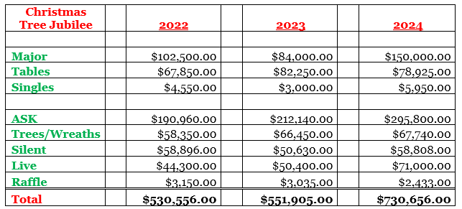

Here is some feedback we have received:
We are truly grateful for all the support in making this Christmas Tree Jubilee THE BEST EVER!!
Other Business-The Giving Machine down at the Ogden Christmas Village will be available for donations for the Weber School Foundation through December 15th.
Adjourn

Next Meeting
January 23, 2025

