MINUTES
Weber School Foundation Board Meeting
9/19/2024 12:00 PM | Meeting held at the Weber School District Office and called to order by Jen Dunyon

Attendance
Present: Jenna Andrascik, Dave Broadbent, Jan Burrell, Gina Butters, Michelle Darrington, Craig Dearden, Scott Dixon, Jeremy Dunn, Jennifer Dunyon, Jamie Ellison, Bryan Hurst, Matt Jensen, Brett Karras, Steve Kier, Clyde Moore, Cami Orr, Emily Oyler, Kathy Saunders, Josh Skidmore, Jennie Taylor & Angie Towns
Excused: Craig Adams, Mark Adams, Dave Andersen, Matt Bell, Bryan Benard, Flora Cassity, Tony Divino, Kori Ann Edwards, Kimberli Green, Branden Hansen, Ashley Loftus, Philip Mickey, Ryan Olsen, Jake Talbot & Kerry Wahlen
Guests: Bonneville High Tapestry Choir & Director Michelle Kirby

Welcome
President Jen Dunyon welcomed everyone to the meeting.

Introduce Cami Orr
Emily introduced Cami Orr to the board members. Cami is our new Foundation employee who will be over Communications and Outreach. She came from the District’s Public Safety & Community Relations department. She has a background in communications and marketing and is excited to work with the Foundation!

Share our Story
Michelle Darrington introduced the Bonneville High Tapestry Choir with Director Michelle Kirby. The choir performed a couple of songs for the board members including the song they will be singing for almond knot delivery. This choir is an amazing support to the foundation and we love supporting their program!

Approval of Minutes
Kathy Saunders made a motion to approve the minutes from the August 15, 2024 meeting with a second from Steve Kier. The minutes were unanimously approved.

Committee Reports
Food Insecurity-Jennie Taylor reviewed the Food Insecurity Committee responsibilities: This committee will work with the Foundation team to identify pantries that are in need of food, clothing or hygiene items, promote and plan food drives and create awareness of this increasing issue in our community. They will also help organize the Bridging the Gap service projects and educate their circle of influence on this ever-growing need. Jennie reported that she, Emily and Lindee Bess met and discussed business to ask to help support the food pantries in our schools. Please reach out to any member of this committee if you have someone who would like to help with this ongoing support!

Special Needs—Jeremy Dunn reviewed the Special Needs Committee responsibilities: This committee reviews Special Needs grant applications from teachers and therapists. The grant requests are first reviewed by the District SPED Department to ensure the request is eligible and appropriate for funding. Grant requests are forwarded to committee members who will review the grants by email for approval following established criteria for adaptive equipment. Jeremy reported since our last meeting we have received one special needs request for orthotics. This request total is $1,338.64. Steve Kier made the motion to approve this with a second from Craig Dearden. The board unanimously approved.
Finance-Emily excused Finance Chair Craig Adams from the meeting today and reviewed the Finance and Investment Committee responsibilities: This committee will advise the Board of Trustees in regard to the investments and following the Investment Policy guidelines. This committee meets as needed with the Financial Advisor to review performance of investments and discuss strategies and approve the yearly budget.
Projects-Kathy Saunders reviewed the Projects Committee responsibilities: This committee reviews class and school grant requests from teachers and Principals. The grant requests are reviewed and approved by principals and by one of the Assistant Superintendents to ensure the request is eligible and appropriate for funding. Grant requests are forwarded to committee members who will review the grants by email for approval following established criteria. Grants are intended to assist teachers with projects or innovative programs that enhance students learning experience. Kathy reported that since our last board meeting, we have received 23 classroom grants and 1 school grant. 21 of the grants were funded through DonorsChoose. The other 2 class grants were for a CTE Collaboration Project and Handheld Microscopes. The school grant was for a Phonics Program. Jeremy Dunn made the motion to approve these projects with a second from Bryan Hurst. The Board unanimously approved.
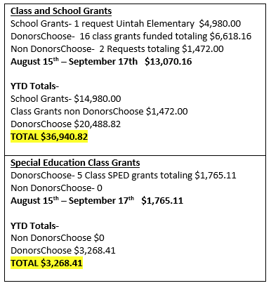
Teen Center-Steve Kier reviewed the Teen Center Committee responsibilities: This committee will inform and educate community members on the need for Teen Centers in Weber School District. Committee members will do this through Social Media, Social Impact Gatherings and Advocacy. Committee members will also directly reach out to their circles of influence and provide the necessary information for them to understand the need and help with fundraising initiatives. Steve reported that the Roy High Teen Center is almost complete with the ribbon cutting scheduled for Thursday, October 10th. The Fremont Teen Center is almost finished with the date for that ribbon cutting to be scheduled soon. The Weber High Teen Center should be complete by the end of October. The West Field High Teen Center’s final design is almost complete.
Steve went over the Teen Center Budget:
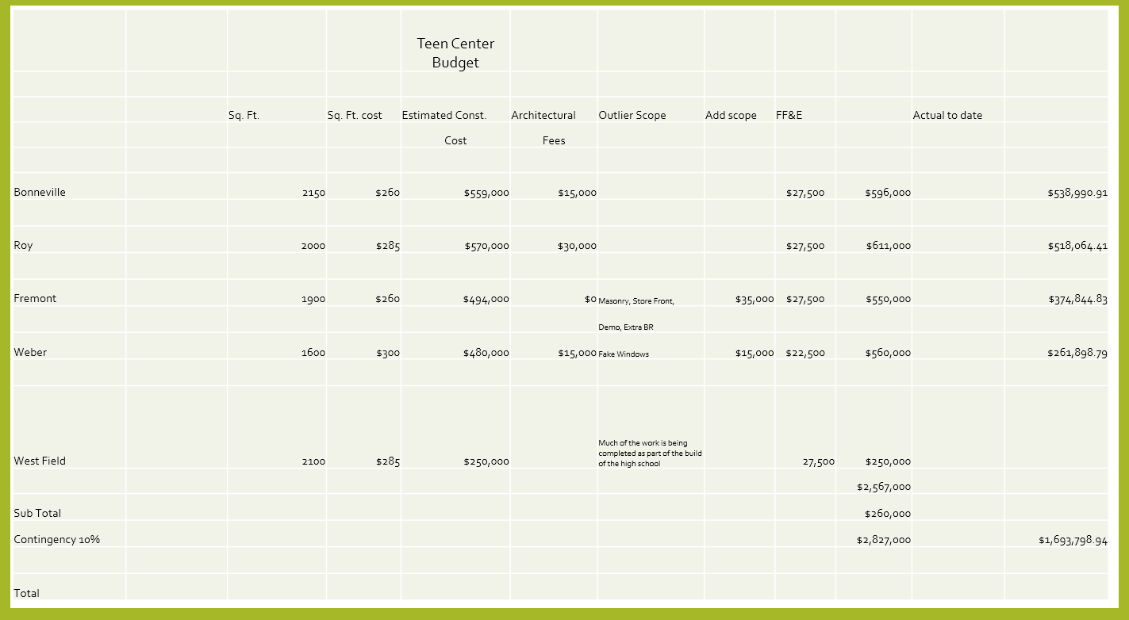
Steve went over the Income and Potential Income:
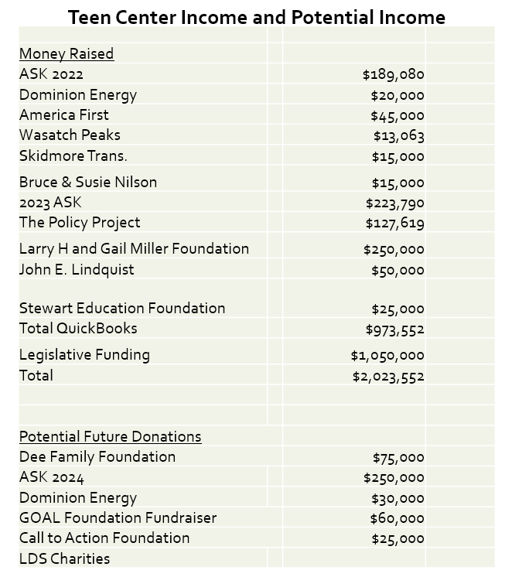

Director’s Report
Jubilee Update-Emily reported that our Jubilee sponsorships go live today! We added three new sponsorship levels this year:
Presenting Sponsor-America First Credit Union ($25,000.00)
Tree Room Sponsor-Josh & Kim Skidmore ($10,000.00)
Entertainment Sponsor-Hogan Construction ($10,000.00)
We have increased our Principal sponsorship level from $1,500.00 to $1,750.00. We will be delivering almond knots on October 7th and 8th. We have started working on the Jubilee Ask Video which should be done by the end of October. Emily met with the Ogden Eccles Conference Center and we are very excited about the 2nd floor remodel. Julie Dixon will be helping us again this year with our Live Auction.
Silent Auction-Jamie Ellison has met with her Silent Auction Committee and they are starting to gather baskets and items. We are shooting for 250 baskets this year! We are grateful for The Boyer Company for providing us space to assemble and store the baskets. If you would like to donate a basket, items or money please contact Jamie.
Trees & Wreaths-Michelle informed the board that we have 3 ladies now on our Tree Room Committee. One will recruit new trees from Davis County, one in Weber County and one will focus on working with the school PTA’s. We already have 10 trees and 1 wreath committed. We need volunteers for tree set up day on Monday, November 25th. Michelle will be sending out all the information. Yard signs are available to take to put in front of your home or business.
Audit Update-The auditors are here working on the 2023-2024 Audit. We will give a full report to the board when it is complete.
Other Business-Tomorrow is the Unified Sports Soccer Tournament at Bonneville High School at 9:45 am. All are encouraged to attend and support our WSD athletes!
Adjourn

Next Meeting
October 10, 2024

