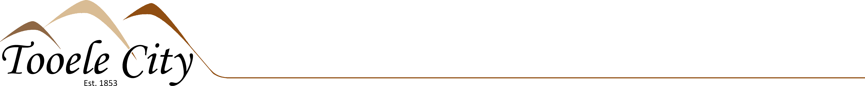

AGREEMENT

TOOELE CITY CORPORATION, a municipal corporation of the State of Utah, (hereinafter “City”), and the North Tooele City Special Service District of 90 N. Main Street, Tooele, Utah, a Utah Special Service District, (hereinafter “District”) enter into this Agreement on the day of , 20___ (the “Effective Date”).

Now, therefore, in consideration of the promises contained in this Agreement, the City and the District agree to the following:

- Services (Scope of Work). The City shall provide to the District an employee to post meeting agendas and approved minutes to the Utah State Public Notice Website, take minutes during meetings, provide drafts to the Board for feedback, take attendance and other duties as needed for the District.

- Compensation.
  - Rate. The District shall pay the City the approximate sum of $1,080.00 per year for the City providing the employee, providing basic benefits and supervision for the employee, and assuming a base hourly rate of $22/hour, pursuant to invoice. This rate may vary depending on the number of meetings held and yearly cost-of-living pay increases.

  - Total Cost Contract. This Agreement is a “Total Cost Contract.” The contract Rate includes all costs and expenses associated with the provision of the Services.

- Term of Agreement. The terms of the contract shall be for three (3) years, and then renewed from year to year upon agreement of the parties.
- Termination. Either party may terminate this Agreement at any time. Should the City terminate this Agreement prior to the Services being fully performed, the City shall pay for those Services performed.
- Complete Agreement. This Agreement is the only agreement or understanding between the parties, and may be modified or amended only by a written document signed by both parties.
- Waiver of Jury Trial. The Parties irrevocably waive any and all right to trial by jury in any legal proceeding arising out of or relating to this contract and the transactions contemplated.

IN WITNESS WHEREOF, the parties have executed this Agreement as of the Effective Date.

TOOELE CITY CORPORATION DISTRICT

____________________________________ _____________________________________
Debra E. Winn, Tooele City Mayor Signature
Print Name/Title:_____________________

Attest:

____________________________________
Michelle Y. Pitt, Tooele City Recorder

SEAL

Approved as to form:

_____________________________________
Roger Evans Baker, Tooele City Attorney

(Revised 10/25/2024)

